2020

DATA WAREHOUSING – DOMINICK FINE FOODS RETAIL STORE CHAIN

ISTM 637 601 | COMPLETED AS A PART OF COURSE CURRICULUM UNDER THE GUIDANCE OF DR. ARUN SEN AND HIS TEACHING ASSISTANT, MANSEERAT BATRA

DESIGN AND IMPLEMENTATION OF A DATA WAREHOUSE FOR RETAIL STORE CHAIN

GROUP 7: ANSHUL SAREEN, KIRAN RODE, NONI GULATI

Table of Contents

***Introduction 2***

***Details about the Data 3***

***Metadata for all OLTP Sources 4***

***ERD 10***

***Literature Survey 11***

***Business Questions 13***

***Independent Data Mart Design 32***

***Dimensional Modelling (STAR Schema) 35***

***Development of ETL Plan 45***

***ETL Implementation 51***

***References 91***

# Introduction

Dominick’s Fine Food, commonly referred to as DFF here, is a retail store chain with locations mainly in Chicago. It is a grocery chain and is a subsidiary of Safeway Inc with its major distribution center located in Northlake, Illinois. Dominick’s came into business in 1918 by opening its first retail store in Chicago west, and expanded to 118 stores by 1998, the year in which it was bought by Safeway. Throughout the 1980s and 90s, there were several experiments involving changes to store layouts. The retail chain sells a variety of products like groceries, freshly prepared foods, bulk foods, and pharmaceuticals among others. Thus, the data profile has a good diversity of products and their sales.

One of the unique things tried by the chain was Omni superstore locations which were warehouse-style supermarkets which included non-food items, movie rental stores, etc. When these stores began to lose money due to loss prevention and throwaway inventorying, they were converted to Dominick’s Fresh Store concept in 1997.

University of Chicago Booth School of Business entered into a partnership with Dominick’s Finer Foods from 1989 to 1994. This partnership engaged in store-level research into shelf management and pricing. 25 different categories of the stores when chosen at random whose analysis led to the formation of this dataset.The dataset contains information about number of customers, their buying habits, sales of stores, purchase history of customers, demographic data, earnings of people, and more. The analysis of the dataset will help Dominick’s Finer Foods to increase their sales per customer over a period of time. It will also enable the store chain to understand the needs of existing customers, analyze market trends, increase profit shares, increase the number of customers by making predictions regarding the observed trends.

The dataset provided is very dirty with missing information in various columns which will hamper the accuracy of analysis. There are errors in the form of wrong spellings, data inconsistencies, and wrong values or exchanged values of different columns. Some files have column headings which are full forms while other files have the same column names abbreviated. There are data redundancies as well which should be removed and perform the required normalization. Thus, it is vital to clean and transform the data before analysis so that we get useful results.

# Details about the Data

The Dominick’s dataset contains approximately nine years of store-level data on the sales of more than 3500 UPCs. This data is collected from more than 100-retail stores of DFF across all the regions in the United States and contains research data for more than 25 categories of products offered by DFF. The dataset is categorized into 4 different categories having customer traffic information at various stores, their purchase details, demographics information, sales data for every store, and more. The data set provided is dirty and contains missing values for multiple fields in different files. The dataset was thoroughly analyzed and transformed to make it consistent and good enough to make valuable business decisions.

The dataset contains two types of files: General Files and Category-Specific Files. The general files contain information related to different categories in the project. It is further divided into two different sub-categories: Customer Count Files and Store-Specific Files. The Customer Count File (CC Files) contains data about the number of customers visiting the stores each day, the dollar amount generated from the sale of different products, number of coupons redeemed by the customers, etc. Store-specific files contain demographic information on different stores of DFF. This data is derived from the US government census data gathered from the Chicago metropolitan area. The Category specific files have been categorized as UPC Files and Movement Files. The UPC files contain one record for each UPC in a category (xxx is the acronym for category). It contains information about product name, size, commodity code, etc. The Movement files contain weekly sales data for each UPC of every store for over five years. This file has got multiple variables like price, unit sold, profit margin, deal code, etc. The files are also sorted by UPC, store, week.

Some of the highlights about the dataset are:

* The most important part of the dataset is its segregation in different files. Partition of data helps in correlating different features and forming an understanding of the entire dataset. The files can be individually used to analyze the datasets and then could easily be joined with other datasets to understand relation between multiple variables from different datasets and form a holistic understanding of DFF stores and sales.
* The data in most of the files is polluted. There are missing values in the dataset. The data needs to be cleaned and transformed before deriving any results from it or making any recommendations. For example: the CCount file has many stores for which the Day attribute doesn’t have any value. For these stores, we cannot determine whether the traffic was high on weekdays or weekends. Similarly, the dollar sales amount and coupon redeemed for certain products in the stores are negative in the file. The sales amount in different stores cannot have negative values. They can at the very least have 0 sales, but not negative sales or coupons redeemed values.

# Metadata for all OLTP Sources

The metadata for the source files is as follows:

### **Customer count file**

The customer count file includes data about in-store traffic on a daily basis. This data is organized store-wise. For every store, data such as the count of customers visiting the store, the sales generated for different products, coupons redeemed is available. Thus, this dataset provides information about customer traffic, total sales, and total number of coupons used in various stores of DFF.

The variables in this dataset are:

|  |  |  |  |
| --- | --- | --- | --- |
| Variable | Description | Type | Length |
| DATE | Date of the Observation | Character | 6 |
| WEEK | Week Number | Numeric | 8 |
| STORE | Store Code | Numeric | 8 |
| BAKCOUP | Bakery Coupons Redeemed | Numeric | 8 |
| BAKERY | Bakery Sales in Dollars | Numeric | 8 |
| BEER | Beer Sales in Dollars | Numeric | 8 |
| BOTTLE | Bottle Sales in Dollars | Numeric | 8 |
| BULK | Bulk Sales in Dollars | Numeric | 8 |
| BULKCOUP | Bulk Coupons Redeemed | Numeric | 8 |
| CAMERA | Camera Sales in Dollars | Numeric | 8 |
| CHEESE | Cheese Sales in Dollars | Numeric | 8 |
| CONVFOOD | Conventional Food Sales in Dollars | Numeric | 8 |
| COSMCOUP | Cosmetics Coupons Redeemed | Numeric | 8 |
| COSMETIC | Cosmetics Sales in Dollars | Numeric | 8 |
| CUSTCOUN | Customer Count | Numeric | 8 |
| DAIRCOUP | Dairy Coupons Redeemed | Numeric | 8 |
| DAIRY | Dairy Sales in Dollars | Numeric | 8 |
| DELI | Deli Sales in Dollars | Numeric | 8 |
| DELICOUP | Deli Coupons Redeemed | Numeric | 8 |
| DELIEXPR | Deli Express Sales in Dollars | Numeric | 8 |
| DELISELF | Deli Self Service Sales in Dollars | Numeric | 8 |
| FISH | Fish Sales in Dollars | Numeric | 8 |
| FISCOUP | Fish Coupons Redeemed | Numeric | 8 |
| FLORAL | Floral Sales in Dollars | Numeric | 8 |
| FLORALCOUP | Floral Coupons Redeemed | Numeric | 8 |
| FROZCOUP | Coupons Redeemed | Numeric | 8 |
| FROZEN | Frozen Items Sales | Numeric | 8 |
| FTGCCOUP | Food-to-Go Chinese Coupons Redeemed | Numeric | 8 |
| FTGCHIN | Food-to-Go Chinese Sales in Dollar | Numeric | 8 |
| FTGICOUP | Food-to-Go Italian Coupons Redeemed | Numeric | 8 |
| FTGITAL | Food-to-Go Italian Sales in Dollars | Numeric | 8 |
| GM | General Merchandise Sales in Dollars | Numeric | 8 |
| GMCOUP | General Merchandise Coupons Redeemed | Numeric | 8 |
| GROCCOUP | Grocery Coupons Redeemed | Numeric | 8 |
| GROCERY | Grocery Sales in Dollars | Numeric | 8 |
| HABA | Health and Beauty Aids Sales in Dollars | Numeric | 8 |
| HABACOUP | Health and Beauty Aids Coupons Redeemed | Numeric | 8 |
| JEWELRY | Jewelry Sales in Dollars | Numeric | 8 |
| LIQCOUP | Liquor Coupons Redeemed | Numeric | 8 |
| MANCOUP | Manufacturer Coupons Redeemed | Numeric | 8 |
| MEAT | Meat Sales in Dollars | Numeric | 8 |
| MEATCOUP | Meat Coupons Redeemed | Numeric | 8 |
| MEATFROZ | Meat-Frozen Sales in Dollars | Numeric | 8 |
| MISCSCP | Misc. Coupons Redeemed | Numeric | 8 |
| MVPCLUB | MVP | Numeric | 8 |
| PHARCOUP | Pharmacy Coupons Redeemed | Numeric | 8 |
| PHARMACY | Pharmacy Sales in Dollars | Numeric | 8 |
| PHOTCOUP | Photo Coupons Redeemed | Numeric | 8 |
| PHOTOFIN | Photo | Numeric | 8 |
| PRODCOUP | Produce Coupons Redeemed | Numeric | 8 |
| PRODUCE | Produce Sales in Dollars | Numeric | 8 |
| PROMCOUP | Promotion Coupons Redeemed | Numeric | 8 |
| PROMO | Promotion Sales in Dollars | Numeric | 8 |
| SALADBAR | Salad Bar Sales in Dollars | Numeric | 8 |
| SALCOUP | Salad Coupons Redeemed | Numeric | 8 |
| SPIRITS | Spirits Sales in Dollars | Numeric | 8 |
| SSDELICP | Self Service Deli Sales in Dollars | Numeric | 8 |
| VIDCOUP | Video Coupons Redeemed | Numeric | 8 |
| VIDEO | Video Sales in Dollars | Numeric | 8 |
| VIDEOREN | Video Rentals (Dollar Amounts) | Numeric | 8 |
| WINE | Wine Sales in Dollars | Numeric | 8 |

### **Store Specific Demographics**

The store specific demographics file contains store-level demographic information. The data has originally been provided by the U.S. government census data for the Chicago metropolitan area which was further processed to produce demographic profiles for each of the DFF stores.

The dataset contains the following fields:

|  |  |
| --- | --- |
| Variable Name | Description |
| age9 | % Population under age 9 |
| age60 | % Population over age 60 |
| ethnic | % Blacks & Hispanics |
| educ | % College Graduates |
| nocar | % With No Vehicles |
| income | Log of Median Income |
| incsigma | Std dev of Income Distribution (Approximated) |
| hsizeavg | Average Household Size |
| hsize1 | % of households with 1 person |
| hsize2 | % of households with 2 persons |
| hsize34 | % of households with 3 or 4 persons |
| hsize567 | % of households with 5 or more persons |
| hh3plus | % of households with 3 or more persons |
| hh4plus | % of households with 4 or more persons |
| hhsingle | % of households with 1 person |
| hhlarge | % of households with 5 or more persons |
| workwom | % Working Women with full-time jobs |
| sinhouse | % Detached Houses |
| density | Trading Area in Sq Miles per Capita |
| hval150 | % of Households with Value over $150,000 |
| hval200 | % of Households with Value over $200,000 |
| hvalmean | Mean Household Value (Approximated) |
| single | % of Singles |
| retired | % of Retired |
| unemp | % of Unemployed |
| wrkch5 | % of working women with children under 5 |
| wrkch17 | % of working women with children 6 - 17 |
| nwrkch5 | % of non-working women with children under 5 |
| nwrkch17 | % of non-working women with children 6 - 17 |
| wrkch | % of working women with children |
| nwrkch | % of non-working women with children |
| wrkwch | % of working women with children under 5 |
| wrkwnch | % of working women with no children |
| telephn | % of households with telephones |
| mortgage | % of households with mortgages |
| nwhite | % of population that is non-white |
| poverty | % of population with income under $15,000 |
| shopcons | % of Constrained Shoppers |
| shophurr | % of Hurried Shoppers |
| shopavid | % of Avid Shoppers |
| shopstr | % of Shopping Stranges |
| shopunft | % of Unfettered Shoppers |
| shopbird | % of Shopper Birds |
| shopindx | Ability to Shop (Car and Single Family House) |
| shpindx | Ability to Shop (Car and Single Family House) |

### **UPC Files**

This file contains a description of each UPC in a category. The files are named as ucpxxx where xxx is the acronym for the category. Each file contains information about a product like product name, product size, number of items in a case, commodity code, item code, and UPC number.

The following variables are present in the UPC file:

|  |  |  |  |
| --- | --- | --- | --- |
| Variable | Description | Type | Length |
| upc | UPC Number | Numeric | 8 |
| com_code | Dominick's Commodity Code | Numeric | 8 |
| nitem | Dominick's item code | Numeric | 8 |
| descrip | Product Name | Character | 20 |
| size | Product Size | Character | 6 |
| case | Number of items in a case | Numeric | 8 |

### **Movement Data by UPC**

The movement file contains sales data for each UPC in a category. This data is arranged by store and stored on a weekly basis. The naming of the file is done using a three-letter acronym for the category.

The variables in the file are:

|  |  |  |  |
| --- | --- | --- | --- |
| Variable | Description | Type | Length |
| upc | UPC Number | Numeric | 8 |
| store | Store Number | Numeric | 3 |
| week | Week Number | Numeric | 3 |
| move | Number of units sold | Numeric | 8 |
| price | Retail Price | Numeric | 8 |
| qty | Number of items bundled together | Numeric | 3 |
| profit | Gross margin | Numeric | 8 |
| sale | Sale code (B, C, S) | Character | 8 |
| ok | 1 for valid data, 0 for trash | Numeric | 3 |

### **Dominick's Stores**

The data description provided under this name constitutes the address and price tier for every DFF store. For example: There is a DFF store located at 7501 W. North Ave., River Forest, 60305 in zone 1 having Store ID 2, and High Price Tier.

### **Week’s Decode Table**

The file contains a week variable that codes the week for which a data period is recorded. It converts calendar weeks into database week and also specifies any special events scheduled for the calendar year.

### **Category Description**

This dataset lists all categories and the UPCs in each category with their description and size. For example, the Bath Soap category contains UPCs like 6 Bar Gift Box! And Strawberry Gel 2 Oz#, etc.

# ERD

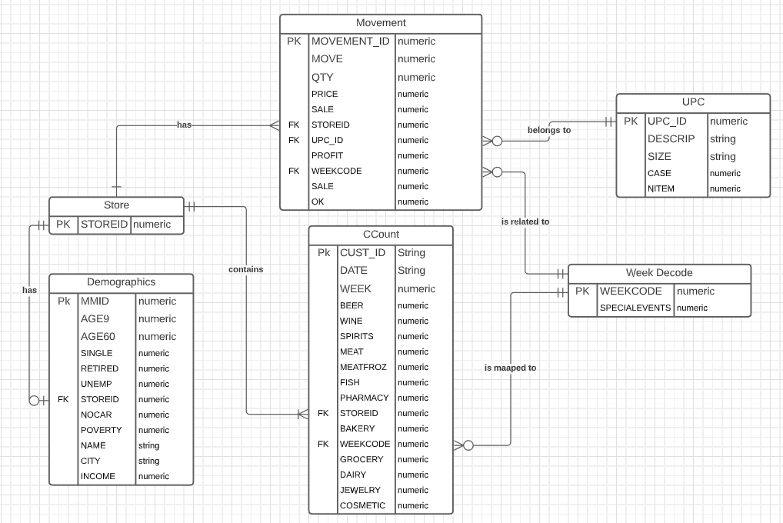

# Literature Survey

After performing extensive research, we decided to focus on the sales forecasting aspect of Dominick’s Finer Foods products. If we consider the beer segment of the industry, it has grown tremendously over the past few decades. The craft brew revolution increased the production of beer by at least six million barrels. Advertising has played an important role in making the beer types reach out to various corners of the world. Using time-series forecasting, we can gain critical insights into the data and use predictive analytics to predict the future values regarding the sales of beer. The current database contains nine years of information for more than 700 types of beer which are distributed in over 100 different stores of Dominick’s Finer Foods food chain. The paper encourages us to utilize variables like price and promotions for forecasting. There is also a lot of competitive information present for these complex variables which makes it difficult to predict accurate forecasting values. There can be an issue of overfitting if all of the information is fed to our model. Thus, usage of most critical variables is necessary which will add value to the business. After gaining strategic insights, the management can make informed decisions which will have a positive business impact on the organization.

One of the major issues present in the data is the granularity level of data which may lead to overfitting of data. The paper talks about the example of soft drinks sold which contains numerous brands, each brand having tens of flavors and packaged in different sized containers.

Similarly, beer is also classified as mass produced beer, craft beer, and imported beer. Each type has captured a significant portion of the market with mass produced beers contributing to the highest number of sales in the United States. Since mass produced beers are less costly, it has a higher percentage of loyal customers. However, recent trends show that there has been an eventual growth in the production and consumption of craft beers. The article compares each type of beer against its own type, crossing price, and elastic demand using empirical implementation of the model.

The analysis states that the crossing price is almost equal to zero which concludes that the effect of change in price of one beer type does not affect the other. The indicator variables and instrumental variables are used to calculate the gross income and the relative pricing of beer. An exception to this are beer snobs who prefer the crafted and imported beers.

Another paper talks about how changing the product attributes can influence the customer preferences for buying a certain product. The paper says that a proportionally equal change in the product;s one attribute changes the preference of people depending on the magnitude of change and its desirability. Consumers may also use a deliberate response method known as System 2 to detect this change. Sellers usually tend to sell their product in big quantities or provide some discount which leads to supersizing and downsizing depending on the strategies. Past research suggests that the bigger-is-better heuristic works well in most of the cases but when there is an absolute change, customers tend to think by analyzing the situation rather than responding to external stimuli.

The example taken is of the price change of cereals and refrigerated juices for examination since both these categories have more customer base. According to the detection-of-change effect, the sale of large sized products should reduce after there is a positive price change. Another method was used to give empirical evidence that people choose the option with higher absolute value change when the change is desirable. Thus, after performing 6 different experiments, it was concluded that consumers rely on absolute weight change and not on proportional weight change.

The effect of Price Points and Price Rigidity on different datasets is another research paper which we studied. The results from this experiment included differences in price changes across products which are priced differently. This study showcased that the product prices of many products ended with the number 9. Further, the study also mentions that the prices ending with the number 9 have a lower probability of changing as compared to the prices which do not end with 9. Also, the average of price change for the prices that end with 9 is larger as compared to the prices that do not end with 9. One major issue with this type of pricing system is that the lower currency denomination is made invalid or often ignored in many countries. Thus, such transaction amounts are required to be rounded up. This leads to the consumer ending up paying more than what is actually required.

# Business Questions

**Business Question 1:** What is the trend in consumption of alcoholic beverages over a period of 10 years?

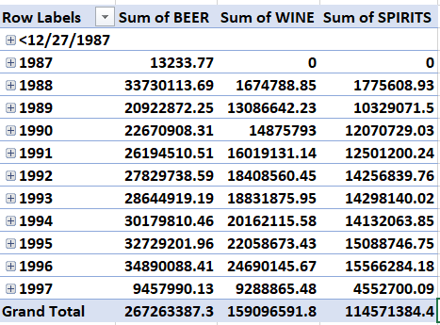

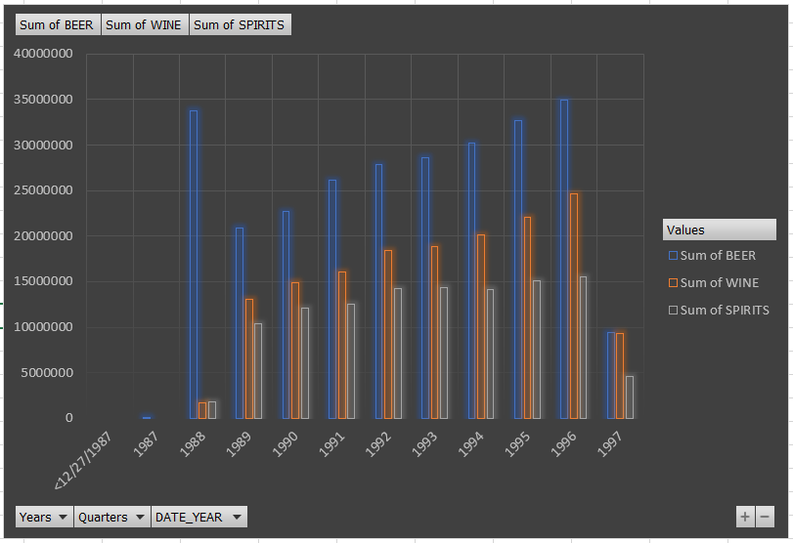

**Justification:**

It is evident that beer consumption is the most for every year from 1988 to 1996. We can also see that the overall alcohol consumption over the years has increased. We can assume that in 1988, wine and spirit were not as popular as beer. Hence, a huge amount of the population consumed only beer. Even when wine and spirit started becoming popular, beer consumption was always at a rising high. This tells that even though other alcoholic beverages were invading the market, the all-time favorite beer had no competition.

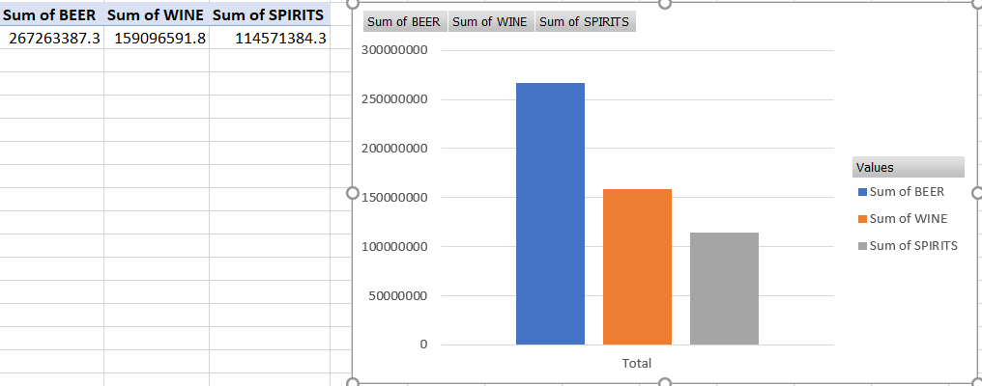

We can also see from the above graph that overall spirit is consumed the least. Wine drinking is at second position and beer tops them all. This information will help the stores in proper inventory management as well as have a good balance between supply and demand.

**ERD:**

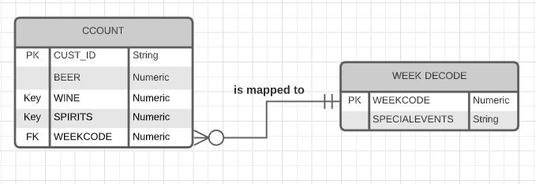

**Business Question 2:** What are the top 10 stores producing maximum alcohol sales?

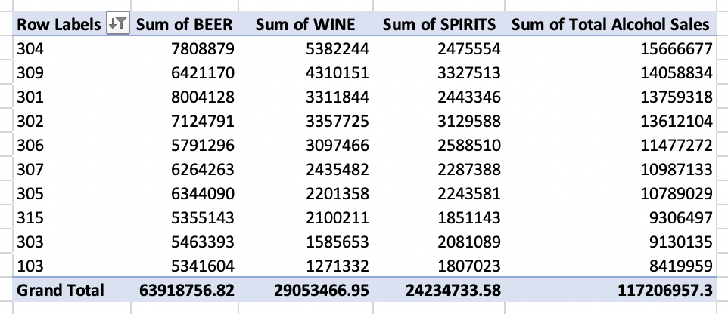

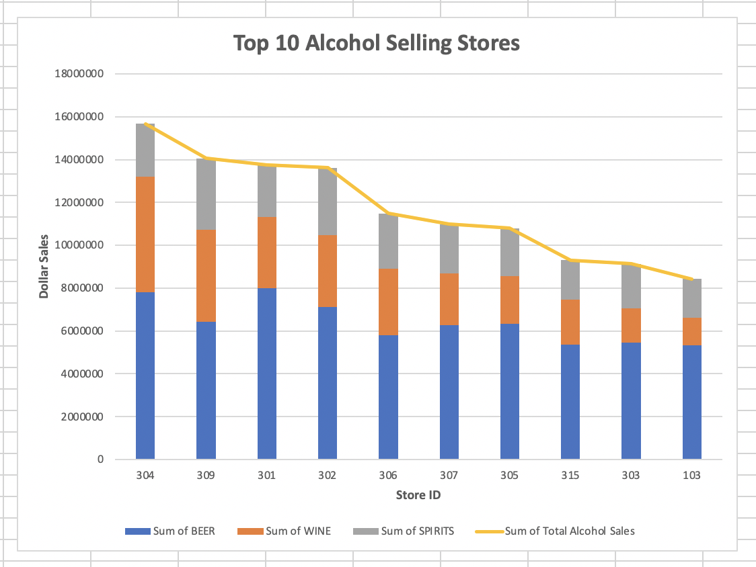

**Justification:**

Every business is interested in knowing the performance of different product categories. The products of DFF can be categorized in different categories like Food, Cosmetics, Pharmacy, Beverage. The categories could be further divided into subcategories. One such subcategory is Alcohol in the beverages category.  This business question focusesses on the sale of Alcohol across different DFF stores. It helps in identifying the top 10 stores that have maximum sales of alcoholic beverages like Wine, beer, and spirits. Knowing the top stores that contribute to highest alcohol sales would help DFF in planning and managing their inventory of alcohol.

**ERD:**

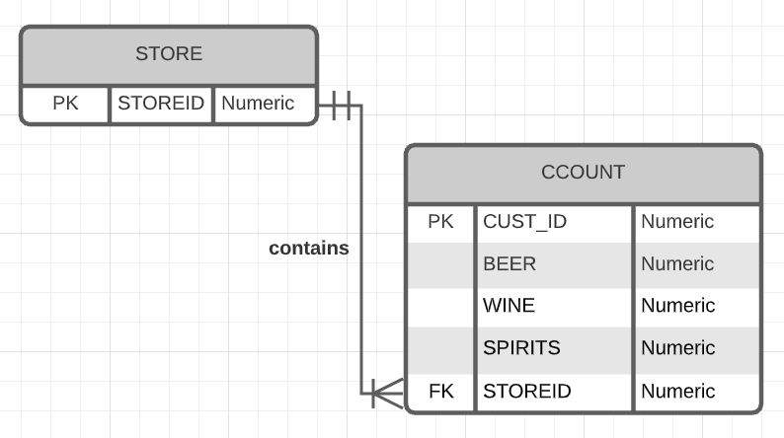

**Business Question 3:** In which part of the year, liquor sales are maximum and why?

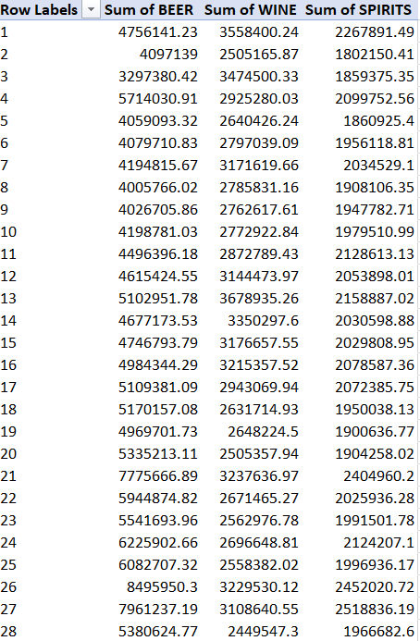

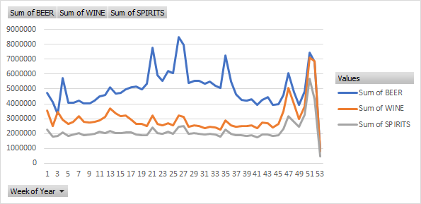

**Justification:**

In the CCount table sales of Beer, Wine & Spirit are given, and we have calculated the Week Number from Week decode table. It is very important for a business to know the time of year when the sales are maximum for a given product. We have calculated the sales of liquor over the weeks of a year. This analysis combines the data from all the years and estimates the total sales of Beer, Wine and Spirits in a particular week. The trend shows that there is a spike in sales at the end of year due to Christmas and New year celebrations. There is also a spike in sales in mid-year (weeks 25-27) which could be due to Memorial Day celebrations. This type of Analysis can help DFF to increase their inventory in those particular weeks. They could be better prepared for the rise in demand and increase their profits.

**ERD:**

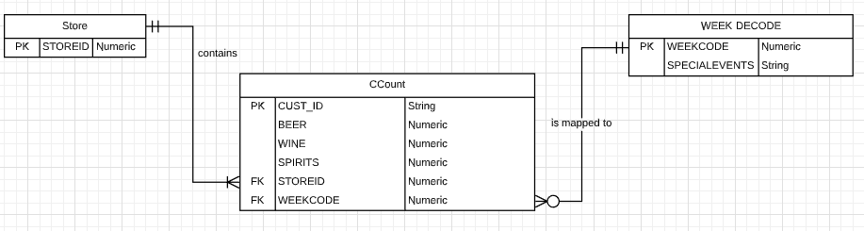

**Business Question 4:** How have the different categories of customers impacted the sales across various stores in the last 8 years?

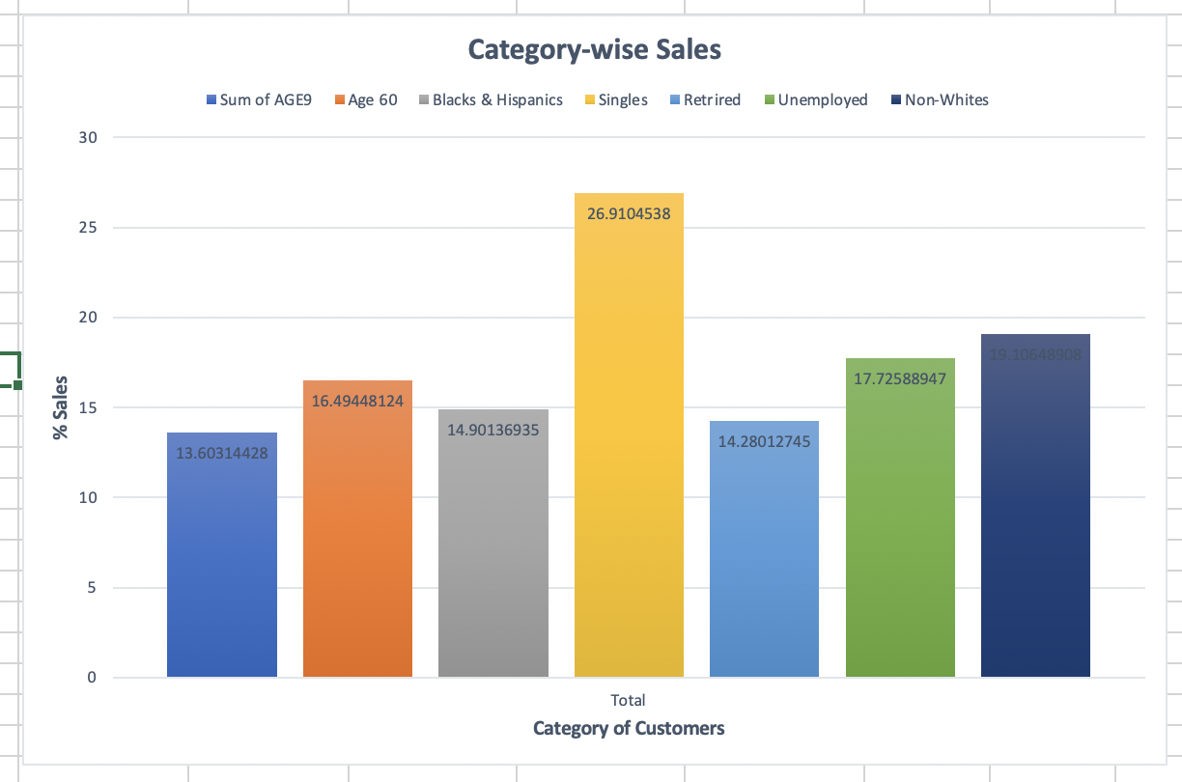

**Justification:**

This business question allows us to understand the buying behavior of different categories of people. It is important to understand this as it will allow us to make strategic decisions related to Return on Investment. The Demographics dataset contains variables representing different categories of people. The sales contribution of different categories of people in various DFF stores is represented in the graph above. The graph talks about the contribution per user category for the past 8 years. We can see in the graph that different categories of people have different buying patterns in Dominick’s store. Some people like retired individuals spend less in DFF stores while others like Singles spend exceptionally high compared to other categories. The business could use this data to launch promotional campaigns to target singles who can enhance the sales further.

**ERD:**

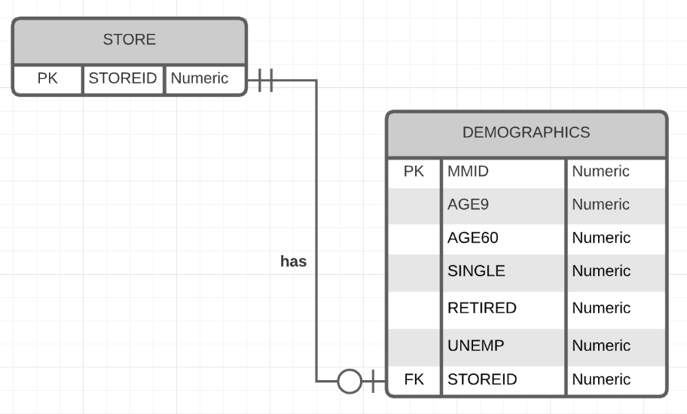

**Business Question 5:** Which are the top 10 stores to sell meat, meat frozen and fish?

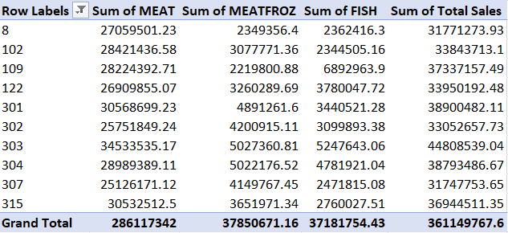

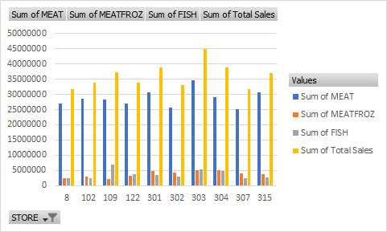

**Justification:**

By calculating the top 10 stores to sell meat and fish, we can compare the consumption of these products and estimate the stores that need more of these products in future. From the graph, we can see that meat has the highest consumption while the consumption of fish and frozen meat is comparable. Sum of total sales give us the top 10 stores with highest consumption of meat and sales. Knowing the top stores that contribute to highest alcohol sales would help DFF in planning and managing their inventory of meat and fish.

**ERD:**

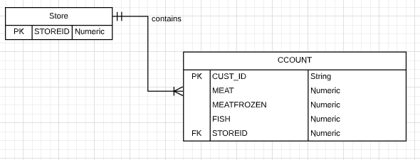

**Business Question 6:** What are the sales of Bakery items during the Thanksgiving period historically?

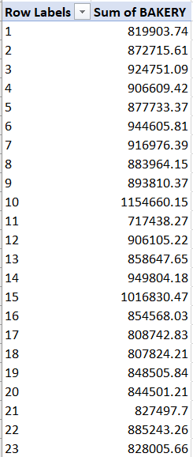

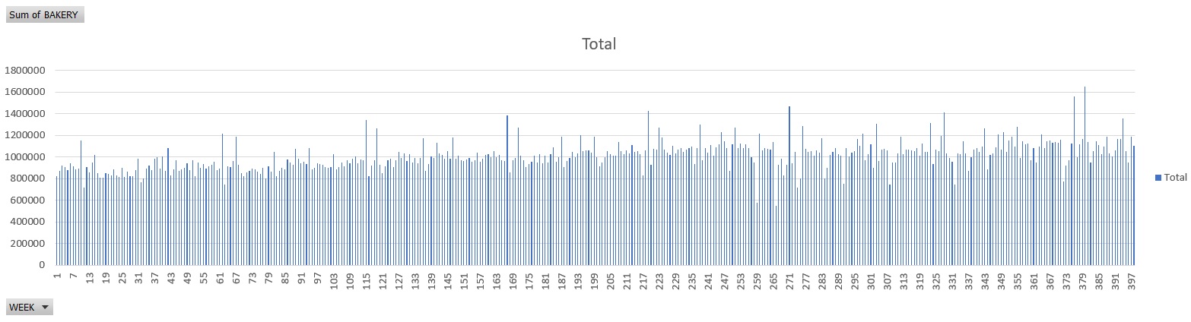

A closer look of the result is given below:

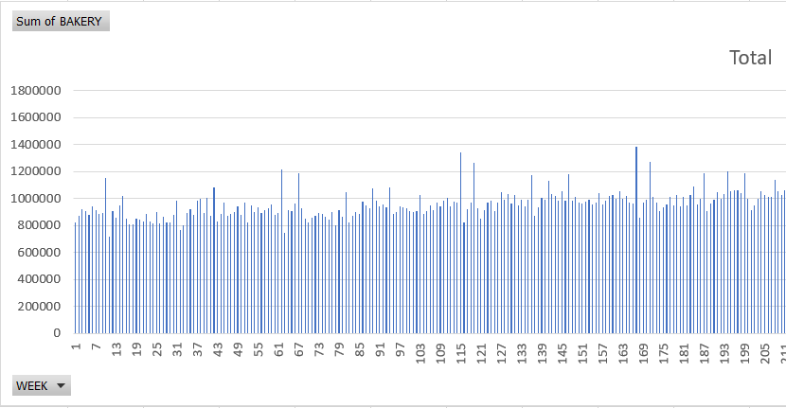

**Justification:**

Since Thanksgiving is the prime time for baking and cooking, it is important to know how much Bakery items are sold during this time period as compared to the whole year. This would help decision makers to make proper investment decisions, resources to increase the quantity of bakery products in a store and concentrate on marketing strategies. We can see from the data that the Bakery sales around week 11, 63, 115, 116 among others are maximum. The Decode Table tells that Thanksgiving is during these weeks.

**ERD:**

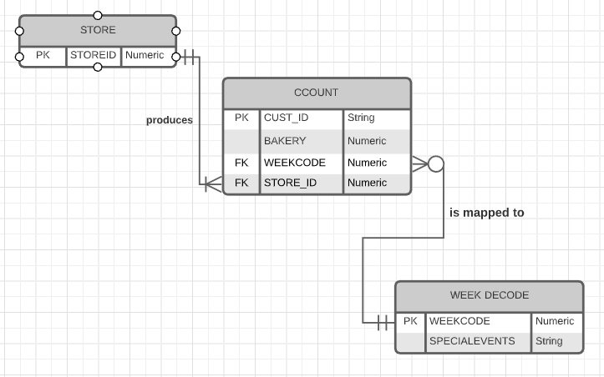

**Business Question 7:** Which stores have the maximum pharmacy sales? What factor can be considered to increase pharmacy sale in other stores?

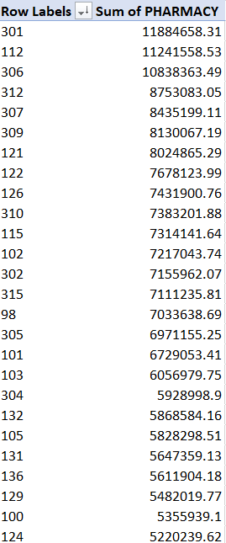

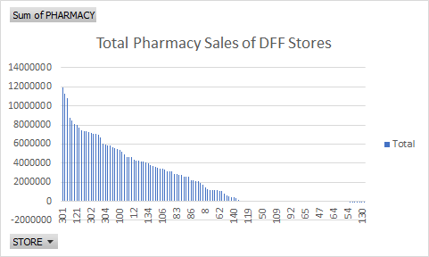

**Justification:**Top stores with maximum pharmacy sales: 301, 112, 306, 312, 307, 309, 121, 122, 126, 310.

Through this data we have calculated the top stores with maximum pharmacy sales. This will tell DFF to maintain and manage the inventory. We can also look at the stores with very less pharmacy sales and think of ways to improve the sales. In the Demographics table, “age60” gives the % of population above the age of 60. Since people above the age of 60 require more medicines as compared to other age groups, we can try to increase the number of stores in areas with the maximum number of people falling in the category of “age60”.

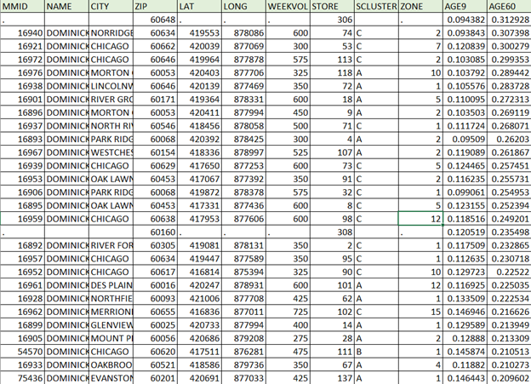

For the Demographics table, we have just sorted the data in descending order of AGE60 percentages. We can observe the stores and the areas with the maximum percentage of old people and try to improve the sales in those areas by increasing the number of stores or by implementing home delivery service.

**ERD:**

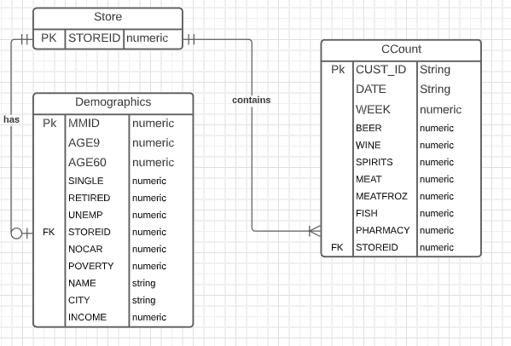

**Business Question 8:** Which stores have contributed most towards profit from Grooming products?

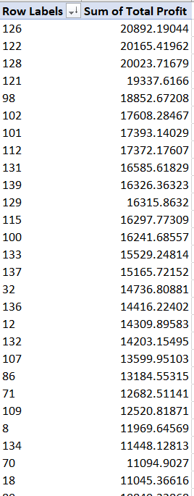

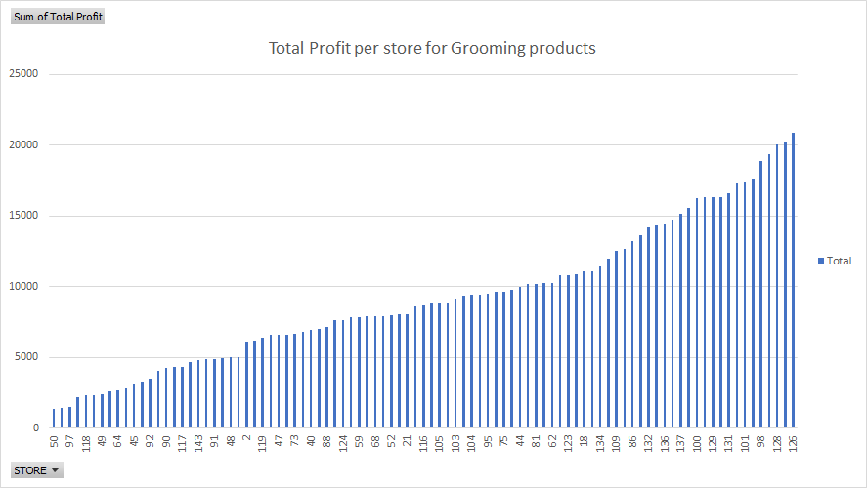

**Justification:**

We have used the Movement Table (WGRO) for grooming products to analyze the stores who have contributed the most towards profit in this domain. This analysis is very important because profit is the most critical factor which determines the success of a store. The stores with minimum profits can be closed or improved and more importance can be given to stores with increasing profits.

We have calculated the total profit from Movements table through formula:

Total Profit = ((Move*Price)/Qty) *(Profit/100)

**ERD:**

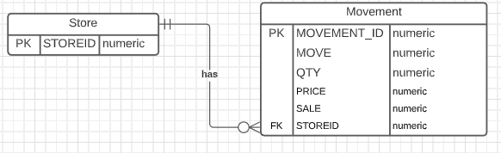

**Business Question 9:** Identify the percentage of customers that are coming to the store with no car?

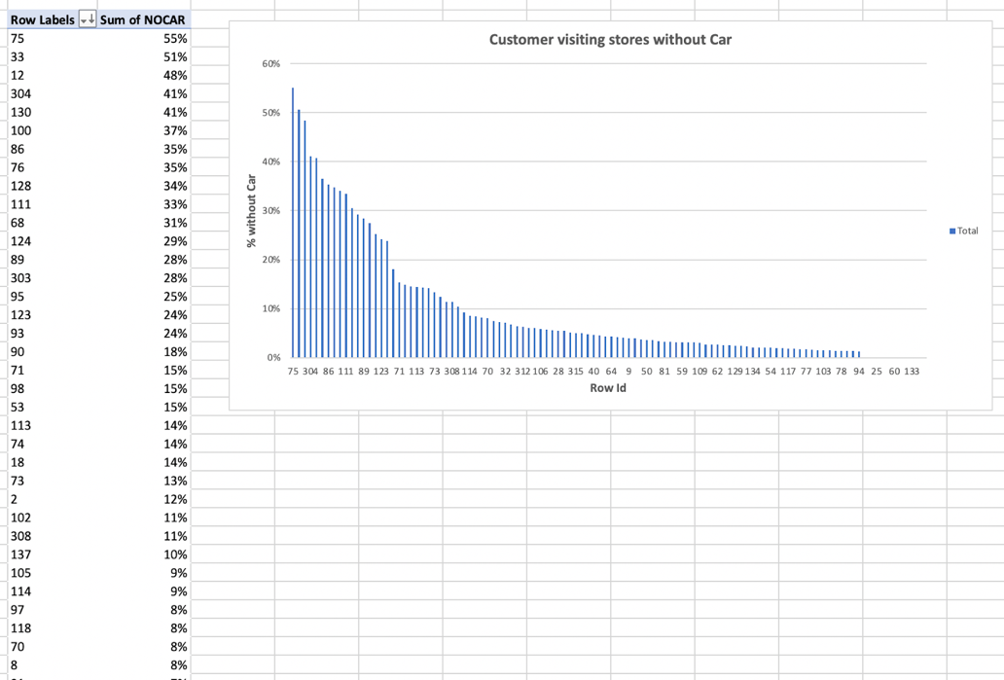

**Justification:**

This business question helps in identifying the number of customers that visit the stores without a car. After looking at the data, it seems that a very small percentage of people come to the store without a car. It implies that the stores are located at a far-off distance from people’s houses and this is why they have to bring a car to the stores. This question allows the business in making several decisions, the first of which is to consider opening stores in residential areas where people can simply walk to the stores. This might be influential in enhancing the sales. Secondly, for existing stores with a very small percentage of no car customers, the business needs to be mindful of the parking space available outside the stores. For store id 97, only 8% of the customers show up doesn’t come via car which implies that there should be enough parking space outside the store so that people could shop freely without worrying of parking congestion. Similarly, there are multiple scenarios related to this question which could help businesses in planning operational things and could enhance the sales.

**ERD:**

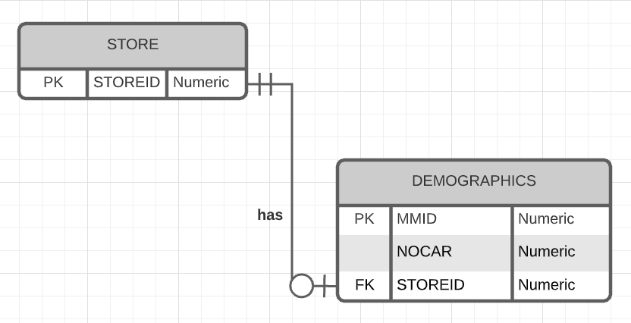

**Business Question 10:** How many unemployed people visit the stores versus how many people with poverty visit the store?

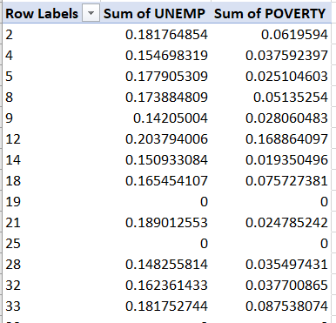

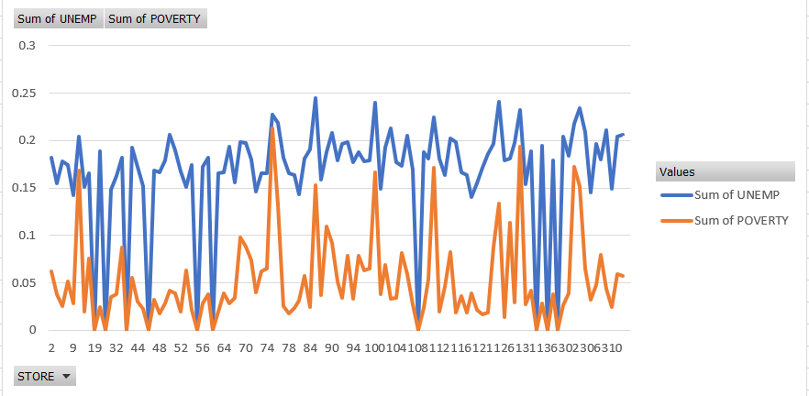

**Justification:**

We can see that at many stores, people who earn very less visit the stores less frequently than people who are unemployed. Unemployment does not necessarily mean lack of money but there are no assumptions for poverty. The stores can start having different programs for the people who are Below Poverty Line (BPL) where such people can buy quality products for cheaper prices. A report states that Walmart has a high amount of wastage of food while another report suggests that HEB marks down the prices late at night and there are shoppers waiting for it. DFF can adopt the same policy. They can look at their produce at the end of the day and mark down prices of perishable products as well as packed foods which are nearing the expiry date. This will help to avoid wastage of product as well as the store chain will be able to help the community in a huge way.

**ERD:**

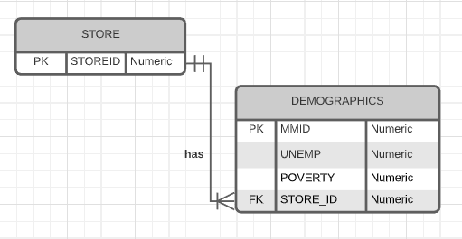

**Business Questions Prioritization**

1. How have the different categories of customers impacted the sales across various stores in the last 8 years?
2. What are the top 10 stores producing maximum alcohol sales?
3. Which are the top 10 stores to sell meat, meat frozen and fish?
4. Which stores have the maximum pharmacy sales? What factor can be considered to increase pharmacy sale in other stores?
5. What are the sales of Bakery items during the Thanksgiving period historically?
6. In which part of the year, liquor sales are maximum and why?
7. How many unemployed people visit the stores versus how many people with poverty visit the store?
8. Identify the percentage of customers that are coming to the store with no car?
9. What is the trend in consumption of alcoholic beverages over a period of 10 years?
10. Which stores have contributed most towards profit from Grooming products?

**Justification for the said priorities:**

## Every business has a lot of metrics and dimensions on which a lot of business decisions are made. These metrics could be evaluated to answer numerous business questions. However, the questions that have the most impact on the business are the ones which are directly related to the Key performance indicators (KPIs) of the business. Based on our understanding of the retail market, DFF should focus on the following three KPIs to measure and enhance their business.

* Availability
* Profitability
* Customer Satisfaction

We have prioritized the questions based on the key performance indicators chosen for DFF. Some questions answer for a single KPI whereas others dictate the performance of multiple KPIs. For instance, studying the sales across different categories of customers presented in question 1 is important to understand how well we are catering to the needs of diverse sections of the society and if our customers are satisfied with our products or not. It helps businesses to plan their promotional campaigns accordingly. Similarly, identifying the top stores for different product categories is vital to ensure we stock sufficient inventory in these stores. Finally, understanding the customer background with the help of demographics information like their employment history, income status, ownership of car, etc. helps the businesses in evaluating the range of products that they should offer to maximize their profits. All in all, it is imperative that we define the priorities so that we could take immediate actions out of data as well as define long-term goals and roadmap for the business.

# Independent Data Mart Design

## Dimension Tables

1. **Dim_Product**

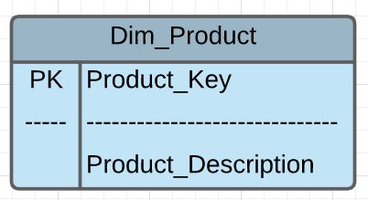

Product_Key – Unique identifier of the product dimension table which has been generated as a surrogate key.

Product_Description – Various product categories present within Dominick’s CCount data. It is generated by transposing certain attributes in the CCount metadata.

1. **Dim_Time**

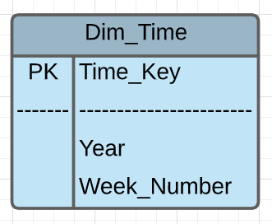

Time_Key – A unique identifier of the time dimension table which has been generated as a surrogate key.

Week_Number – The identifier for the week in the year when sales have occurred.

Year – The identifier for the year when sales have occurred.

1. **Dim_Demographics**

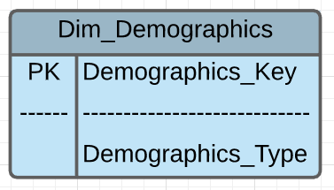

Demographics_Key – Unique identifier of the demographic dimension table which has been

generated as a surrogate key.

Demographics_Type – Various demographic types present within Dominick’s Demo data. It is

generated by transposing certain attributes in the Demo metadata.

1. **Dim_Store**

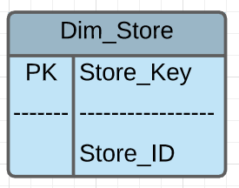

Store_Key – A unique identifier of the store dimension table which has been generated as a surrogate key.

Store_ID – The assigned number to a particular store.

## Fact Tables

1. **Fact_ProductSales**

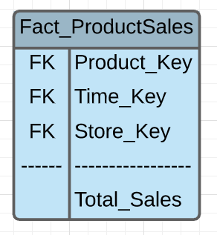

Fact Table Keys:

Time_Key – A unique identifier for time dimension which has been generated as a surrogate key.

Product_Key – A unique identifier for products, which has been generated as a surrogate key.

Store_Key – A unique identifier of the store dimension table which has been generated as a surrogate key.

Fact Table Measures:

Total_Sales – This attribute denotes the dollar value of sales for a product [found in CCount].

1. **Fact_Demo_Info**

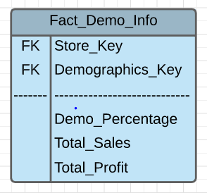

Fact Table Keys:

Store_Key – A unique identifier of the store dimension table which has been generated as a surrogate key.

Demographics_Key – Unique identifier of the demographic dimension table which has been

generated as a surrogate key.

Fact Table Measures:

Demo_Percentage - This attribute represents the demographic percentage for each demographic.

Total_Sales - This attribute denotes the dollar value of sales for a product [found in CCount].

Total_Profit - This attribute denotes the dollar value of the profits obtained for a product [found in CCount].

# Dimensional Modelling (STAR Schema)

## Product Data Mart

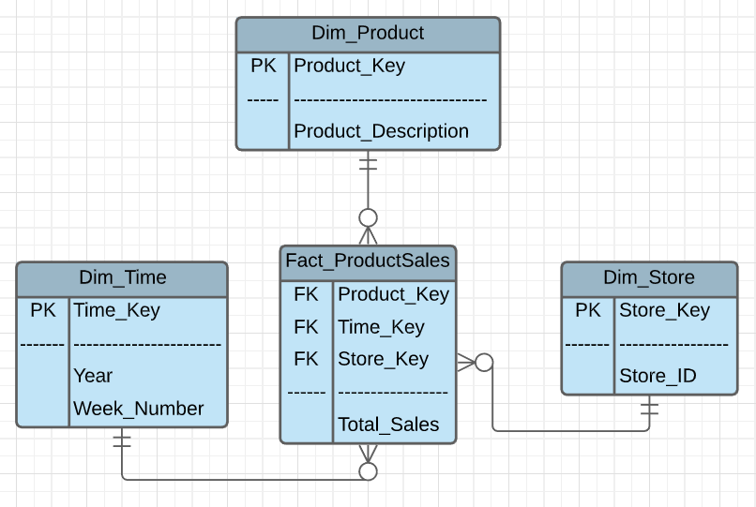

## Demographics Information Data Mart

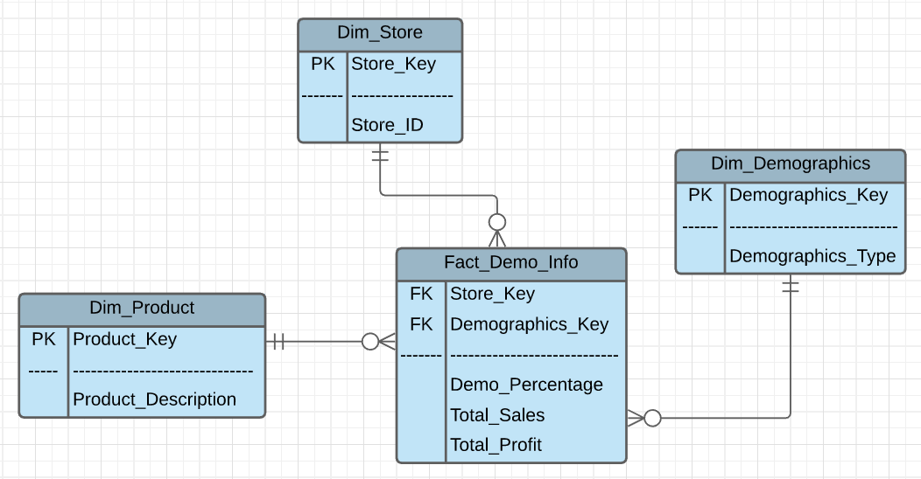

## Data Warehouse Schema & Justification

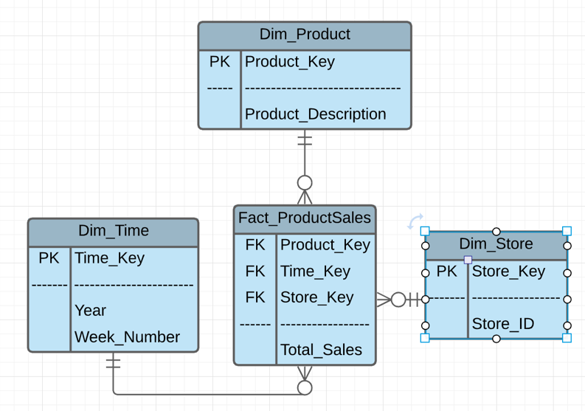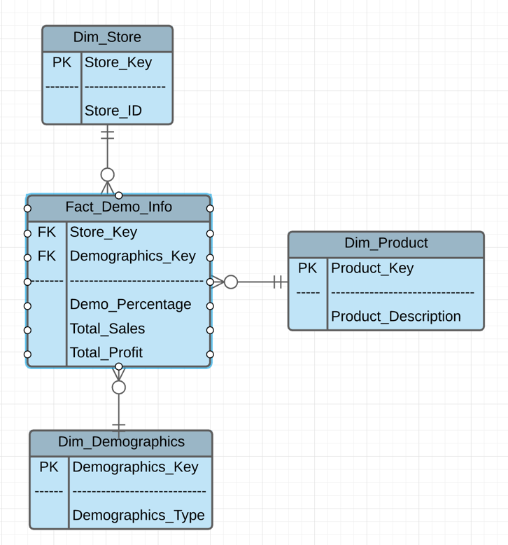

The dimension and fact table shown above together form the schema of the data warehouse we are building for Dominick Fine Foods. In the data warehouse schema, we have 2 data marts that will allow us to answer the business questions that we have formulated for DFF’s data. The first data mart is the Product Sales data mart and the second one is Demographic Information data mart. The Product data mart contains sales metrics in the Product Sales fact table and is connected with the Product, Store, and Time dimension table. The Demographics data mart contains Demographic Information of different stores and sales of different products in the Fact Demo Information fact table connected with Store, Demographics, Product dimension table. Both the data marts together form the data warehouse schema and will help us in answering the business question numbered 3,4,5,7, and 8. The attributes in this schema will allow us to understand the dimensional and factual information of the Dominick’s stores across various dimensions and measures. The questions 3,4,5,7,8 that we are looking forward to address using this data warehouse will now be addressed as 1,2,3,4,5 respectively throughout the end of this report and the justification for these questions is provided using the justification matrix presented below:

|  |  |  |  |  |  |  |  |  |  |
| --- | --- | --- | --- | --- | --- | --- | --- | --- | --- |
| Business Question 1 | Business Question 2 | Business Question 3 | Business Question 4 | Business Question 5 | Dim_Time | Dim_Store | Dim_Demographics | Dim_Product |  |
| In which part of the year, liquor sales are maximum and why? |  | Which are the top 10 stores to sell meat, meat frozen and fish? |  |  | ✔️ | ✔️ |  | ✔️ | Fact_Product_Sales |
|  | How have the different categories of customers impacted the sales across various stores in the last 8 years? |  | Which stores have the maximum pharmacy sales? What factor can be considered to increase pharmacy sale in other stores? | Which stores have contributed the most towards profit from Grooming products? |  | ✔️ | ✔️ | ✔️ | Fact_Demo_Info |

## Mapping Table

|  |  |  |  |  |
| --- | --- | --- | --- | --- |
| Source Table | Source Table Attribute | Dimension Table | Dimension Attribute | Mapping Function |
|  |  | Dim_Time | Time_Key | An auto increment in the form of surrogate key is generated as the primary key |
|  |  | Year | This is a calculated column. It is calculated using the Week_Number column keeping in mind the initial data from which data is present. |
| Week Decode | Week# | Week_Number | - |

|  |  |  |  |  |
| --- | --- | --- | --- | --- |
| Source Table | Source Table Attribute | Dimension Table | Dimension Attribute | Mapping Function |
|  |  | Dim_Store | Store_Key | An auto increment in the form of surrogate key is generated as the primary key |
| Demo | Store | Store_ID | - |

|  |  |  |  |  |
| --- | --- | --- | --- | --- |
| Source Table | Source Table Attribute | Dimension Table | Dimension Attribute | Mapping Function |
|  |  | Dim_Demographics | Demographics_Key | An auto increment in the form of surrogate key is generated as the primary key |
| Demo | Multiple demographic columns present in the demographics file | Demographics_Type | This column is generated by transposing the metadata of the demo table |

|  |  |  |  |  |
| --- | --- | --- | --- | --- |
| Source Table | Source Table Attribute | Dimension Table | Dimension Attribute | Mapping Function |
|  |  | Dim_Product | Product_Key | An auto increment in the form of surrogate key is generated as the primary key |
| CCount | Various product categories present in the CCount file | Product_Description | This column is generated by transposing the metadata of the CCount table |

|  |  |  |  |  |
| --- | --- | --- | --- | --- |
| Source Table | Source Table Attribute | Fact Table | Dimension Attribute | Mapping Function |
|  |  | Fact_Product_Sales | Product_Key | This attribute serves as the primary key and is derived from Dim_Product |
|  |  | Time_Key | This attribute serves as the primary key and is derived from Dim_Time |
|  |  | Store_Key | This attribute serves as the primary key and is derived from Dim_Store |
| CCount | Various product categories present in the Dominick’s data | Total_Sales | This field is generated using the metadata of the CCount file and aggregating it based on different product categories |

|  |  |  |  |  |
| --- | --- | --- | --- | --- |
| Source Table | Source Table Attribute | Fact Table | Dimension Attribute | Mapping Function |
|  |  | Fact_Demo_Info | Store_Key | This attribute serves as the primary key and is derived from Dim_Store |
|  |  | Demographics_Key | This attribute serves as the primary key and is derived from Dim_Demographics |
| Demo | Various demographic categories present in the Dominick’s data | Demo_Percentage | This field is generated using the metadata of the Demo Table |
| CCount | Various product categories present in the Dominick’s data | Total_Sales | This field is generated using the metadata of the CCount file and aggregating it based on different product categories |
| WGRO | Move, Price, Qty, Profit | Total_Profit | This attribute is obtained from the transformations of 4 columns of the WGRO file using the formula: ((Move*Price)/Qty) * (Profit/100) |

## Physical Design Plan

The next step is to construct a physical design for the data warehouse such that it is compatible with the physical environment comprising of database servers, application, separate ETL, OLAP and reporting processes. The separate physical environments help to reduce dependency of production, development, and testing processes on each other. Issues can be solved without halting the production process and this helps to make the physical design more efficient. While designing a data warehouse we are concerned with storage of database objects, indexing, partitioning and performance. We want to build a data warehouse which is efficient and works well with underlying infrastructure consisting database, operating system, and third-party tools. 

Standardization

Data Structure for Storage

Indexing

Clustering

Aggregation

Partitioning

**PHYSICAL DESIGN STEPS**

* **Standardization**

Standardization is very important in a data warehouse as it helps to maintain consistency throughout the entire datasets. An organization can have multiple departments like IT, HR, Sales, Finance, etc. and if they need to collaborate and manage data across the organization then certain standards are required. If the same naming convention of database objects is used for the entire data warehouse, it becomes simpler for departments to query the database. Data Standardization helps the end users to use and analyze the data in a consistent and more efficient manner. The structure is unknown to the consumer and thus the representation is standardized to make sure there is no difficulty in aggregating or comparing the datasets. We have used consistent naming convention in our project. We have named the dimension tables as ‘Dim_Tablename’ (e.g. Dim_Product) whereas the attribute name is represented as ‘TableName_AttributeName’ (Demographics_Type).

**Schema for Dimension Demographics**

|  |  |  |
| --- | --- | --- |
| Dim_Demographics | Table | varchar (255) |
| Demographics_Type | Attribute | varchar (255) |

* **Aggregation**

Sometimes we need summarized data on a regular basis and such demands require the creation of summary or aggregate tables. Faster retrieval of data is very necessary and to save processing time, the data is aggregated in a separate table. Aggregation helps to improve performance and query time. Aggregating data from multiple sources can take quite some time and it is not acceptable in an OLAP world where instant analysis is required.

In our data mart models design, we have created fact tables with the aggregated result. The dimension table ‘Dim_Product’ and ‘Dim_Time’ helps to aggregate historical data of sales which is stored as ‘Total_Sales’ in the Fact table.  In one of our questions, we have used the aggregated result of sales to find out the part of the year in which the sales of liquor were maximum. This helped to analyze the data faster and in a more efficient manner. The historical data helped us to figure out the peak in sales during the Christmas season. If the data was stored in separate tables based on time, then it would be cumbersome to aggregate results.

* **Partitioning**

A data warehouse can contain millions of records and it could take a lot of time to query so many records every time we want to do analysis on a particular subject. Partitioning is used to facilitate easy management of data, help in backup & recovery and to enhance performance of our data warehouse. It makes the management a lot easier by partitioning each fact table into multiple partitions and optimizing the performance. The size of a single fact table can be very huge (hundreds of gigabytes) and thus it requires partitioning for faster retrieval of data. Backup and recovery of huge datasets is difficult and can lead to loss of data.

We can do horizontal partitioning in which a fact table can be partitioned on the basis of time, dimension, size of table, etc. Vertical partitioning is carried out by Normalization and Row Splitting methods. In our project, we have done horizontal partitioning on the basis of time segments where we have stored the product sales data on the basis of week. This helps us to produce weekly sales data and keep it for faster retrieval through partitioning.

* **Clustering**

Placing related data in the same block of storage can help to improve performance and faster retrieval of queries. If the related data like Employee workload and bandwidth data stored in the same block of storage then it is easier to retrieve information about work management in the office. This helps managers to efficiently analyze the requirement and use of its resources so that he could better manage workflows. To cluster data, we need to accumulate the related table and store on the same piece of physical storage. Clustering is mainly used to identify group of similar objects in a large dataset consisting of different categories like sales department, IT or finance department. Clustering can be done using various methods like Partitioning methods, Fuzzy clustering, or Model-based clustering.

* **Indexing**

Indexing is a technique used to optimize the performance by reducing the number of accesses required when a query gets processed. Indexing is done so that data can be retrieved faster from millions of records. It is used to locate and access the data in a database. Indexing consist of various attributes like access types, access time, deletion time, space overhead, etc. Indexing has many types like Clustered indexing, Secondary indexing, Multilevel indexing, etc. While deciding an indexing strategy we need to consider the column to be indexed. B-Tree and bitmap indexes are the most popular for the design of data warehouses.

In our project we can design our model using B-Tree indexes on single-column primary keys like Product_Key, Store_Key, Demographics_Key, etc.

* **Data Structures for Storage**

After we have performed the necessary design techniques like clustering, partition and indexing we need to store our data in such a way that it can be retrieved fast and with optimal performance. The physical storage needs to be designed in such a way thatprocessingtime of queries can be reduced.We need to create separate storage spaces for staging area and application data. We need to plan our storage on the basis of data type and data demands. We can store the data temporarily or permanently depending on the need and importance of the dataset.

In our project, we are using historical data of products and sales. We need to make sure that the data is retained as it is very necessary for our analysis. We would keep it separate from the demographic data which is comparatively smaller in size and can be reproduced easily.

# Development of ETL Plan

ETL is one of the most critical processes during data warehouse design. ETL stands for Extract, Transform and Load and is a type of data integration process referring to the mentioned distinct but interrelated steps. Each of these processes has its own significance. It covers wide operations from how the data is extracted followed by transformation of data in desired format. Finally, the data is loaded in data into the data warehouse in dimensional and fact tables. There are no fixed predefined steps to carry out ETL operations. All the operations are carried out based on the structure of available data and final end goal of the data warehouse based on business demands.

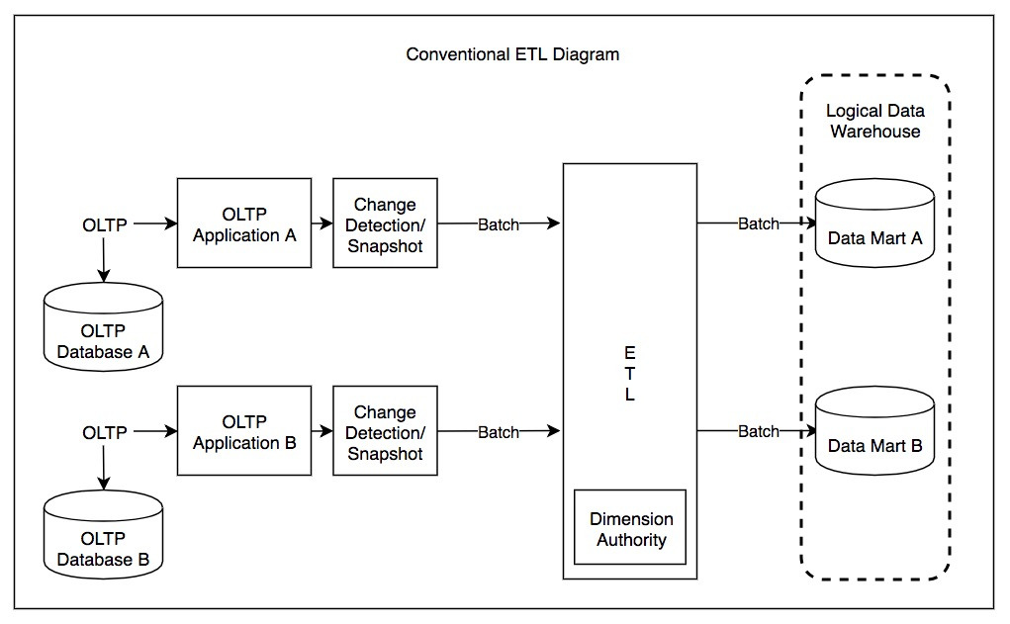

*Image Source: https://en.wikipedia.org/wiki/Extract,_transform,_load*

Extraction is the process of retrieving the data from one or multiple sources. The data is accessed through the extraction process and the data can have multiple formats of storage. The most common data types are databases, flat files, and web services. Some of the most commonly used data sources are Oracle, SQL Server, MySQL, and Hana among others. Data extraction can be performed using push notification, incremental extract or full extract. A solid data cleansing approach should be used to deal with multiple problems like invalid and duplicate data, data inconsistencies, referential integrity, naming conflicts, etc. Thus, data analysis, data profiling, and data mining should be performed.

Further transformation is applied on the data to make it more meaningful for the final loading phase. Data is cleaned and transformed from one format to another depending on the needs of the data warehouse which can be dependent upon the number of data sources, data errors, and the degree of heterogeneity. After the completion of data cleaning, the data is moved to a target system for further processing. Examples of transformation can include generation of surrogate keys and different calculated columns. There are 2 types of data transformation - multistage and in-warehouse data transformation.

Lastly, the data is loaded into the dimensional and fact tables. An efficient way to load the data would be to disable the indexes and constraints and then make them active once data loading is completed. Data aggregation needs to be done in order to improve the performance of the system.

## Target Data needed in the data warehouse

|  |  |  |  |
| --- | --- | --- | --- |
| Source Data | Data in Staging Area | Data in Data Warehouse (Dimensional Tables) | Data in Data Warehouse (Fact Tables) |
| CCount | CCOUNT | Dim_Product | Fact_ProductSales  &  Fact_Demo_Info |
| Time Data | Week_Decode | Dim_Time |
| Demographics | DEMO | Dim_Demographics, Dim_Store |
| WGRO | WGRO | Dim_Product |

## Data Sources

|  |  |
| --- | --- |
| Source | Data |
| CCount.scv | Product Categories and Sales Data |
| Demo.csv | Demographics Data and Store Data |
| Week Decode in Dominick Manual | Time Data |
| WGRO.csv | Movement file having Grooming Product Data |

## Data Mapping

|  |  |  |  |
| --- | --- | --- | --- |
| Source File Name | Source File Attributes | Staging Area Table Name | Staging Area Table Attributes |
| CCount.csv | Store | CCount | STORE_ID |
| WEEK | WEEK |
| BEER | BEER |
| WINE | WINE |
| SPIRITS | SPIRITS |
| MEAT | MEAT |
| MEATFROZ | MEATFROZ |
| FISH | FISH |
| PHARMACY | PHARMACY |
| COSMETIC | COSMETIC |
| BAKERY | BAKERY |
| GROCERY | GROCERY |
| DAIRY | DAIRY |
| Demo.csv | MMID | Demographics | MMID |
| AGE9 | AGE9 |
| AGE60 | AGE60 |
| SINGLE | SINGLE |
| RETIRED | RETIRED |
| UNEMP | UNEMP |
| STOREID | STOREID |
| NOCAR | NOCAR |
| POVERTY | POVERTY |
| NAME | NAME |
| CITY | CITY |
| INCOME | INCOME |
| Week_decode.csv | Week# | Week_Decode | Week_number |
| Start | Start |
| End | End |
| Special_Events | Special_Events |
| WGRO.csv | UPC | WGRO | UPC |
| STORE | STORE |
| WEEK | WEEK |
| MOVE | MOVE |
| QTY | QTY |
| PRICE | PRICE |
| SALE | SALE |
| PROFIT | PROFIT |
| OK | OK |

|  |  |  |  |  |
| --- | --- | --- | --- | --- |
| Staging Area Table Name | Staging Area Table Attributes | Data Warehouse Table | Data warehouse Table Attributes | Mapping function |
| Demo | Various demographic categories transposed | Dim_Demographics | Demographics_Key | An auto-incremental key in the form of surrogate key is generated as a primary key |
| Demographics_Type | This field is generated by transposing the metadata of demo staging table |
| CCount | Various product categories present in the Dominick data | Dim_Product | Product_Key | An auto-incremental key in the form of surrogate key is generated as a primary key |
| Product_Description | This field is generated by transposing the metadata of CCount staging table |
| Week_Decode | Week_no | Dim_Time | Week_no | An auto-incremental key in form of surrogate key is generated as a primary key |
| Start | Week_Num_in_Year | This column is derived from start date column to fetch the week corresponding to the date. |
| Start | Year | This column is derived from start date column to fetch the year corresponding to the date. |
| CCount | Aggregated sales across product categories | Fact_ProductSales | Product_Key | An auto-incremental key in form of surrogate key is generated as a primary key |
| Time_Key | An auto-incremental key in form of surrogate key is generated as a primary key |
| Store_Key | An auto-incremental key in form of surrogate key is generated as a primary key |
| Total_Sales | Total sales for a particular category |
| CCount  &  Demo |  | Fact_Demo_Info | Store_Key | An auto-incremental key in form of surrogate key is generated as a primary key |
| Demographics_Key | An auto-incremental key in form of surrogate key is generated as a primary key |
| Demo_Percentage | An auto-incremental key in form of surrogate key is generated as a primary key |
| Total_Sales | Sales for a particular store |
| Total_Profit | Profit for stores based on demographics |

## Data Extraction Rules

Data extraction is one of the foremost and critical processes in ETL and also in designing data warehouses. We can have multiple sources for data extraction which can also be in different formats. We can extract data from databases, csv, excel or flat files. In this project, the data sources are in csv format. The goal of data extraction is to get all of the data in SQL Server where data will be further transformed. Extreme care must be taken during data extraction to avoid any effects on the source systems which would affect their performance. These source systems are mostly OLTP systems which monitor daily transactions of the business. Any negligence during the data extraction process would lead to low performance of source systems. Also, before extracting data from the systems we must be well aware about the business requirements and should have good knowledge about the data and metadata associated with the data. Few trivial issues should also be taken into consideration during data extraction such as changes in format of data over a period of time, changes in the data type, Null parameters etc.

The data for DFF is available in different comma separated (.csv) source files. All the data from the source files have been loaded in the staging area named – ‘601_Group7_staging_area’ in SQL Server Management Studio.

## Data Transformation & Cleansing Rules

Once the data from source is loaded in the staging area, the next action item is to transform and clean the data. Based on the requirements and business questions, the data present in staging area is analyzed and cleansed to transform it into a form that could be loaded in the data-warehouse. Certain transformation rules have been applied to the data to clean the data and make it consistent. The general transformation and cleaning rules applied to the data are:

1. **Removal of Dirty data**

The source files contain a number of columns which are not required to answer the business questions set aside for DFF. These columns are thus irrelevant and need to be eliminated from the data warehouse. A lot of columns like Promo, Produce, Camera, etc. are removed from CCount table. Similarly, a row in demographics data contain cells populated with a dot (.) value. This row is not useful for answering the business questions and thus can be removed from the table.

1. **Removal of Null Values**

A lot of columns and rows in different source files consists of null values. These null values need to be eliminated from the data before the data is loaded in the data marts.

1. **Removal of Negative Values**

A lot of columns such as week and sales in CCount table contain negative values. The rows having negative values for columns we need in our data warehouse will be removed from the source tables.

1. **Creation of Surrogate Keys**

As a part of Data warehouse implementation, surrogate keys have been developed for all dimension and fact tables before the tables are loaded in the data warehouse.

1. **Conversion of Data Types**

While loading data from source to staging, all the columns have been loaded as varchar data types. The data type for these columns need to be changed to appropriate data types like int, float, date etc. required in the data warehouse.

## Organization of the Data Staging Area

The data from source data locations is extracted and stored in a temporary location before loading it in the data warehouse. This temporary location that house the data is known as data staging area. The data in the data staging area is in the form of different tables that contain the data for DFF. Several transformation and cleaning operations are applied on the data in the data staging area to clean the data and create it in a form suitable for loading in the data warehouse. The data staging area in our project contains the following tables: Demo table, CCount table, week_decode table, and WGRO table.

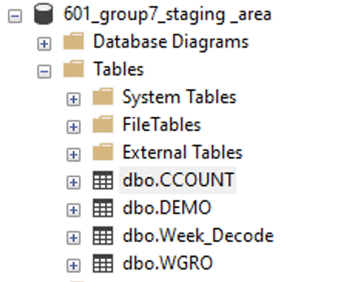

## Procedures for Data Extraction & Loading

Once we are sure of the of the data sources and the data to be loaded, the next step is to actually extract the data from the varied sources and load it in the staging area. In our business case, we used the following procedure to extract the data and load it into various staging tables. The data extract phases represent extractions from source systems to make all of it accessible for further processing. The main objective of this phase is to retrieve all the required data from the source systems with as little time and resources as possible. In Full Extractions, many source systems cannot identify to users which data was changed since the last extraction. Thus, a full extraction of all data is necessary each time changed data is needed from those individual sources. A full extract requires maintaining a copy of the last extract in the same format to identify changes when a later extract becomes available. The ETL team is responsible for capturing data-content changes during the incremental loads after an initial load. In Update Extractions, when source systems can provide notifications that specific data has been changed and further identify each change, this is the easiest way to extract the data. Most data sources provide a mechanism to identify changes so that database replication can be supported. In Incremental Extractions, some source systems are unable to provide notification that an update has occurred, but they can identify which records were modified, and provide an extract of only those records. During subsequent ETL steps, the system needs to identify changes and propagate them down. One of the drawbacks of incremental extraction is that it may not be possible to detect deleted records in source data. There are 2 types of loads: full loads and incremental loads. In data warehousing, the loading occurs depending on the business needs of the organization. The loading can be real-time, daily, weekly, or monthly.

# ETL Implementation

The ETL process for the data warehouse has been implemented with the help of SQL server management studio (SSMS) and SSIS (Microsoft Visual Studio – SQL server data tools). The steps involved in the ETL implemented have been described below and the screenshots have been included to guide the step-by-step process and for ease in understanding.

## Data Extraction: Extracting data from .csv files and populate in staging area

1. Week Decode

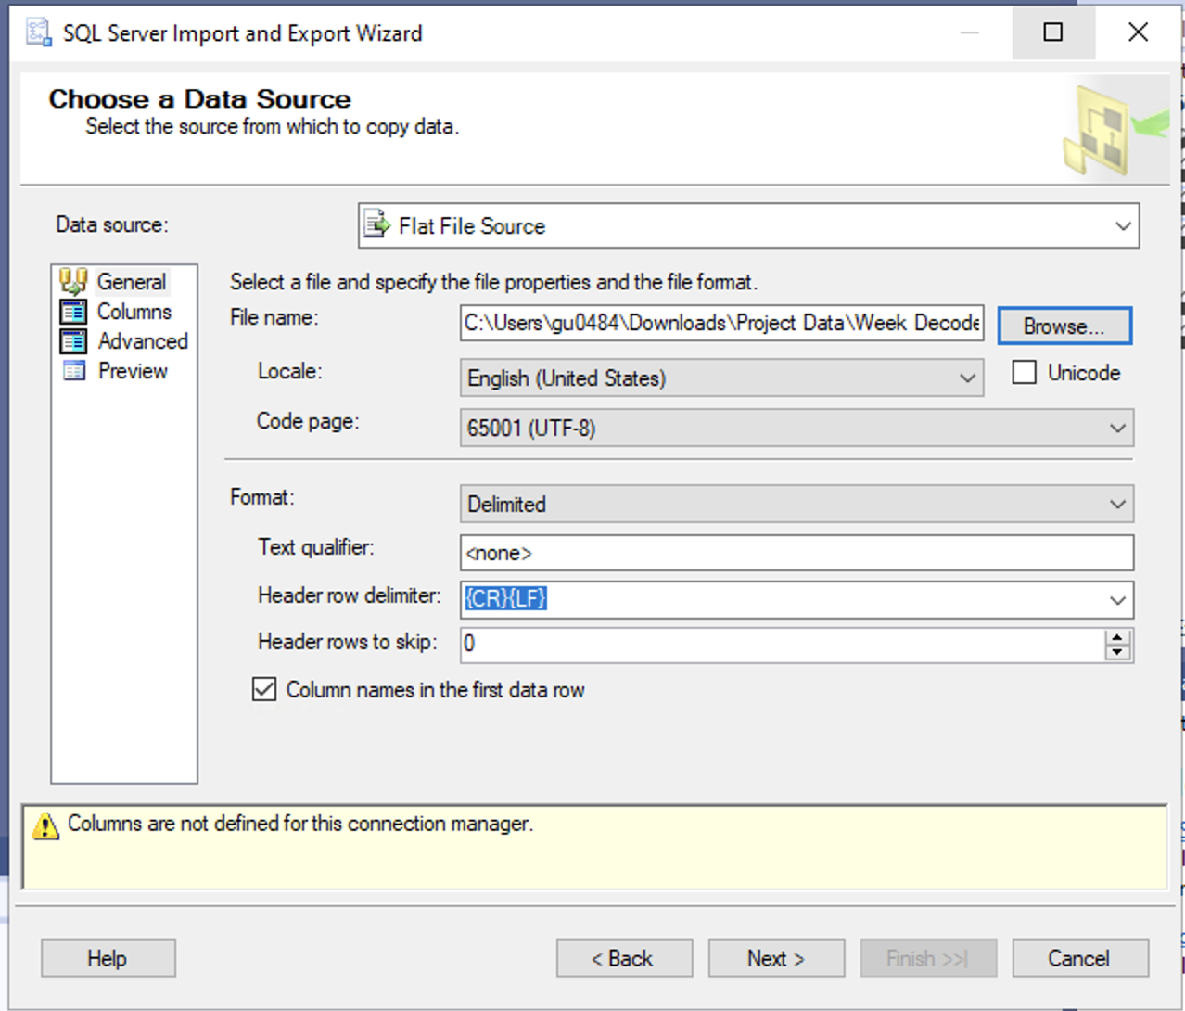

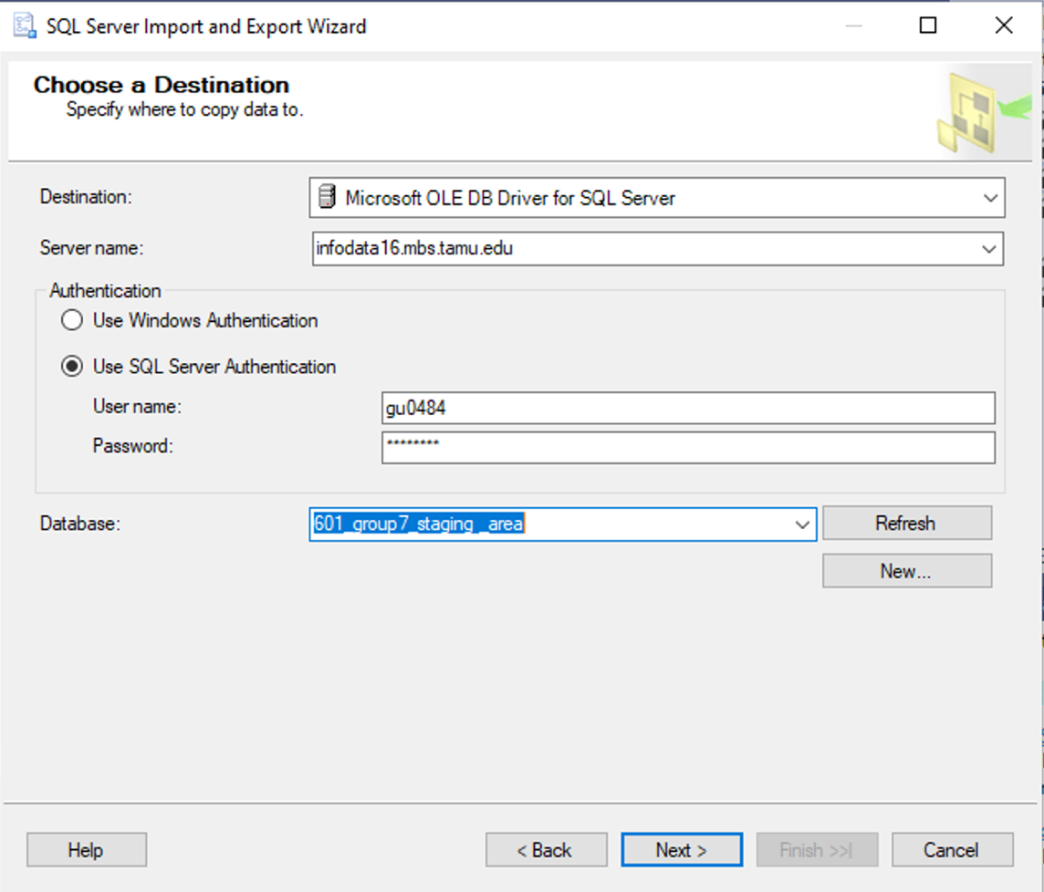

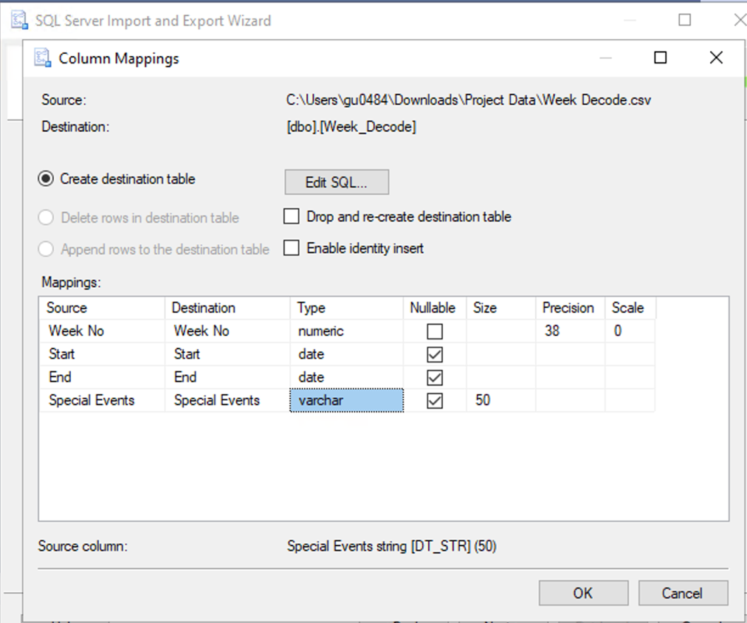

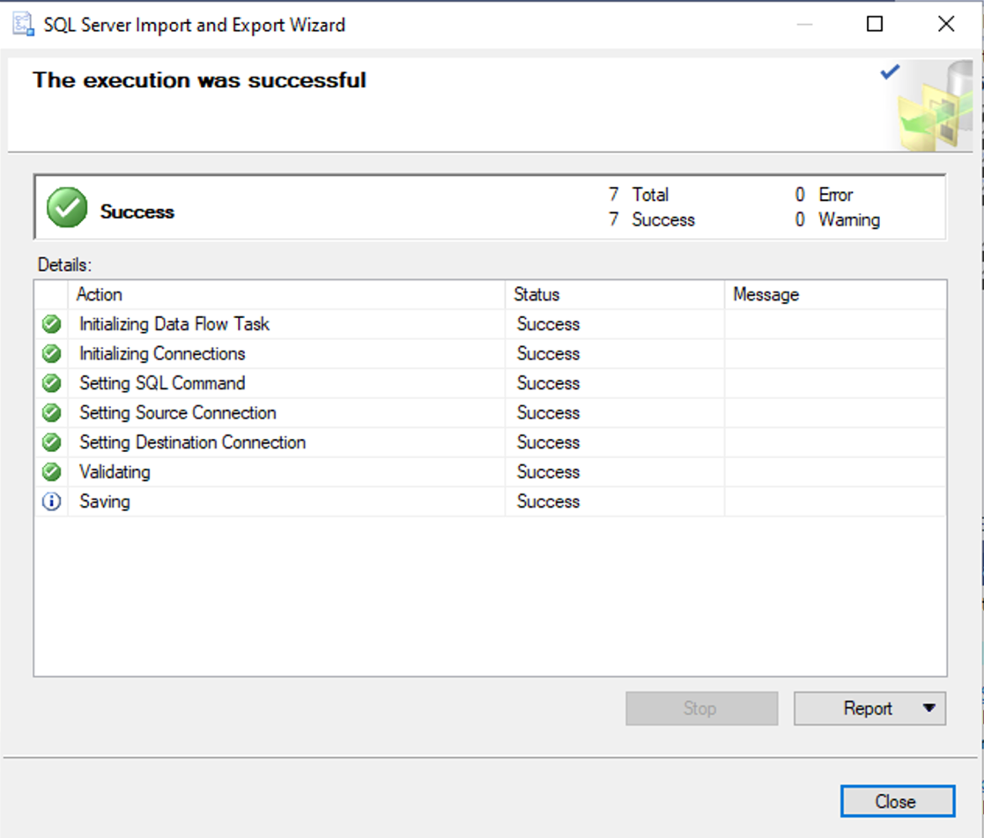

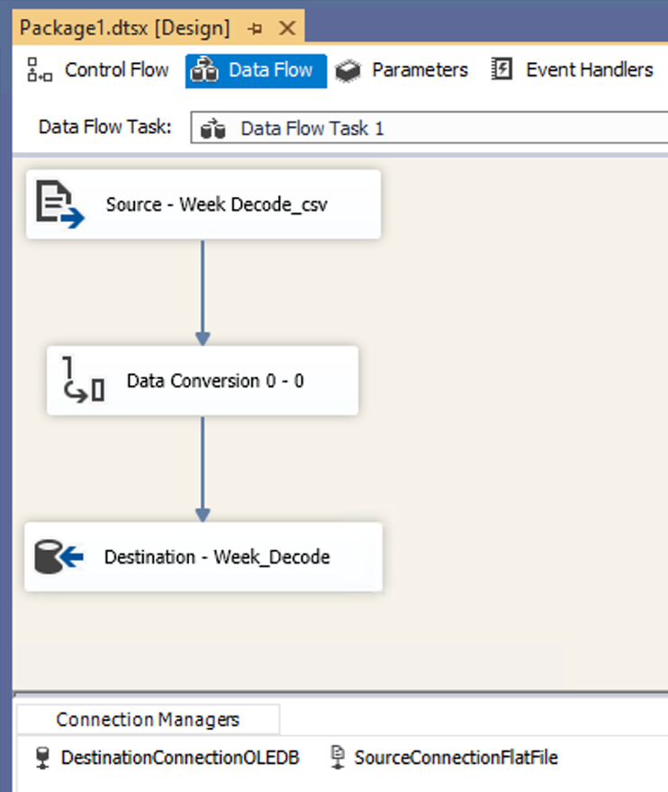

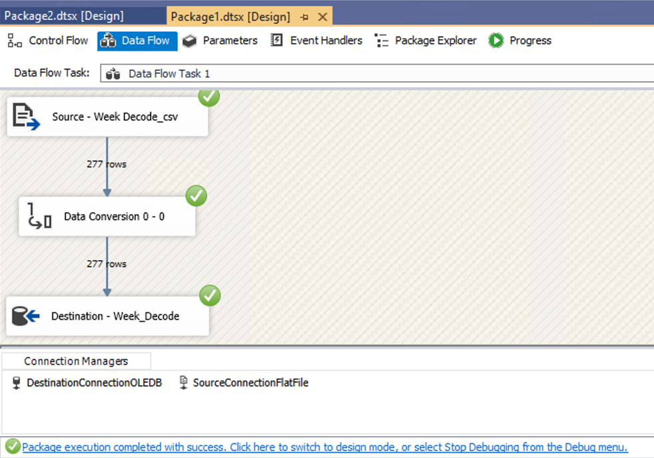

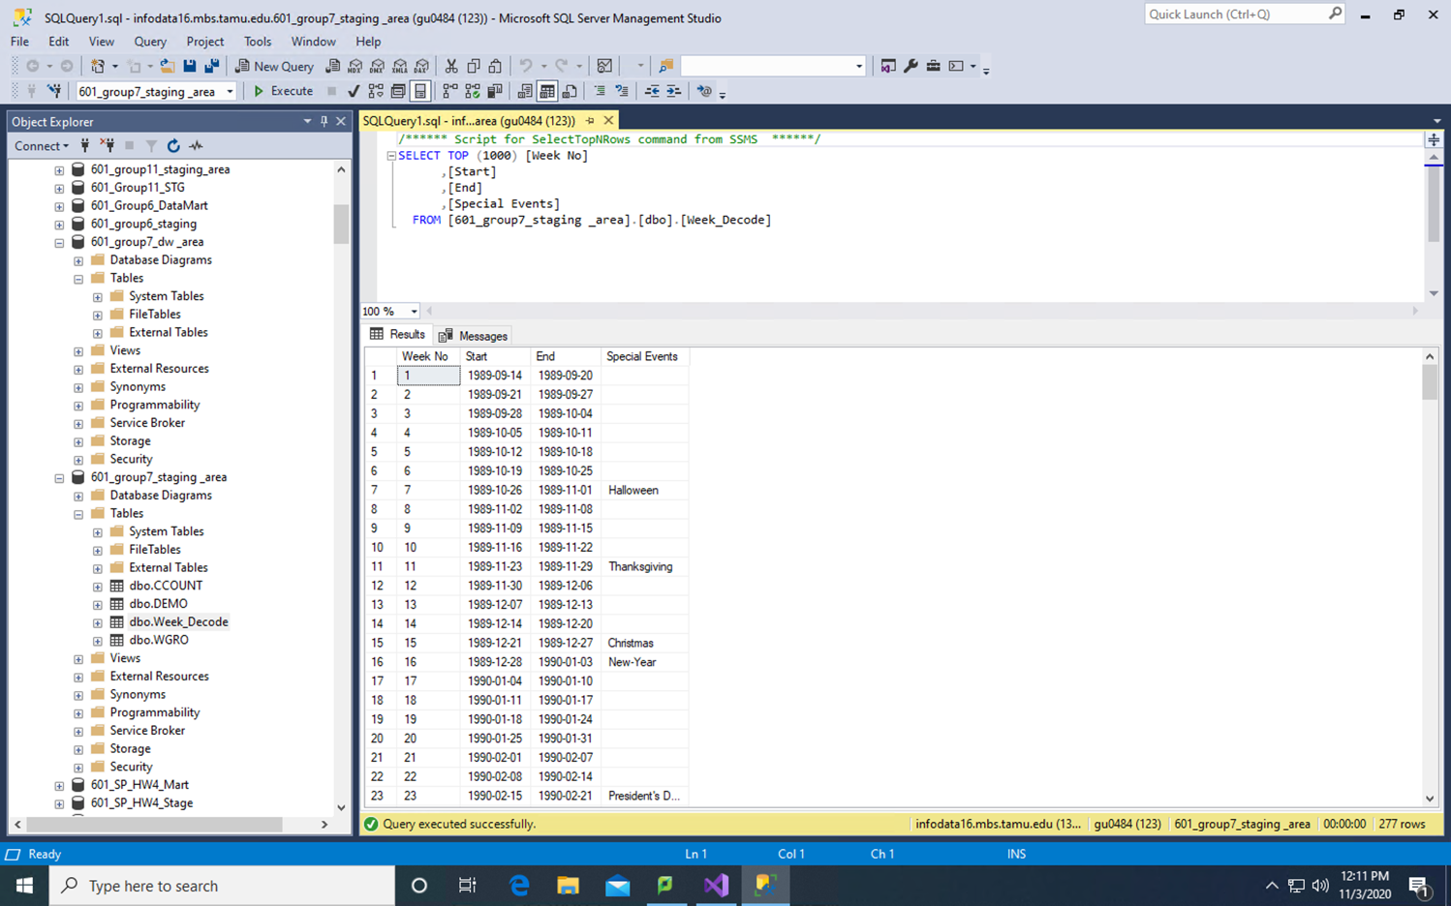

In a similar fashion, the other sources files are extracted in the staging area and their screenshots are below:

1. CCOUNT

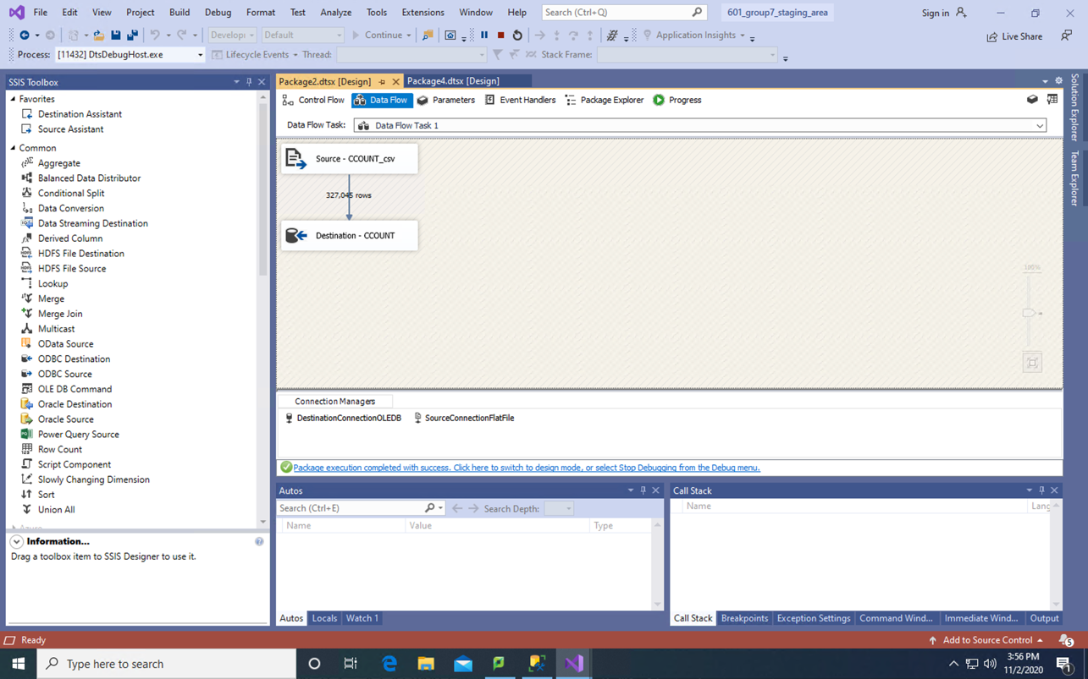

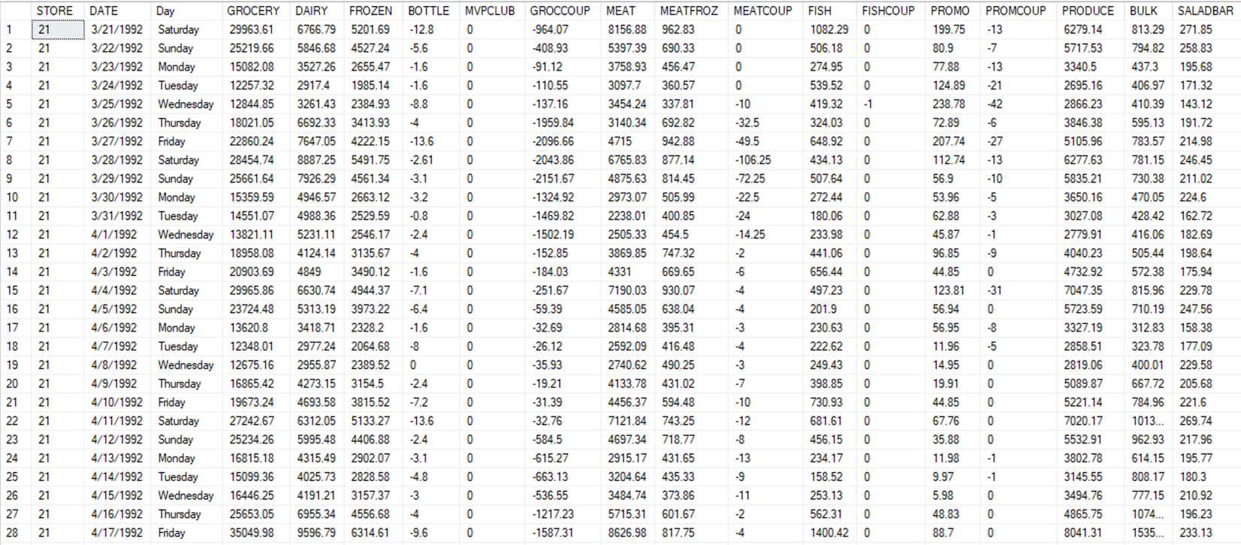

1. DEMO

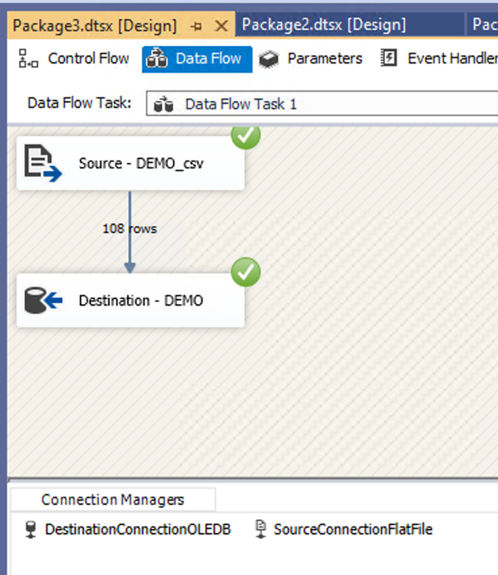

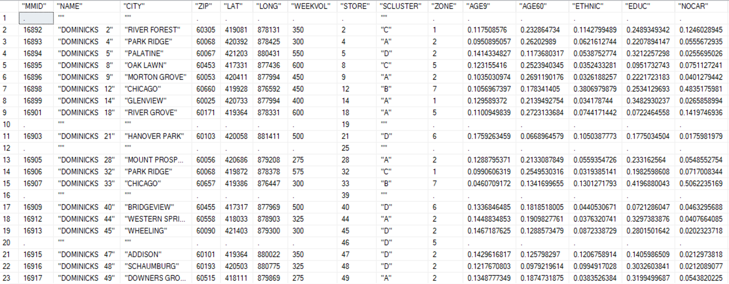

1. WGRO

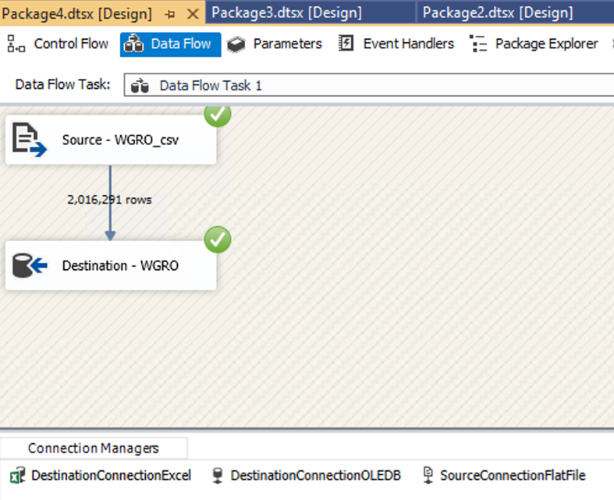

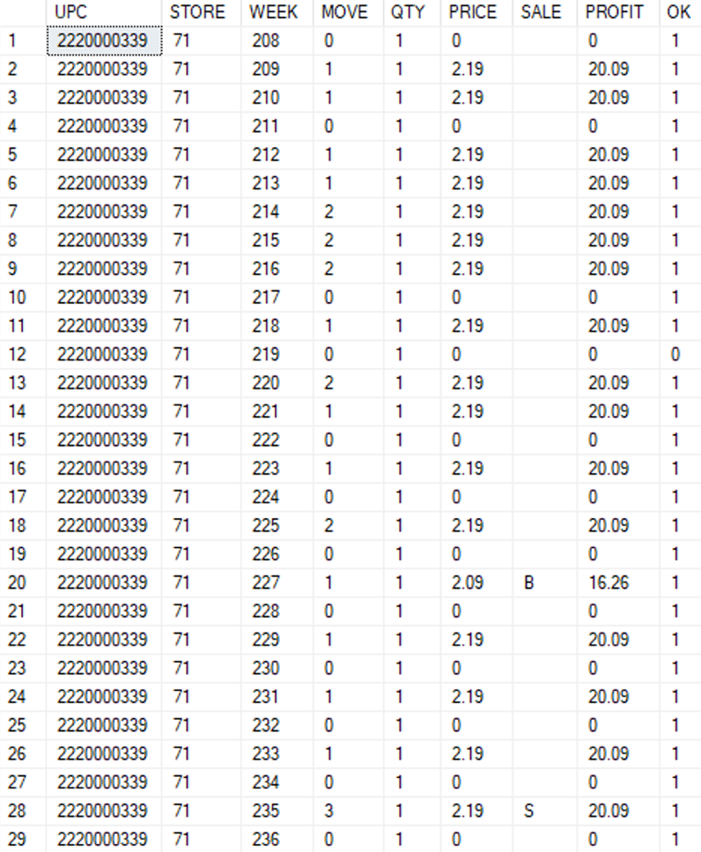

## Data Transformation and Dimension Table Creation

1. Week Decode

Week decode table in staging has been transformed to include an additional column for Year and week of the year column. This is done using derived column transformation available in SSIS toolbox and the new data is stored in ‘[dbo].[Week_decode_temp]’ database in staging area. The transformed table i.e. Week_decode_temp is then used to create a dimension table in ‘601_group7_dw _area’ database in SSMS.

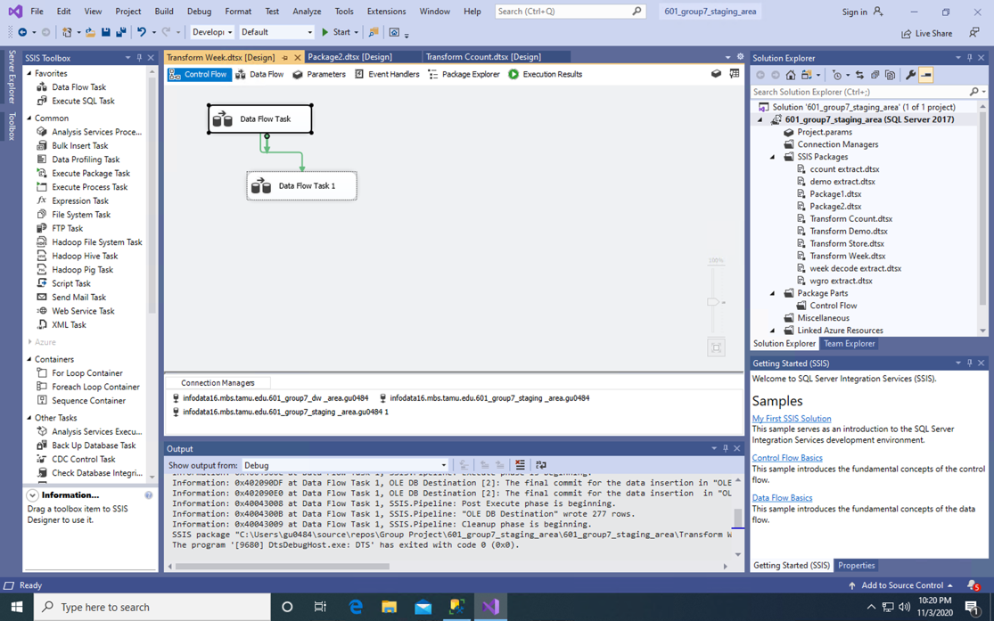

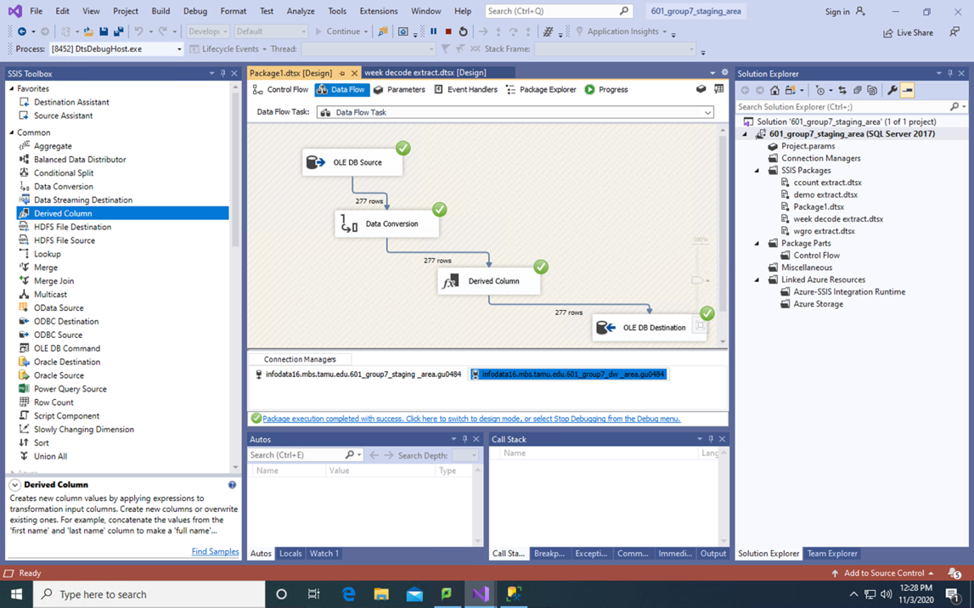

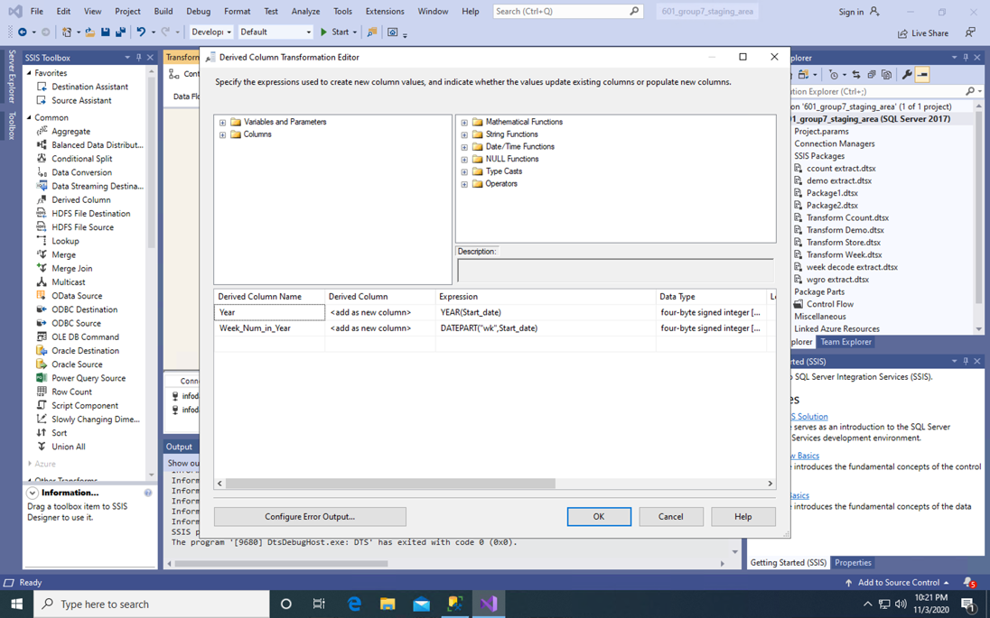

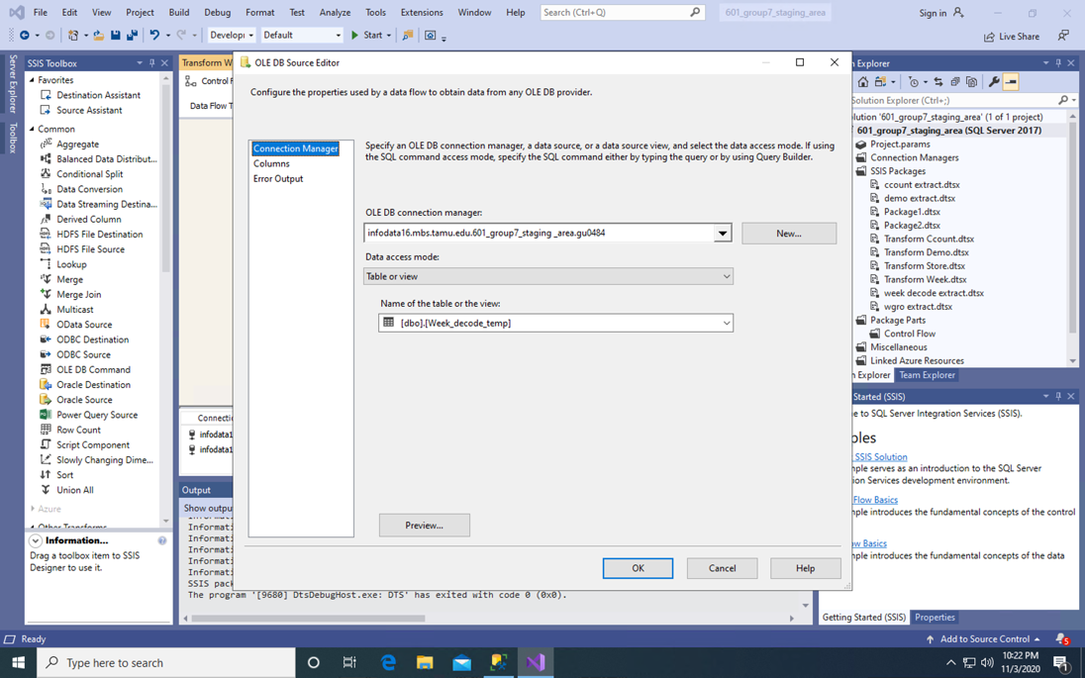

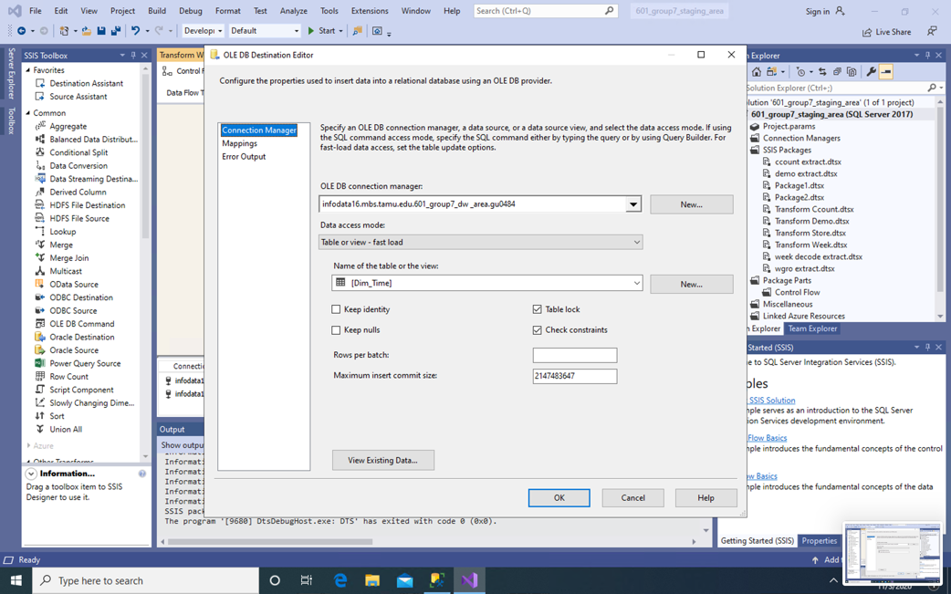

SQL query to create Dim_Time Table is:

CREATE TABLE Dim_Time (

Time_Key int identity(1,1) PRIMARY KEY,

Year int,

Week_Number int);

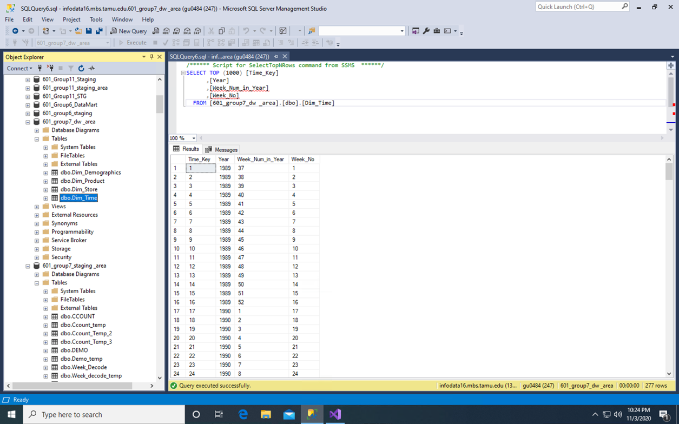

1. Demographics

To transform the demographics data before creating the dimension table, we first replicated all the data from ‘Demo’ table in staging to a ‘Demo_temp’ table in staging using a Data Flow Task. The screenshot of SSIS and SSMS are below:

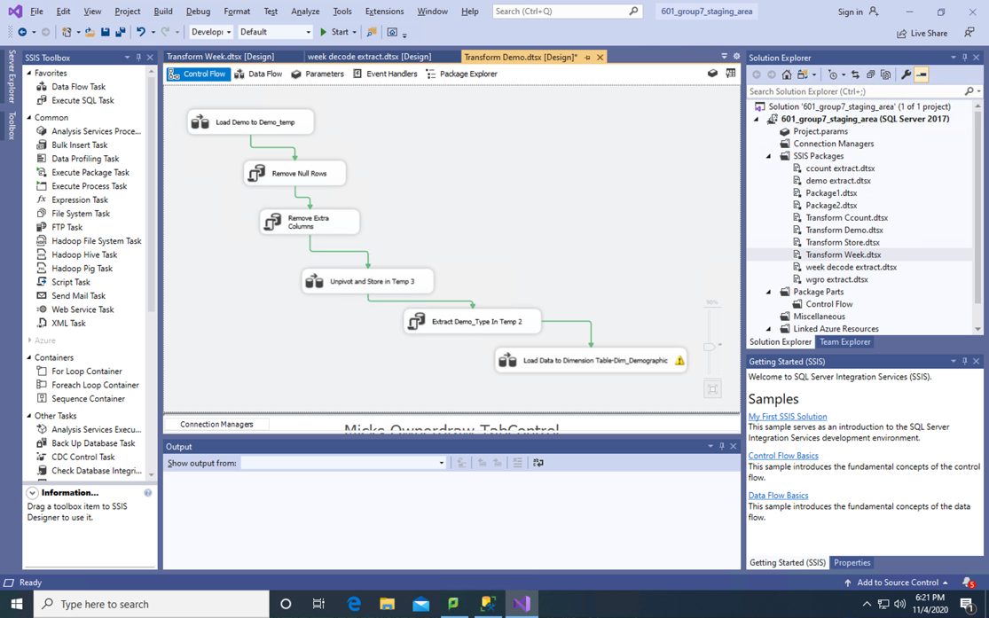

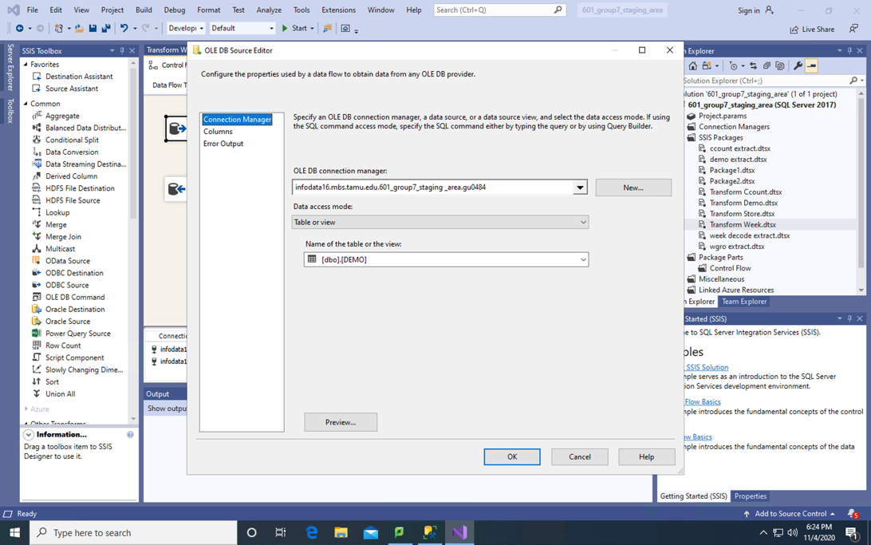

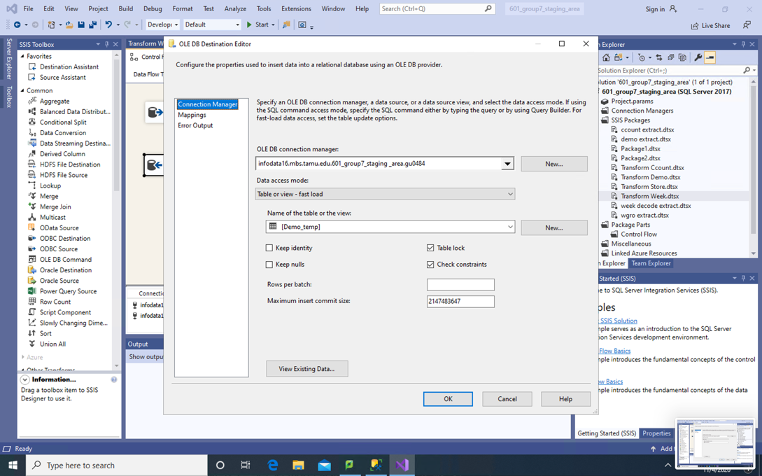

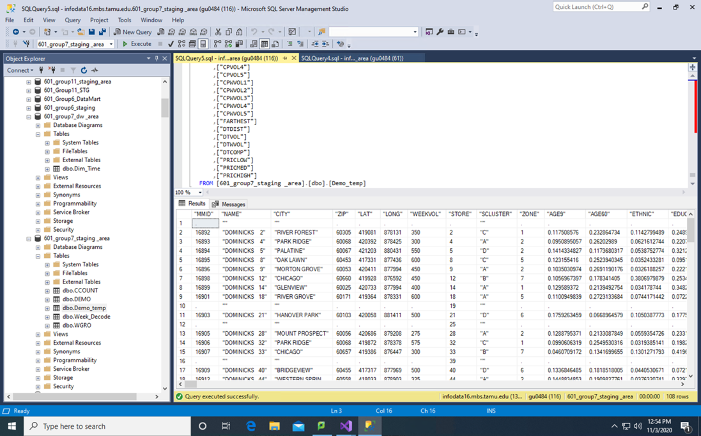

All the data is now available in Demo_temp table in staging DW area.

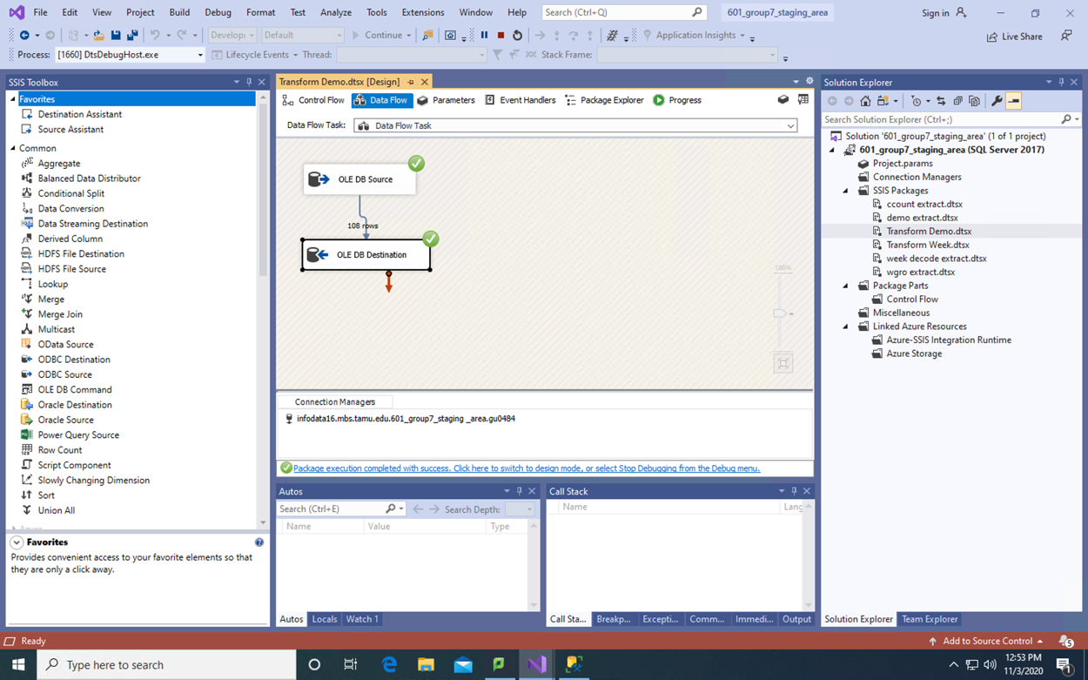

All the data is not in Demo_temp table in staging area.

Now, we will perform all the transformations on ‘Demo_temp’ table to clean the data and make it useful for further use.

First of all, we remove the rows having Null values or (.) values in records.

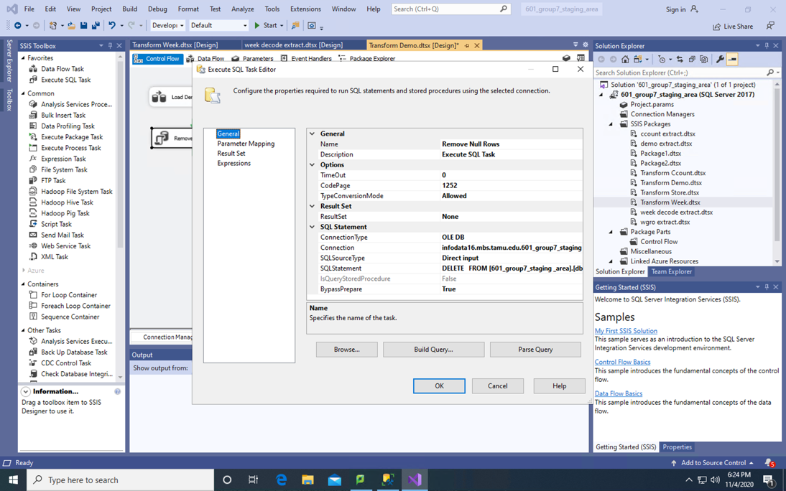

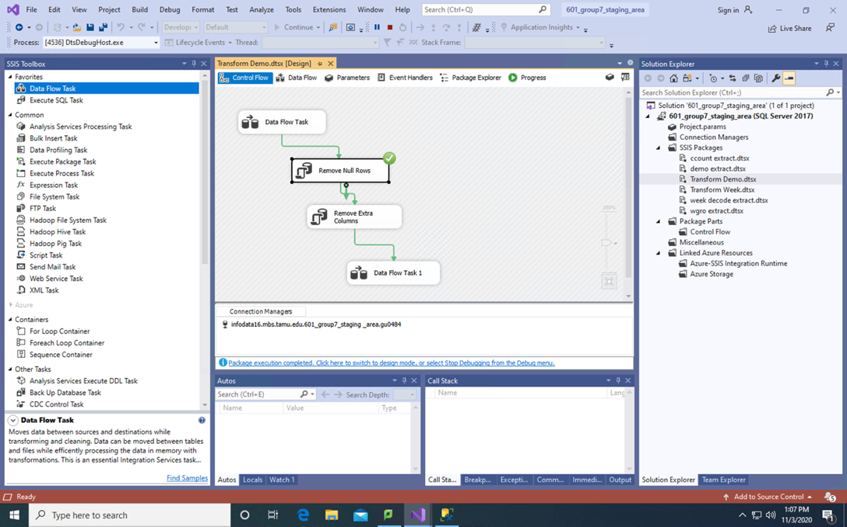

Second, we removed columns we don’t need to answer business questions.

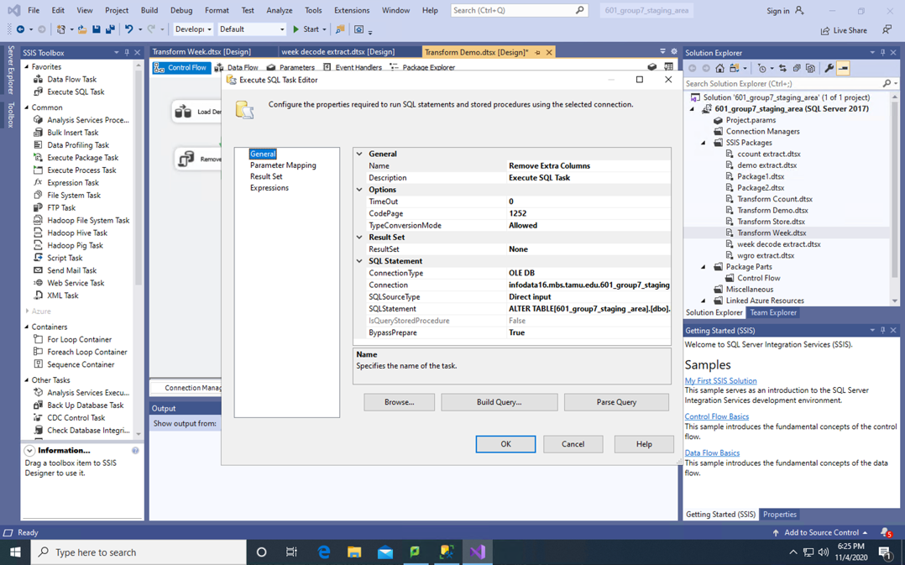

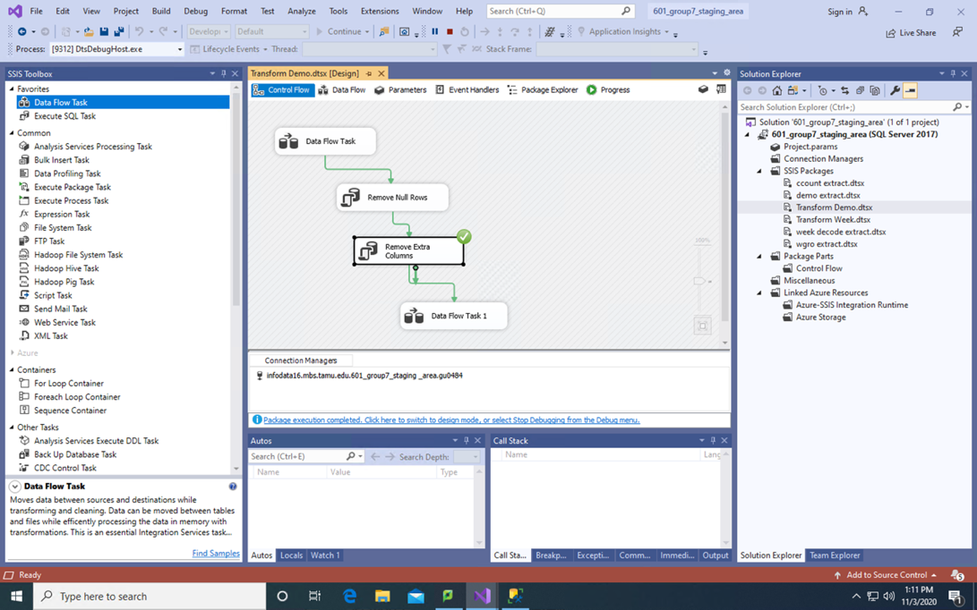

These were the only 2 transformations required in Demo_temp staging table.

SQL queries for transformations are:

* + DELETE FROM [601_group7_staging _area].[dbo].[Demo_temp] where ["MMID"] like '.';
  + We have dropped the columns from Dempgraphics table which were not required for our particular business questions.

Third, we pivoted data to make it in a form needed for Dimension table.

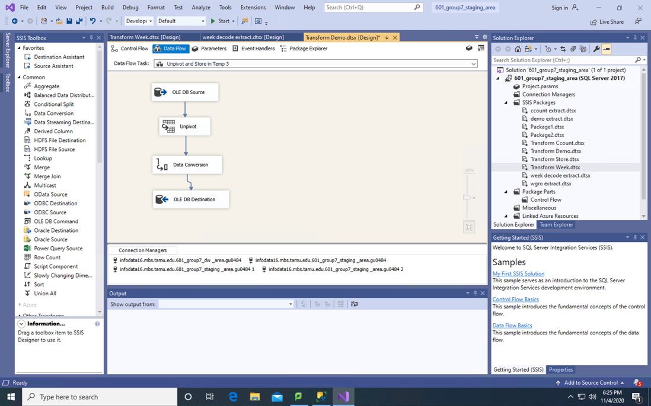

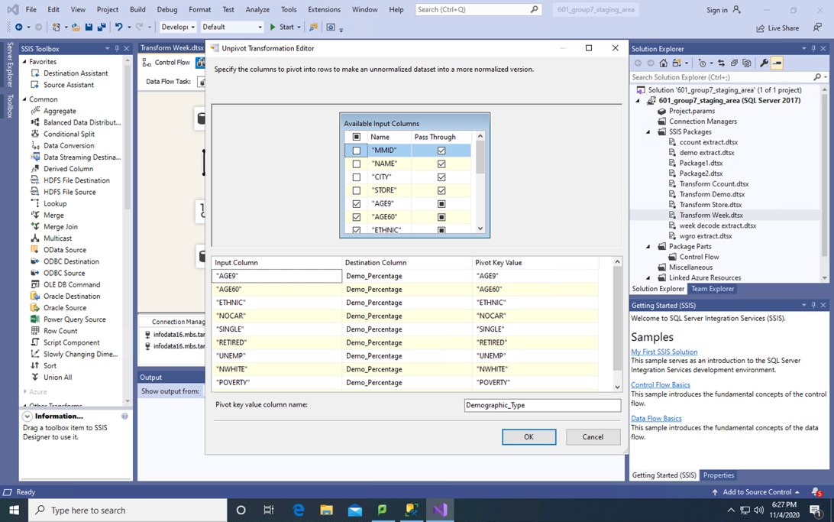

Changed the data type of a column to the one we need in dimension table.

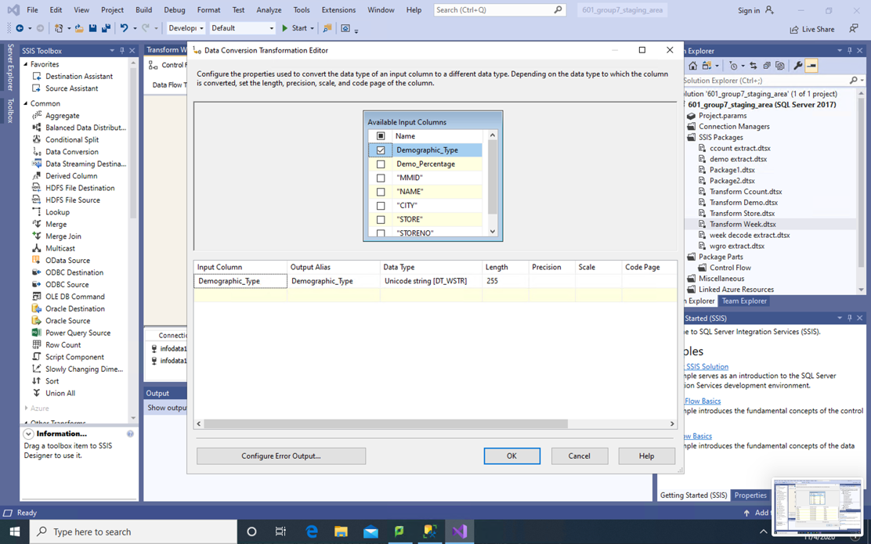

Now, we loaded distinct data in another table so that we could use it to make dimension table.

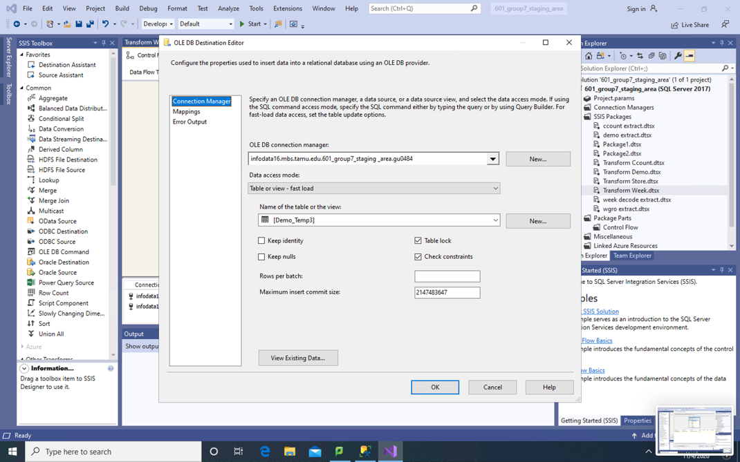

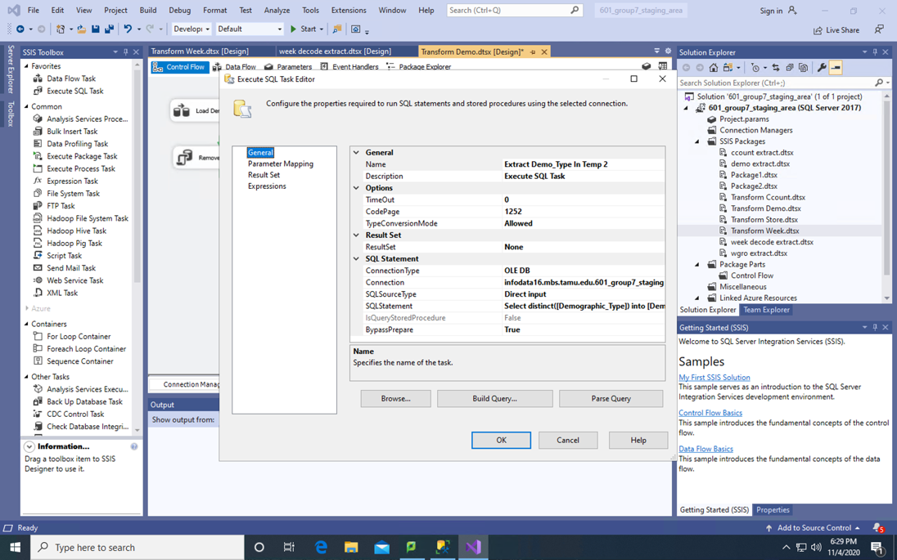

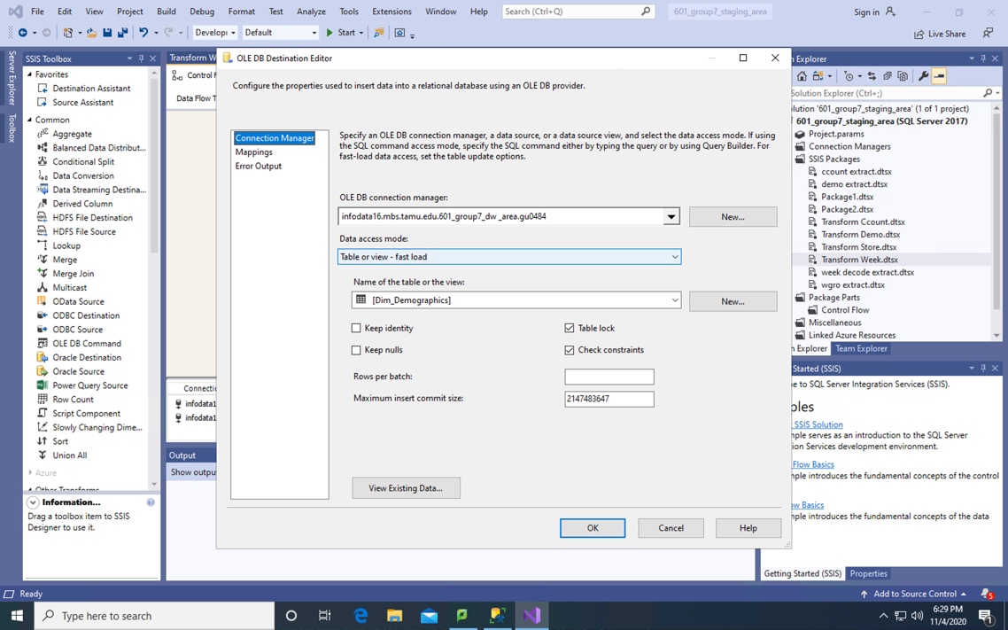

SQL query to create Dim_Demographics is:

CREATE TABLE Dim_Demographics (

Demographics_Key int identity(1,1) PRIMARY KEY,

Demographics_Type nvarchar(50));

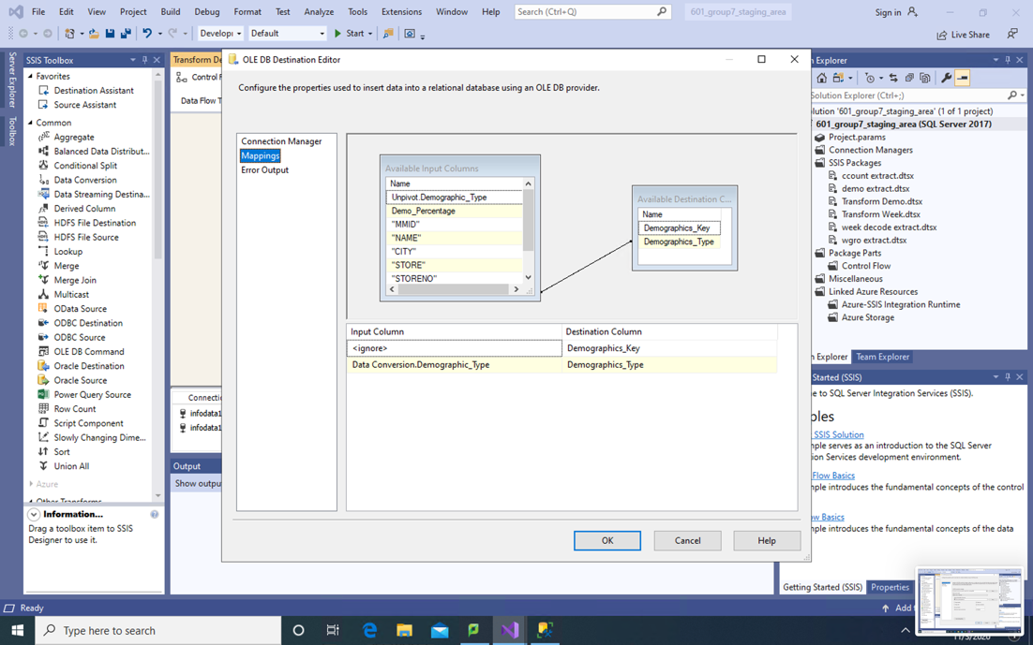

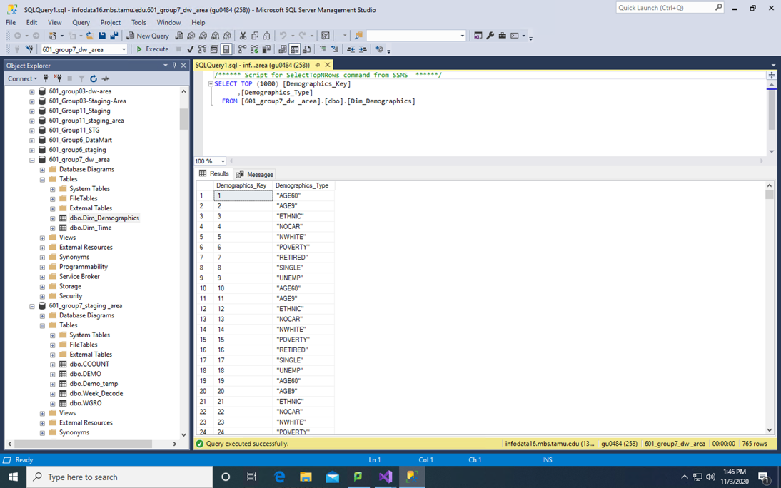

1. CCount

To transform CCount in order to remove dirty data, we first created a ‘Ccount_temp’ table in ‘601_group7_staging _area’ where we can perform all transformation operations. To do this, we created a data flow task in SSIS package and exported ‘CCOUNT’ to ‘Ccount_temp’. The screenshots are shown below:

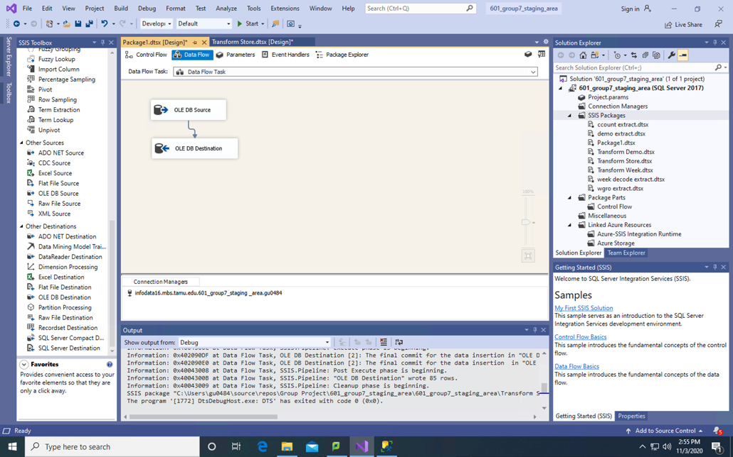

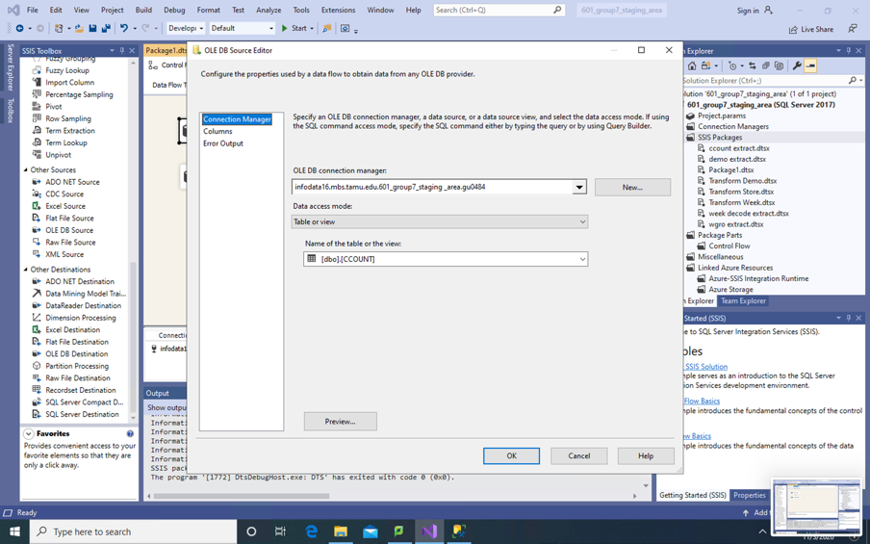

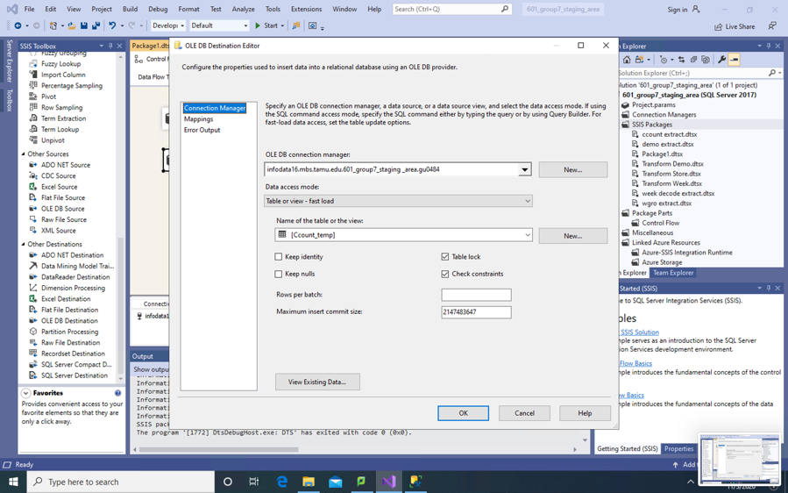

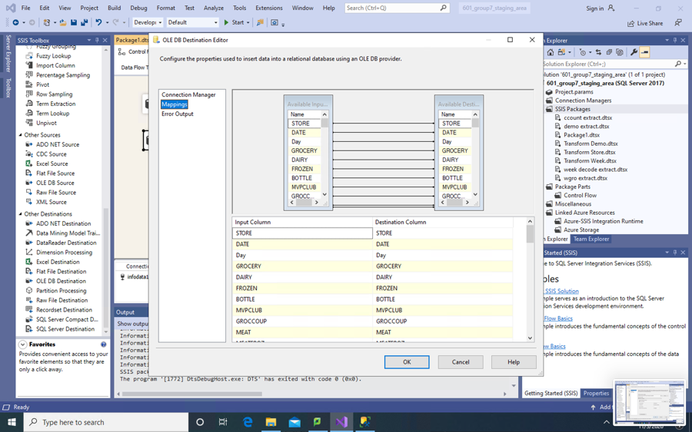

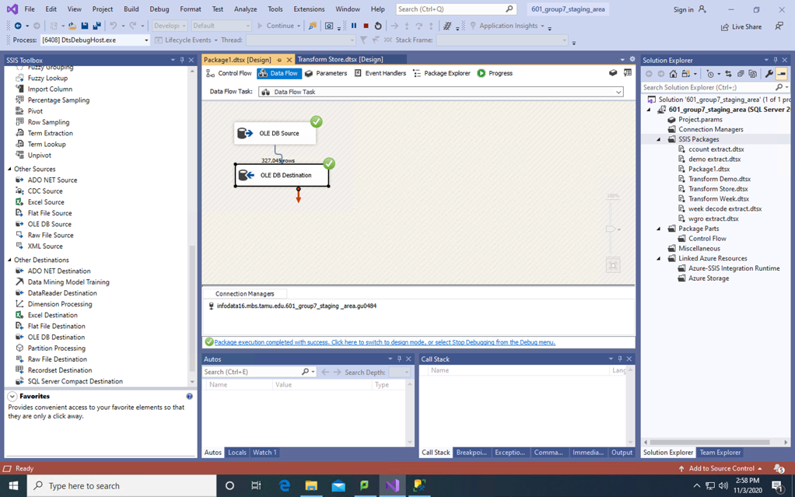

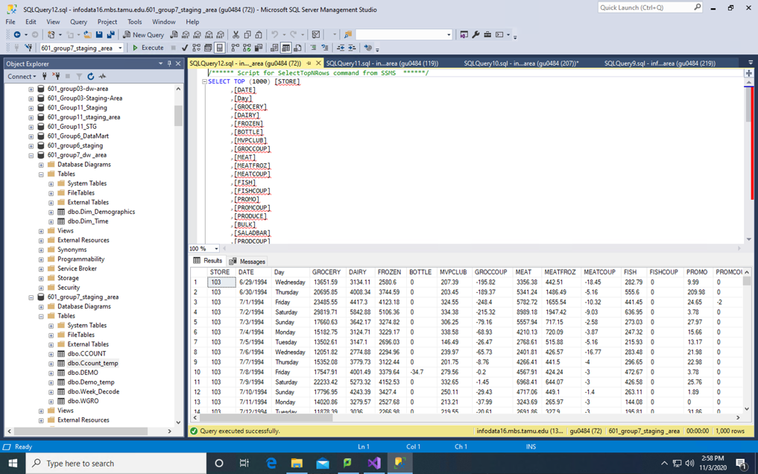

Now, we will perform all cleaning operations on this Ccount_temp table in staging.

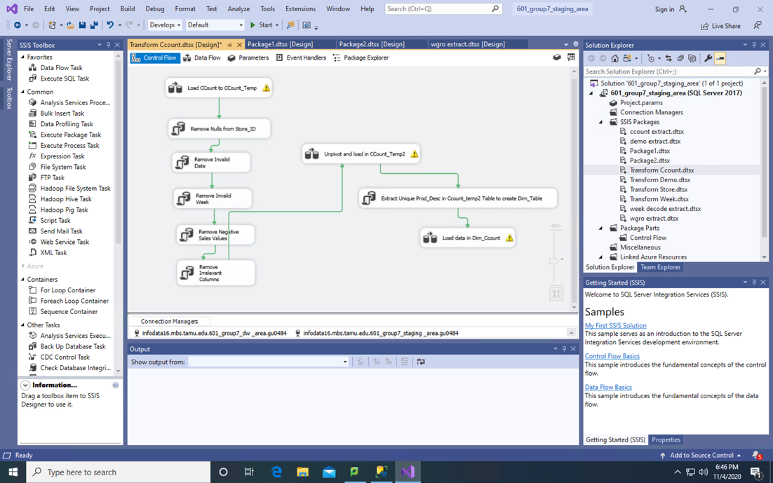

SQL queries for above transformation tasks:

Delete FROM [601_group7_staging _area].[dbo].[Ccount_temp] where Store not like '%[0-9]%';

Delete FROM [601_group7_staging _area].[dbo].[Ccount_temp] where DATE not like '%[0-9]%';

Delete FROM [601_group7_staging _area].[dbo].[Ccount_temp] where WEEK like '-%';

Delete FROM [601_group7_staging _area].[dbo].[Ccount_temp] where BEER like '-%' OR WINE like '-%' OR SPIRITS like '-%' OR MEAT like '-%' OR MEATFROZ like '-%' OR FISH like '-%' OR PHARMACY like '-%' OR BAKERY like '-%' OR GROCERY like '-%' OR DAIRY like '-%' OR JEWELRY like '-%';

Alter table [601_group7_staging _area].[dbo].[Ccount_temp] drop column

[GROCERY],[DAIRY],[BOTTLE],[MVPCLUB],[GROCCOUP],[MEATCOUP],[FISHCOUP],[PROMO],[PROMCOUP],[PRODUCE],[BULK],[SALADBAR],[PRODCOUP],[BULKCOUP],[SALCOUP],[FLORAL],[FLORCOUP],[DELI],[DELISELF],[DELIEXPR],[CONVFOOD],[CHEESE],[DELICOUP],[PHARCOUP],[GM],[JEWELRY],[COSMETIC],[HABA],[GMCOUP],[CAMERA],[PHOTOFIN],[VIDEO],[VIDEOREN],[VIDCOUP],[MISCSCP],[MANCOUP],[CUSTCOUN],[FTGCHIN],[FTGCCOUP],[FTGITAL],[FTGICOUP],[DAIRCOUP],[FROZCOUP],[HABACOUP],[PHOTCOUP],[COSMCOUP],[SSDELICP],[BAKCOUP],[LIQCOUP];

After the cleaning tasks, the transformed table looks like the one in screenshot below:

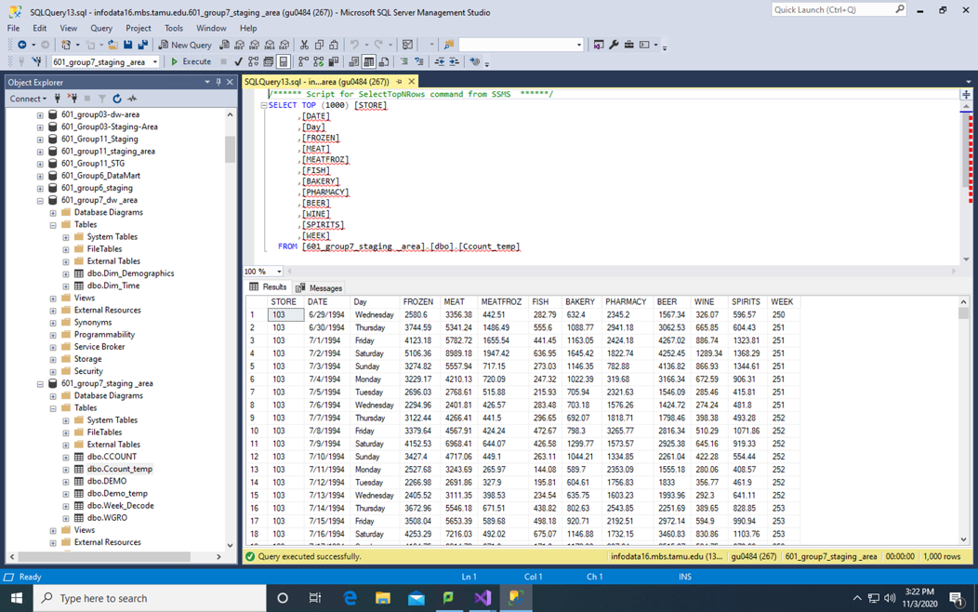

Now, we unpivot the table to make it in a form that could be used to create dimension and fact table and stored it in CCount_Temp2 table.

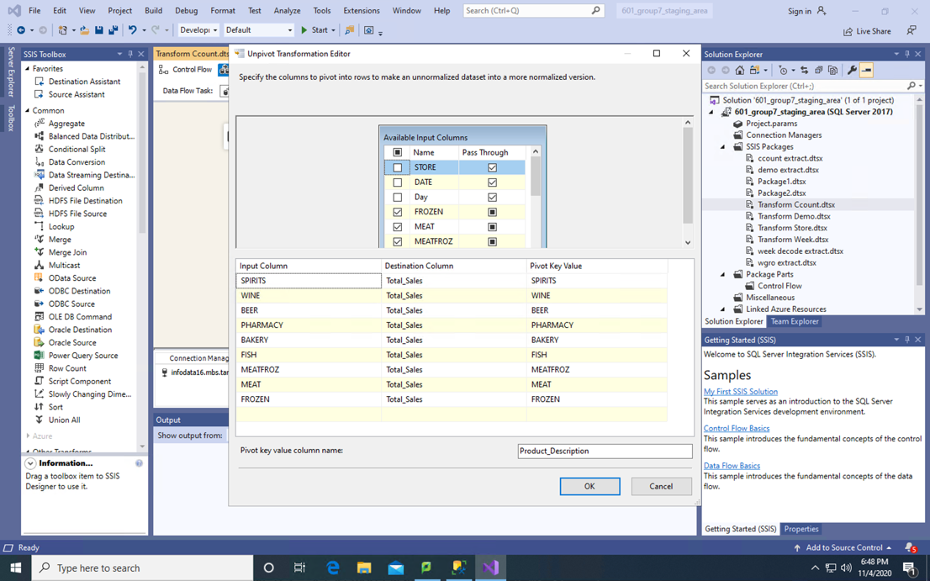

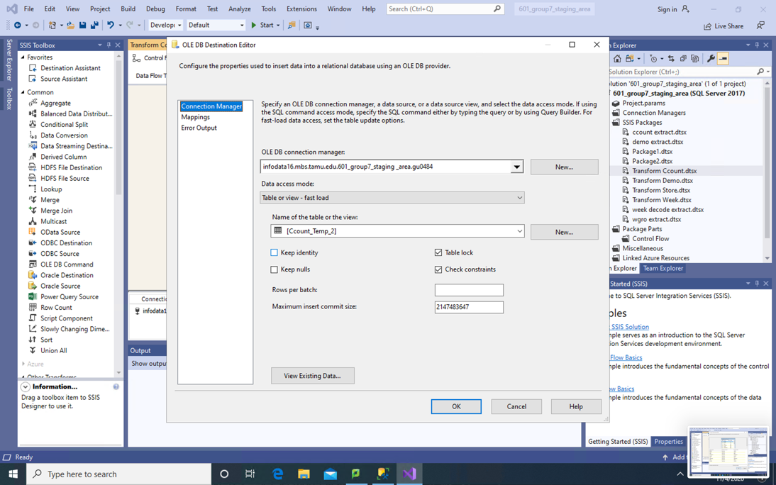

On the unpivoted data in CCount_Temp_2 table, we run a query to extract distinct Product_Description and store it in new CCount_Temp3 table which will be used for loading data in Dimension table.

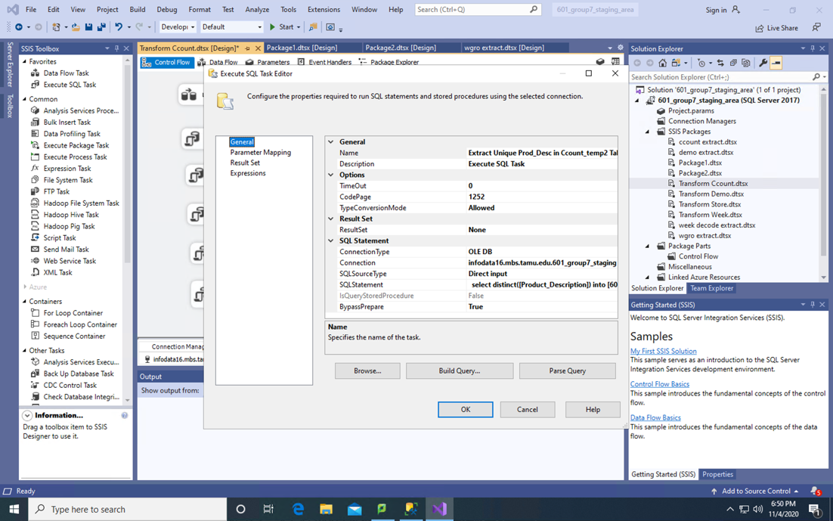

Now load data in Dim_Product in [601_group7_dw _area] using a data flow task in SSIS.

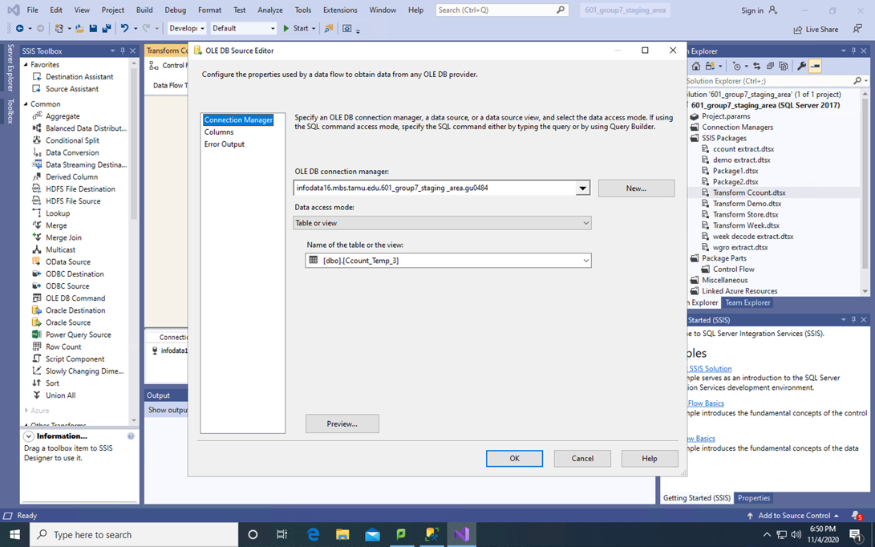

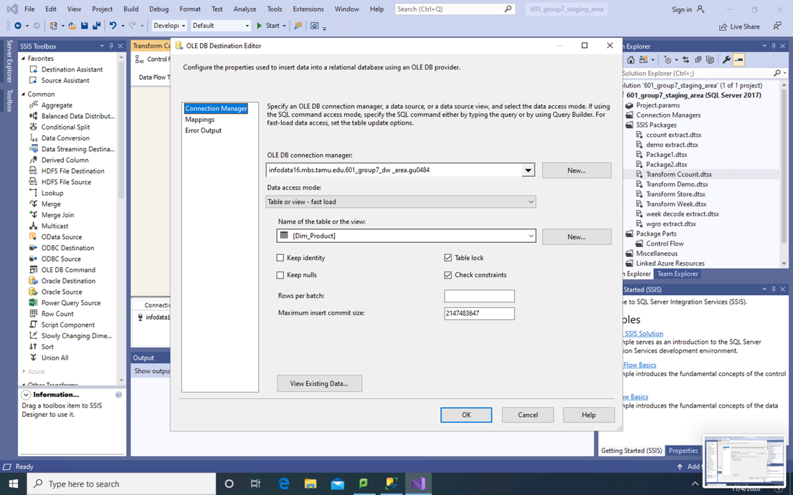

SQL query to create Dim_Product table is as follows:

CREATE TABLE Dim_Product (

Product_Key int identity(1,1) PRIMARY KEY,

Product_Description nvarchar(50));

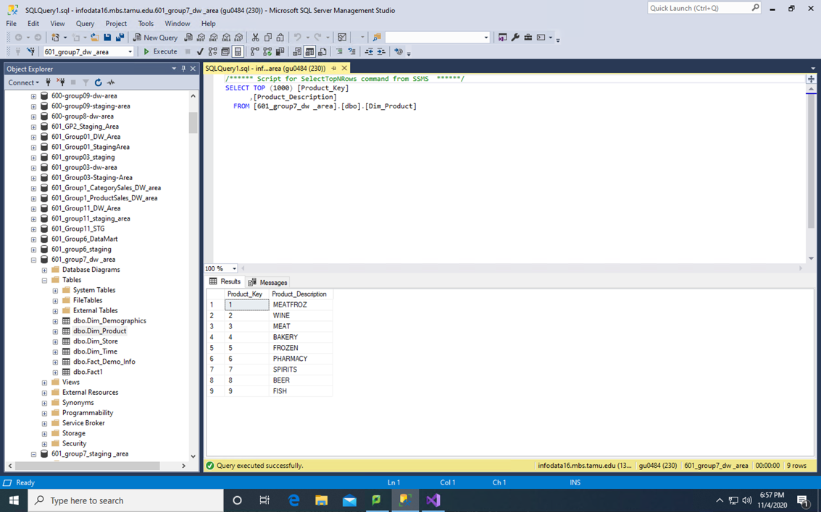

1. Store

In order to build Dim_Store, we need to extract data from Demo_temp staging table and load it to Dim_Store dimensional table in DW database.

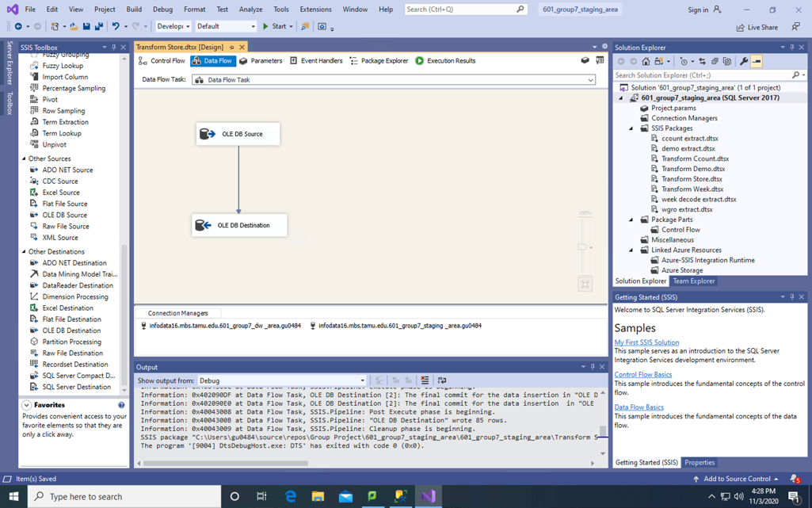

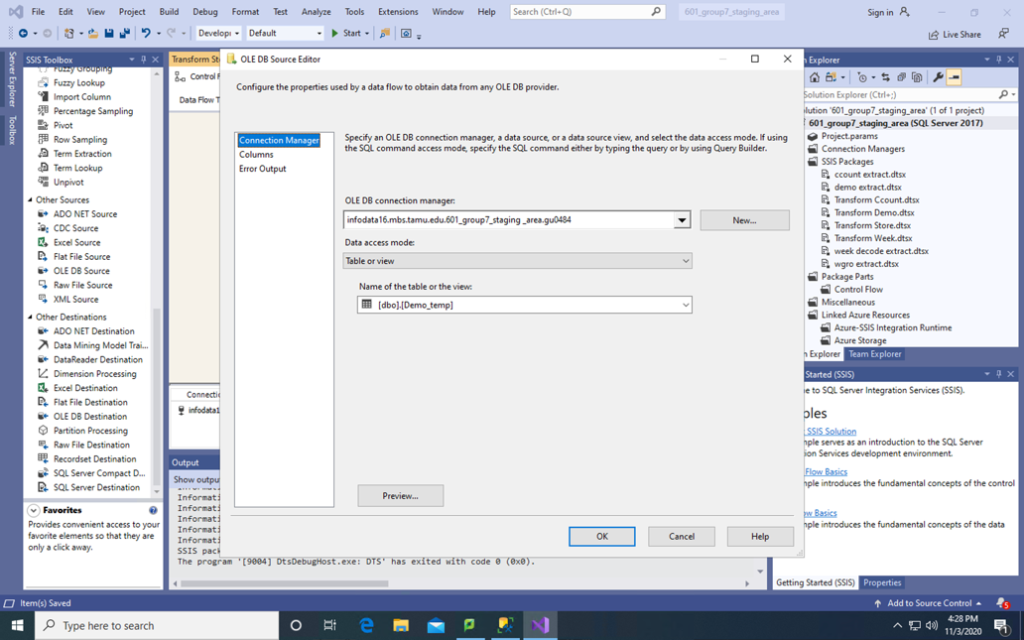

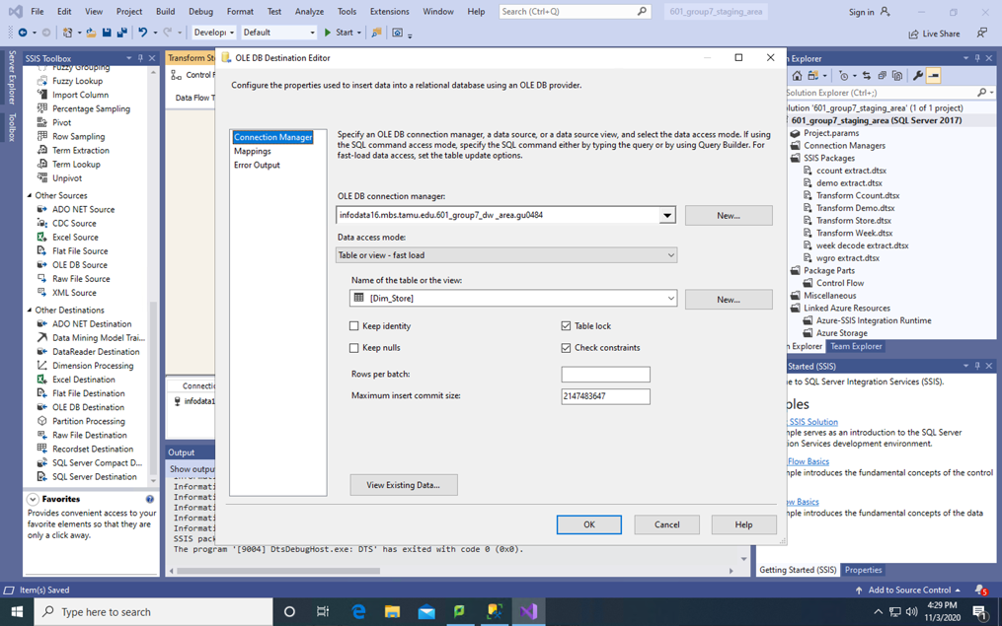

SQL to create Dim_Store Dimension Table:

CREATE TABLE Dim_Store (

Store_Key int identity(1,1) PRIMARY KEY,

Store_ID int);

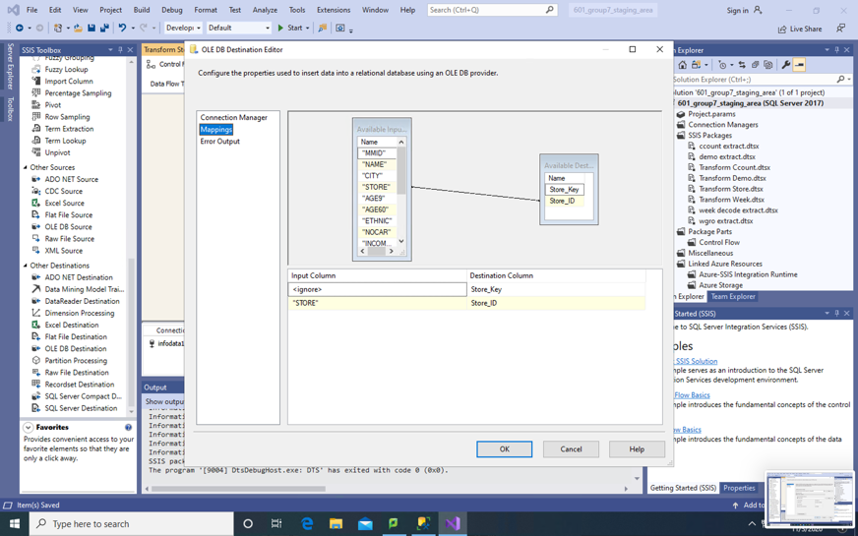

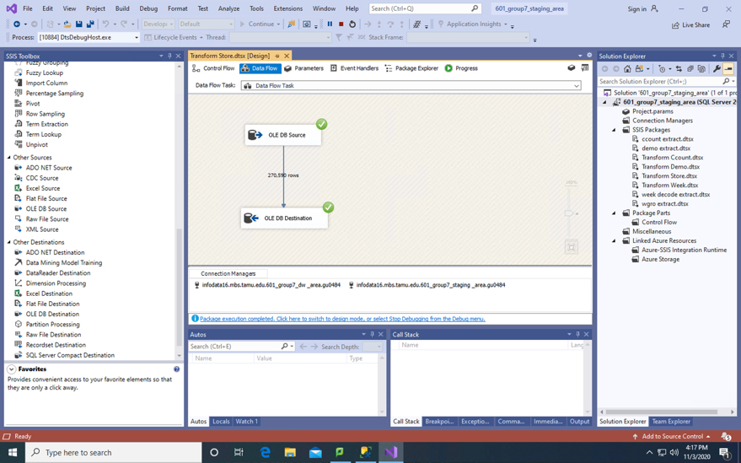

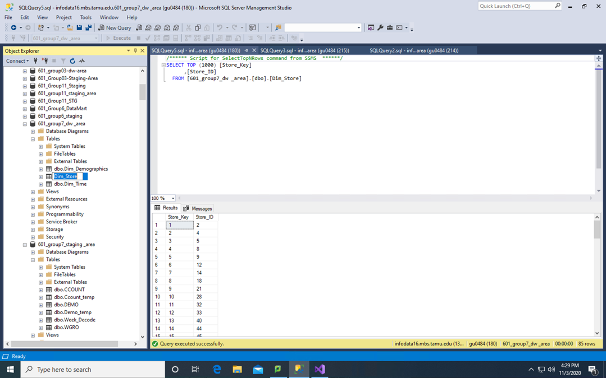

## Creation of Fact Tables

**Fact_ProductSales**

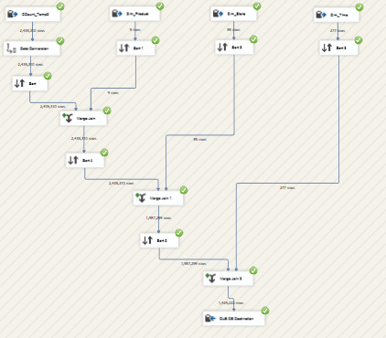

CREATE TABLE Fact_ProductSales (

Product_Key int,

Time_Key int,

Store_Key int,

Total_Sales float,

Constraint Pk_TotalSales PRIMARY KEY ([Product_Key], [Time_Key], [Store_Key])

);

To calculate Total Sales of Product, we have joined CCount_Temp_2 table present in our staging area and Dim_Product present in data warehouse area. Data Conversion has been performed to convert Data into Date datatype, Store into four byte signed int, etc. We sort the tables by Product Description and then join them to get Product_Key, Total_Sales and Store.

**Data Conversion of CCount_Temp_2**

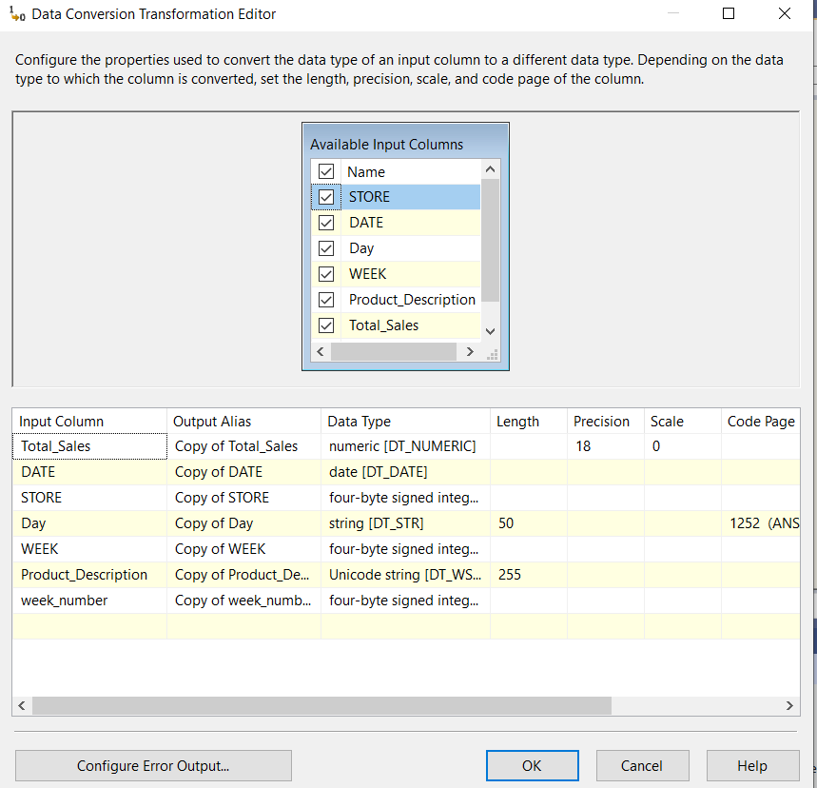

**Sort by Product_Description of CCount_Temp_2**

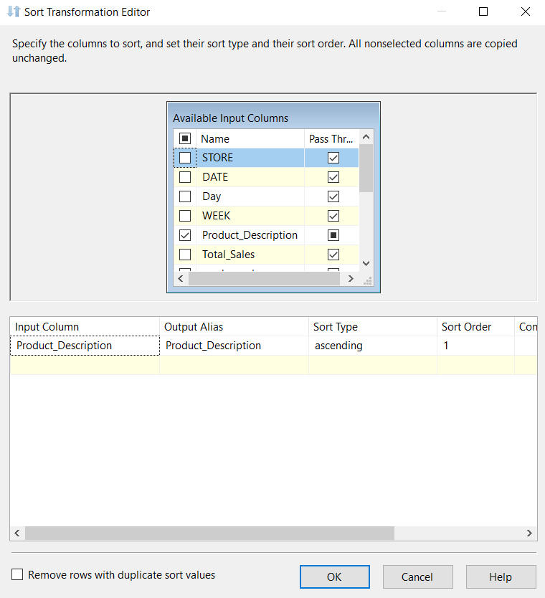

Similarly, we have sorted Dim_Store on the basis of Store number and Dim_Time on the basis of Week.

**Merge Tables:**

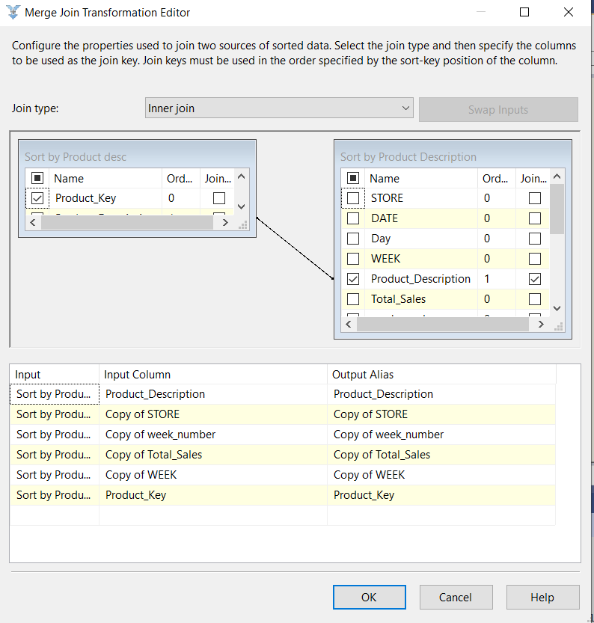

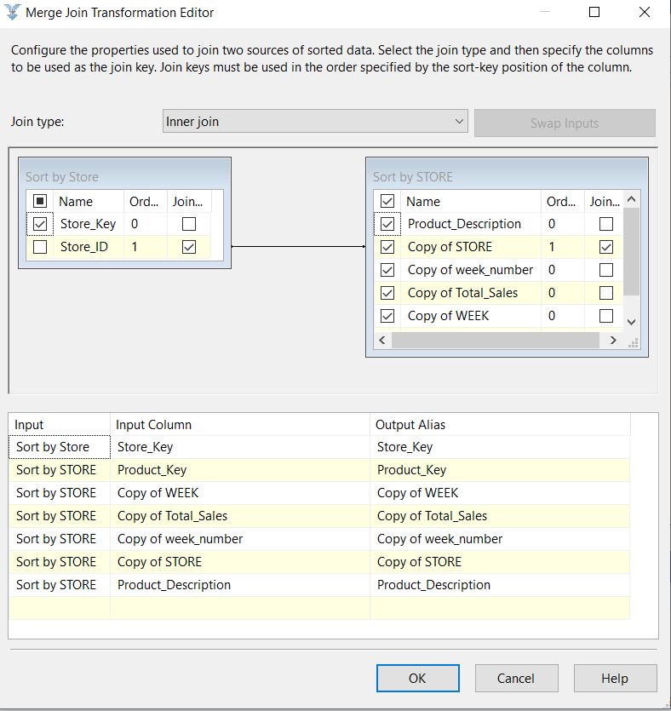

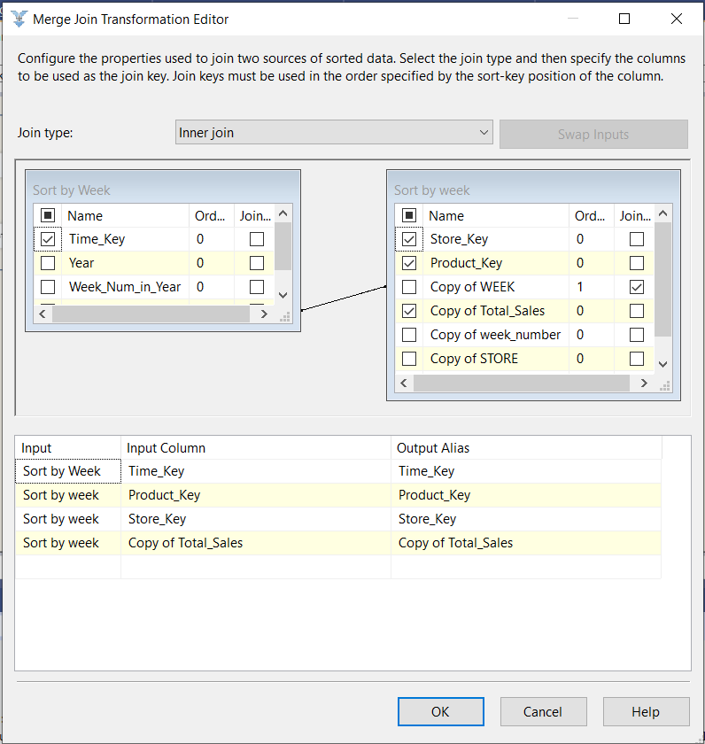

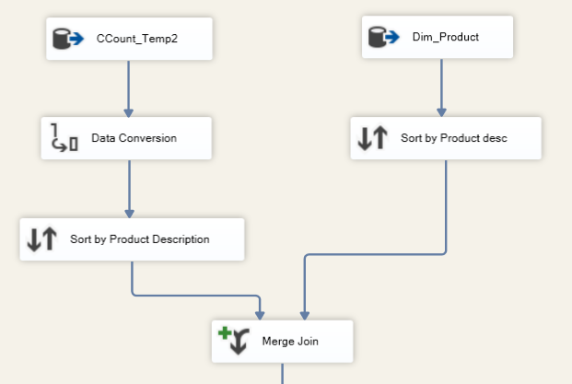

Then we join the merged result of CCount_Temp_2 and Dim_Product with our Dim_Store source. They are sorted by Store numbers and then joined to produce Total Sales on the basis of Store and Products.

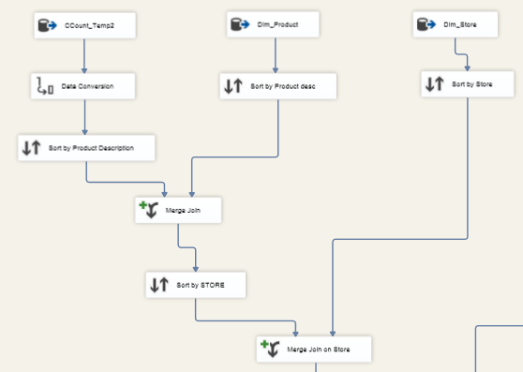

In the final step, we join the merged results of the previous step with Dim_Time source. The tables are sorted on the basis of week and then joined to produce Total Sales on the basis of Store, Product and Time.

In the end we load the results in our OLE DB destination (Fact_ProductSales).

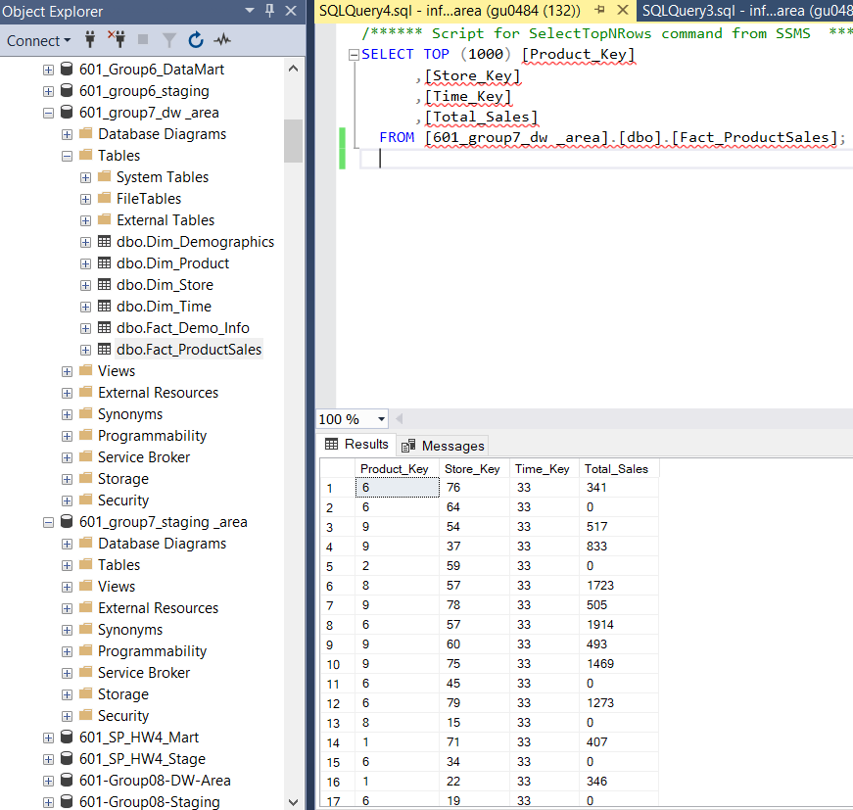

**Fact_Demo_Info**

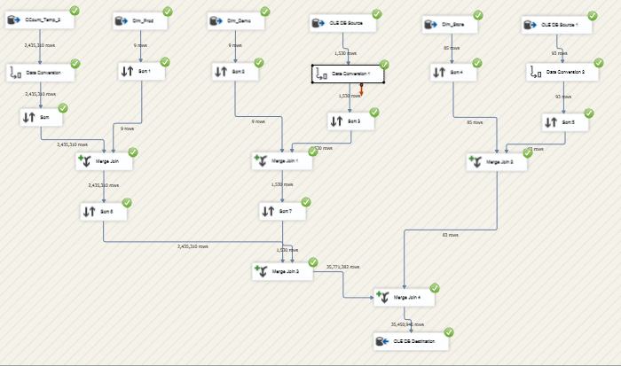

CREATE TABLE Fact_Demo_Info (

Product_Key int,

Demographic_Key int,

Store_Key int,

Total_Sales float,

Demo_Percentage float,

Total_Profit float,

Constraint Pk_TotalProfit PRIMARY KEY ([Product_Key], [Demographic_Key], [Store_Key])

);

We have used CCount_temp_2 and Dim_Product tables to calculate the Total_Sales, Dim_Demographic & Demo_Temp3 to calculate the Demo_Percentage and Dim_Store & WGRO_Temp to calculate Total Profit for Grooming Products.

**Data Conversion of Demo_Temp3 table.**

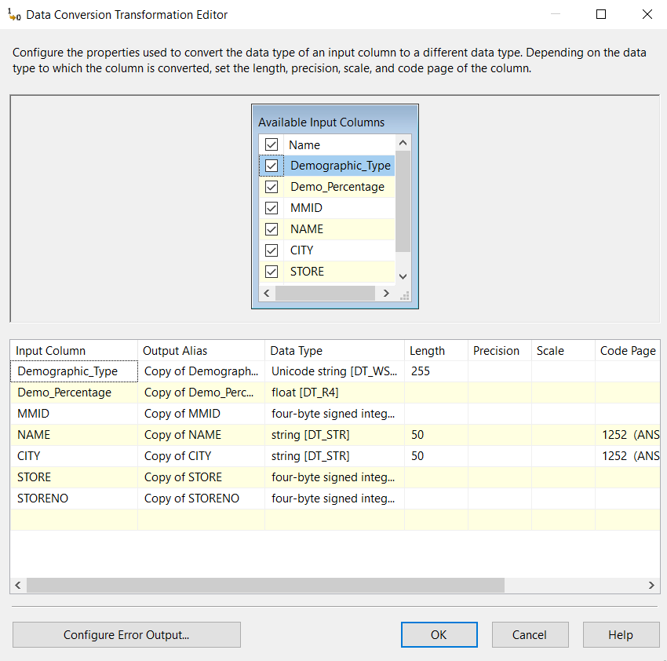

Similarly, we have performed data conversion on CCount_Temp_2 and WGRO_Temp.

**Sort of Dim_Demo and Demo_Temp3 tables by Demographic Type.**

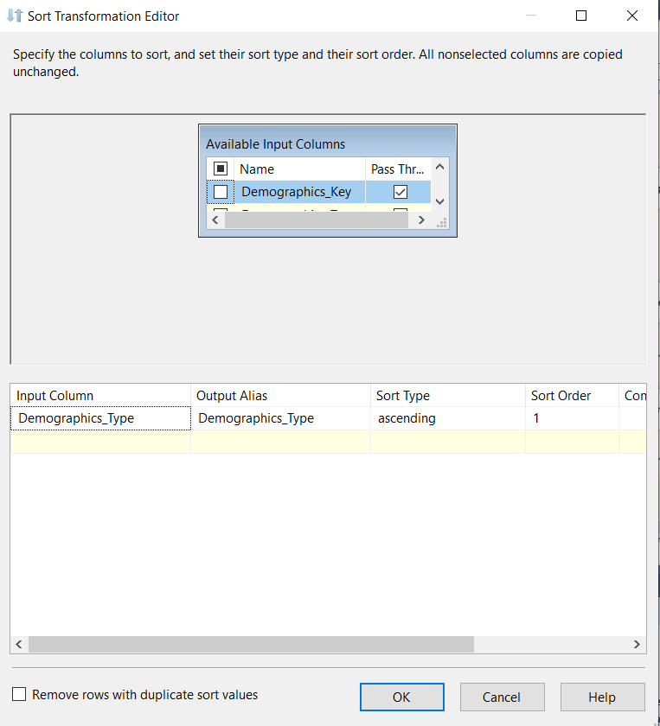

Similarly, we sort CCount_Temp_2 and Dim_Product by Product description, and sort Dim_Store and WGRO_Temp tables by Store number.

**Merge Tables:**

Merge Table to calculate Total_Sales on the basis of product and store.

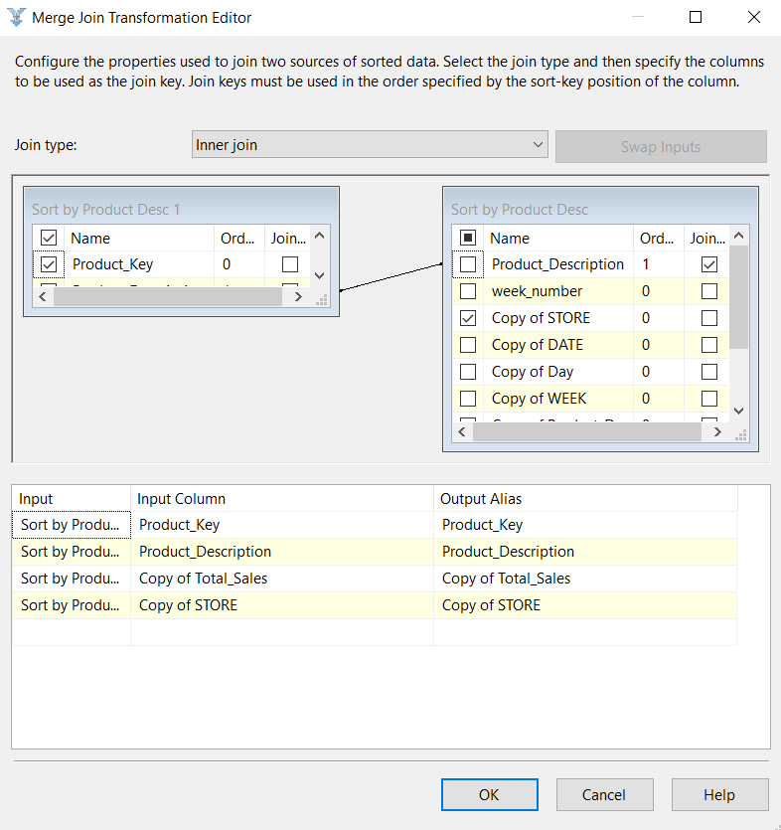

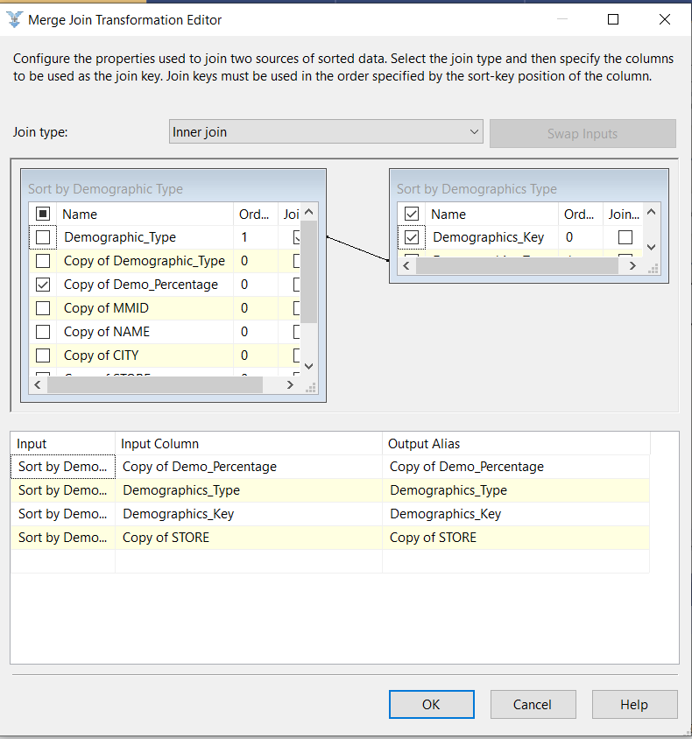

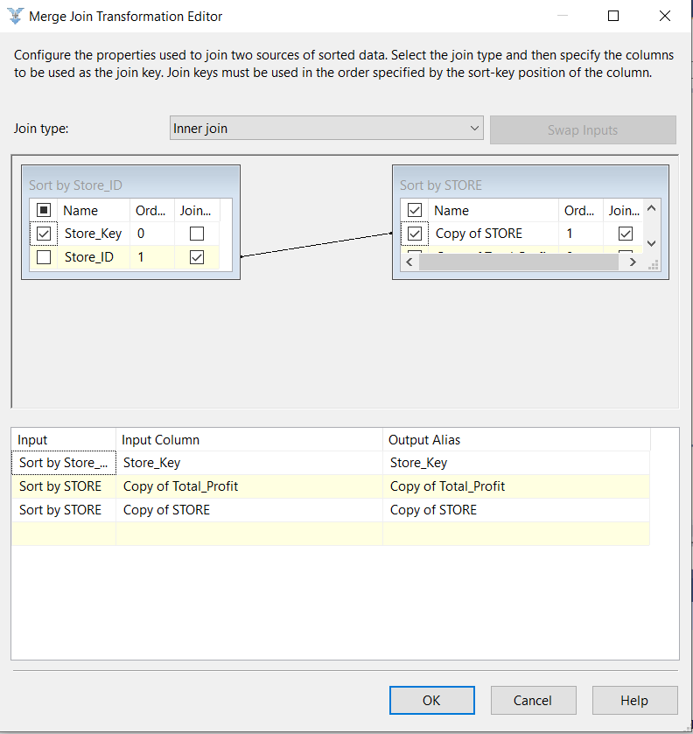

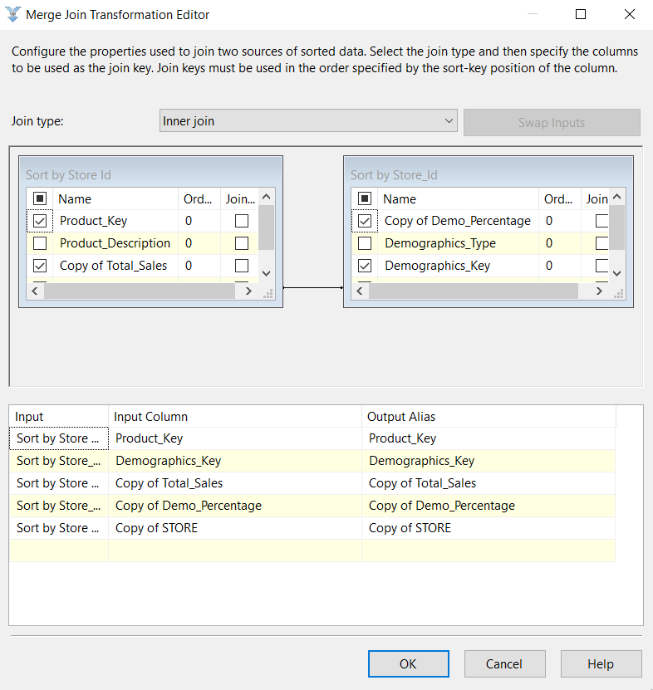

Finally, we merge the results from the three merge joins into a single destination to calculate Total_Sales, Demo_Percentage and Total_Profit on the basis of store, product and demographics.

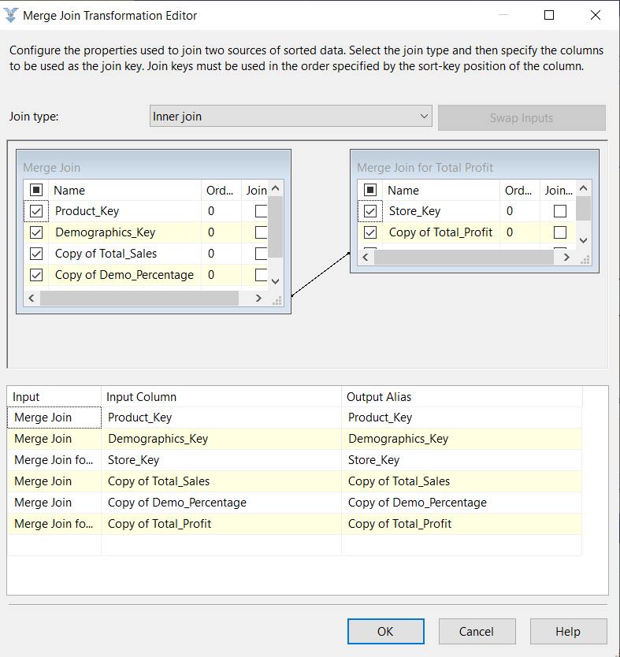

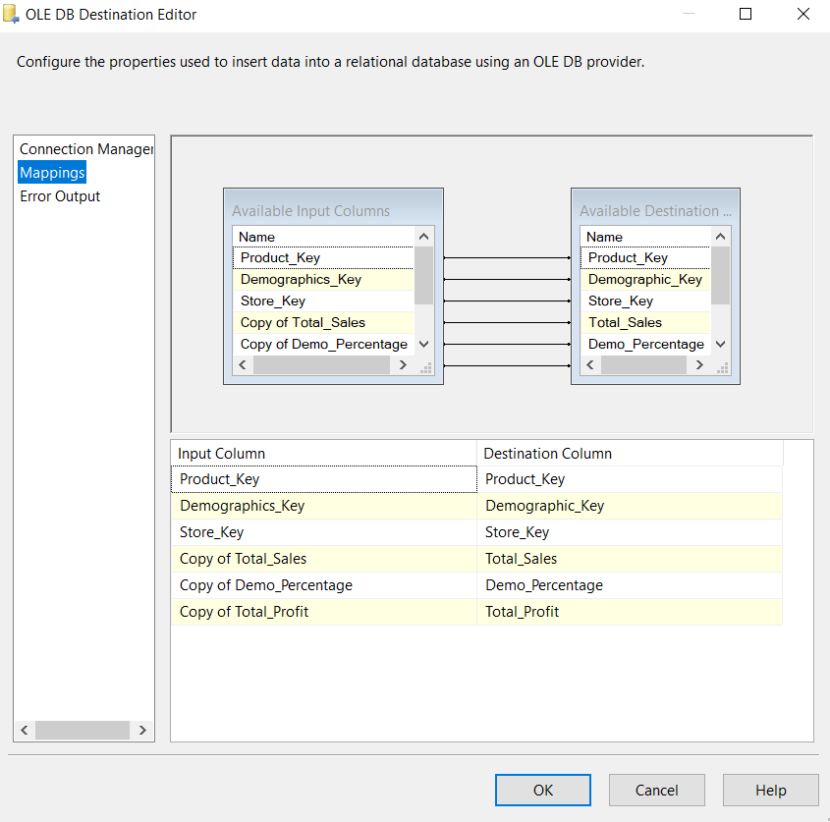

# Reporting Plan

**Overview of BI reporting**

Business Intelligence (BI) reporting is the process of utilizing softwares to collect, understand and present business information in a form that is suitable for making strategic business decisions. A lot of tools are available in the market that can help organizations in identifying trends, highlight inefficiencies, or uncover areas of improvement. BI reporting allows creation of real time reports which are intuitive and can fasten the decision making process in the organizations. If done correctly, they allow easy slice and dice of information across different categories and therefore enhance productivity. They can also be used to generate reports from a wide variety of historical data and could be used across various departments and industries. They have the capabilities to deliver aggregated and summarized reports. Reports generated by BI reporting tools could be further analyzed and queries for insights. SSRS, a reporting tool, can be used to generate interactive reports, data visualizations, and analytical dashboards. Examples of BI reporting tools include Tableau, SSRS, Report Builder, Power BI, QlikView, among many others.

**Benefits**

Reporting of data is essential to draw insights from the data. Different types of graphs, charts, visualizations, and plots makes it easy to understand data and enhances the experience of deriving insights from the data. Some of the crucial benefits of BI reporting are:

* Quick identification of trends in data and fasten decision making process by business leader
* Allows competitive data analysis and provides valuable insights
* Offers seamless drill down and slice and dice features for intuitive analysis
* Allows easy customization and integration of data from various sources

**Reporting for this project**

The following tools were used to answer individual question of this project:

|  |  |
| --- | --- |
| Question Number | Tools Used |
| Business Question 1 | Tableau |
| Business Question 2 | SSAS + SSRS |
| Business Question 3 | Tableau |
| Business Question 4 | SSRS |
| Business Question 5 | SSAS |

## Target Reports that satisfy the Business Question

**Business Question 1**: In which part of the year, liquor sales are maximum and why?

To answer the question, we used Tableau, a Business Intelligence tool to create the report.

Data Marts Used: Product Data Mart

Dimension Table Used: Dim_Time, Dim_Product, Dim_Store

Fact Table Used: Fact_ProductSales

Measures in report: Total_Sales

Aggregating Total_Sales by Product_Description and then filtered Product_description to contain only Wine, Beer and Spirits products. Represented the entire data on a Time series denoting Week number.

**Business Question 2**: How have the different categories of customers impacted the sales across various stores in the last 8 years?

For answering this question, we used SSRS to generate the required report.

Data Mart used: Demographics Information Data Mart

Dimension Tables used: Dim_Product, Dim_Demographics, Dim_Store

Fact Table used: [FACT_DEMO_INFO]

The columns are: Demographics Type, Store ID, Total Sales

The results are displayed in a drill-down format based on the Dempgraphic Type.

**Business Question 3**: Which are the top 10 stores to sell meat, meat frozen and fish?

To answer the question, we used Tableau, a Business Intelligence tool to create the report.

Data Marts Used: Product Data Mart

Dimension Table Used: Dim_Store, Dim_Product

Fact Table Used: Fact_ProductSales

Measures in report: Total_Sales

Aggregated Total_Sales by Store Key and Product_Description and then created 2 filters. One filter to include only meat, fish, and meat frozen products and then a second filter to display only top 10 stores based on total sales.

**Business Question 4**: Which stores have the maximum pharmacy sales? What factor can be considered to increase pharmacy sale in other stores?

To answer this question, we used SSRS tool to create the report.

Data Marts Used: Product Data Mart

Dimension Table Used: Dim_Store, Dim_Product

Fact Table Used: Fact_ProductSales

X axis: Store number

Y axis: Total Sales

Aggregating Total_Sales by Product_Description and then filtered Product_description to contain only Pharmacy products in each store.

**Business Question 5**: Which stores have contributed the most towards profit from Grooming products?

To answer this question, we used SSRS tool to create the report.

Data Marts Used: Demographics Information Data Mart

Dimension Table Used: Dim_Store, Dim_Product

Fact Table Used: Fact_Demo_Info

Measures in report: Total_Profit

Aggregating Total_Profit by Store_No and then filtered Product_description to contain only Grooming products.x

## Mappings from Independent Data Marts to Report Attributes

**Business Question 1**: In which part of the year, liquor sales are maximum and why?

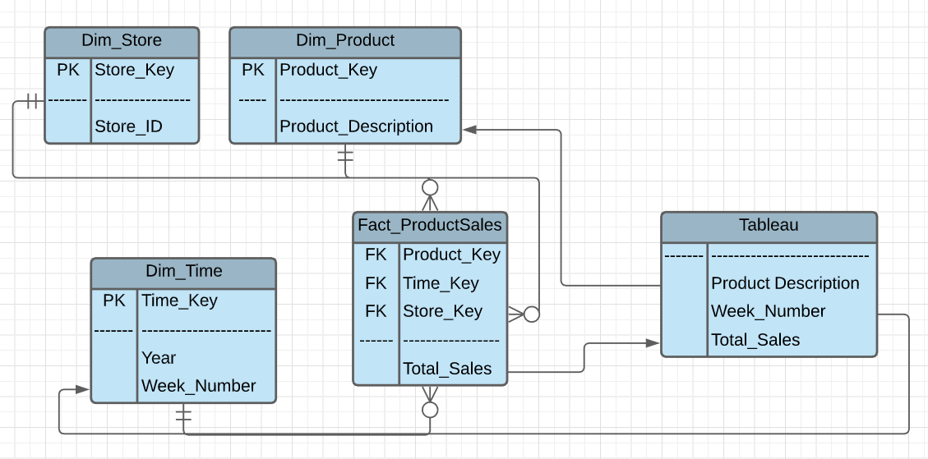

**Business Question 2**: How have the different categories of customers impacted the sales across various stores in the last 8 years?

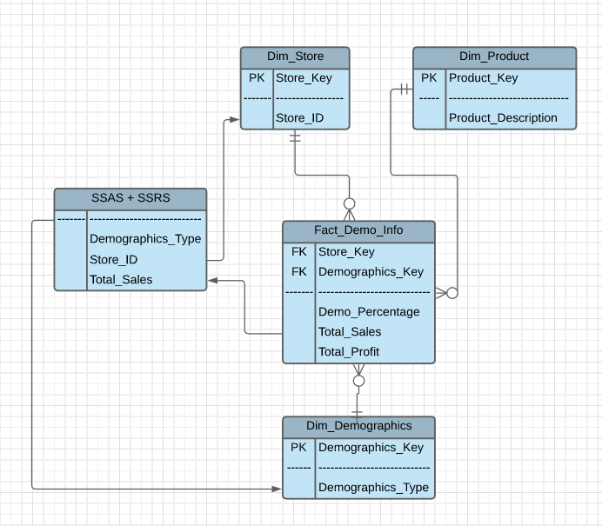

**Business Question 3**: Which are the top 10 stores to sell meat, meat frozen and fish?

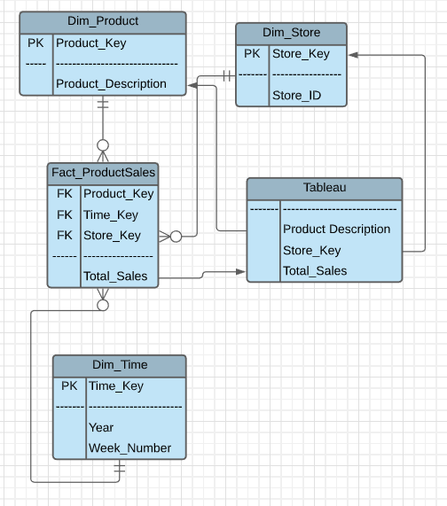

**Business Question 4**: Which stores have the maximum pharmacy sales? What factor can be considered to increase pharmacy sale in other stores?

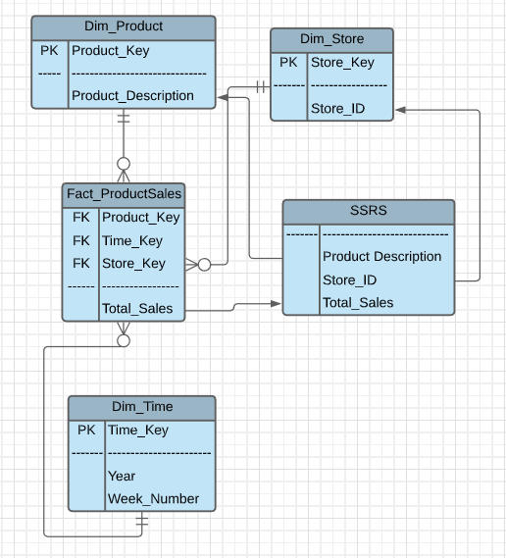

**Business Question 5**: Which stores have contributed the most towards profit from Grooming products?

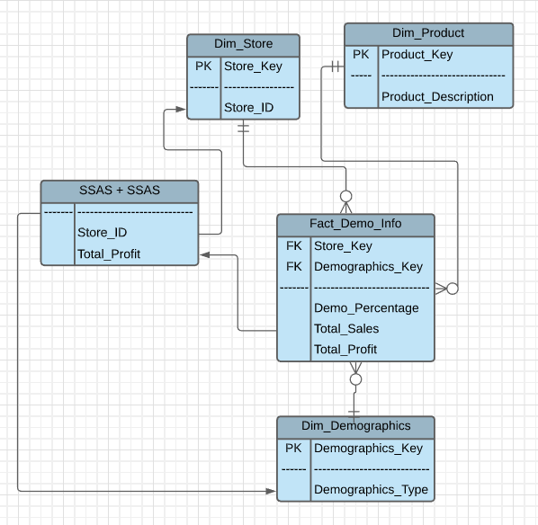

## Report Templates/ Report Building for Business Questions

**Business Question 1**: In which part of the year, liquor sales are maximum and why?

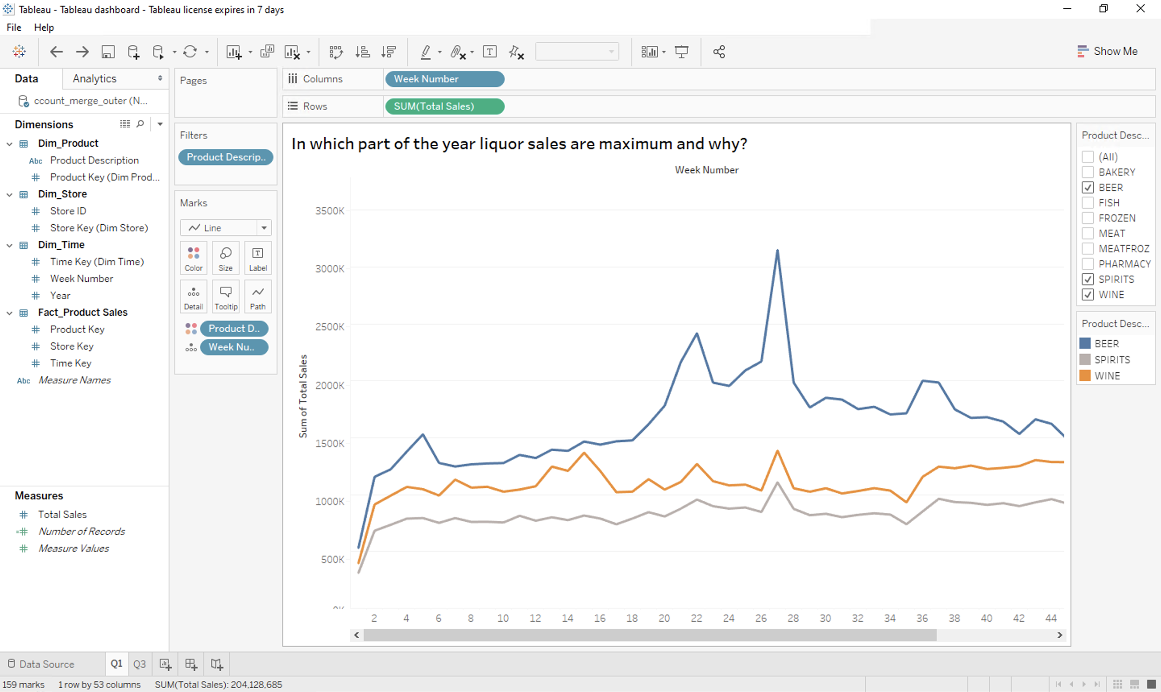

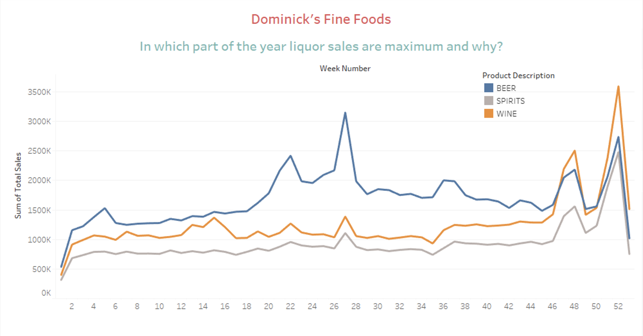

Justification: From this question, we wish to understand the sales of alcohol across different stores. This information will help Dominick’s Fine foods in planning and management of inventory. This business question has been answered using the BI tool, Tableau. A connection was established with the 601_Group7_DW_Area’ database in SSMS and then the dimension tables and the fact table of Product Data Mart were pulled in as the data sources in tableau. Product description attribute from product dimension table is correlated with week number from week dimension table and total sales from Product fact table. A filter is created for product description to include only beer, spirits, and wine. The product description attribute is then pulled onto the color marks shelf to add different colors for different products in the line chart. This visualization helps us tell that the sales are maximum after the 50th week. We can confirm this with the fact that people tend to buy alcohol during the year end holiday season and thus, DFF should make sure that they stock up sufficient inventory of alcoholic beverages during that time of the year.

**Business Question 2**: How have the different categories of customers impacted the sales across various stores in the last 8 years?

* 1. Cube Structure

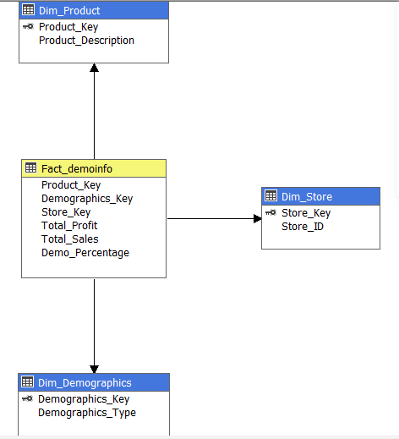

* 1. Deployment in Visual Studio

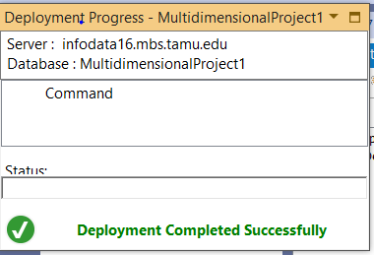

* 1. Model Deployed

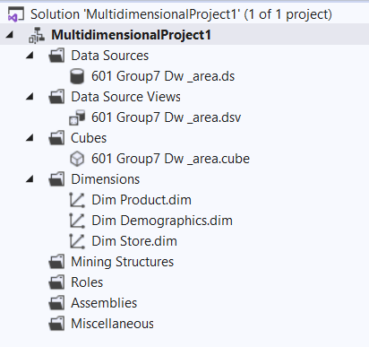

* 1. SSAS Output

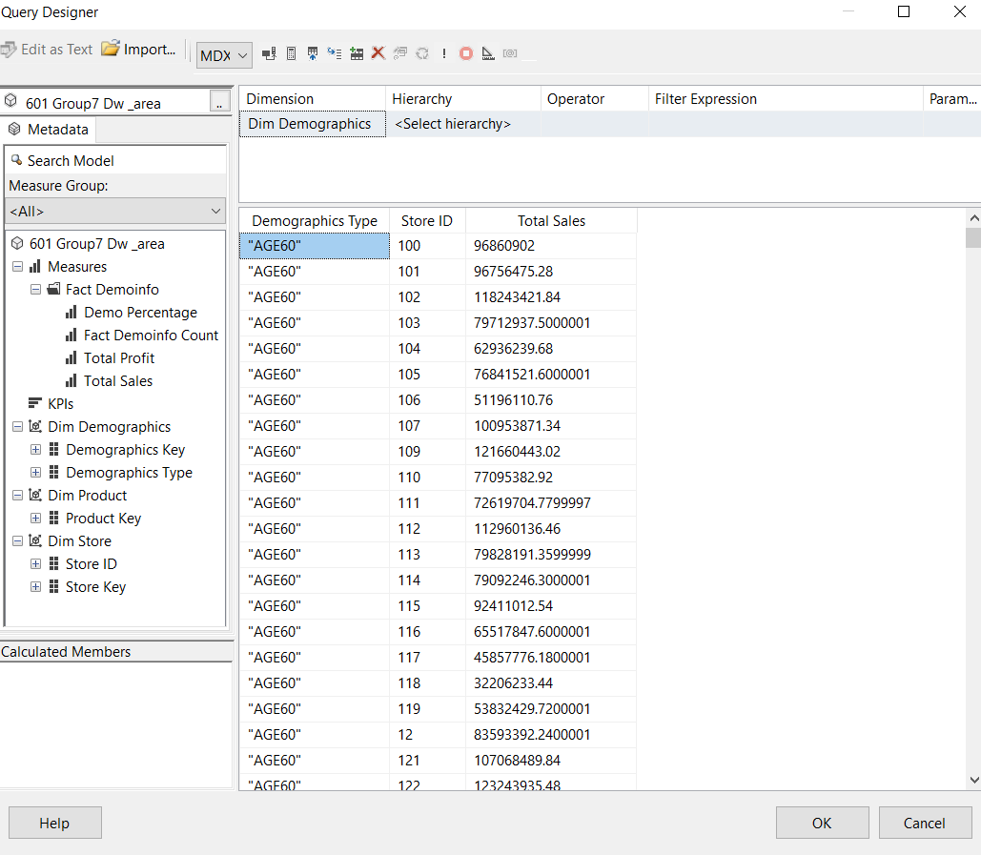

* 1. Server-Side Implementation

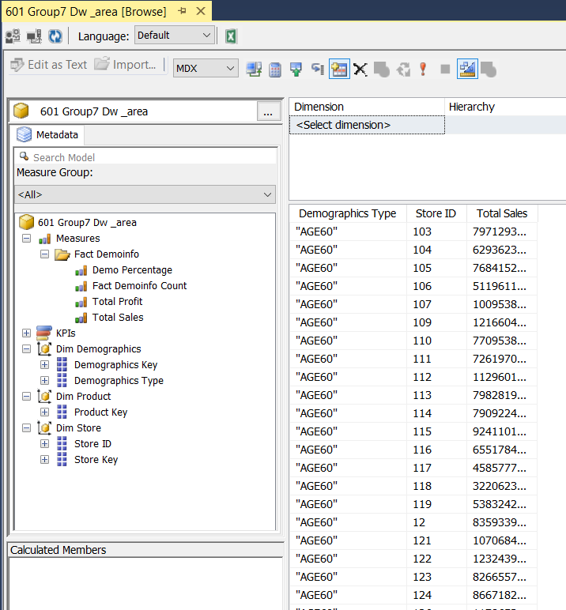

* 1. SSRS Implementation

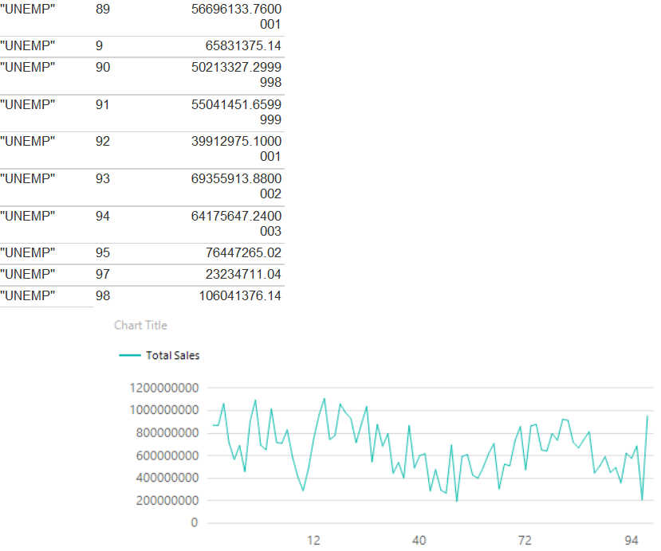

* 1. Report on server side

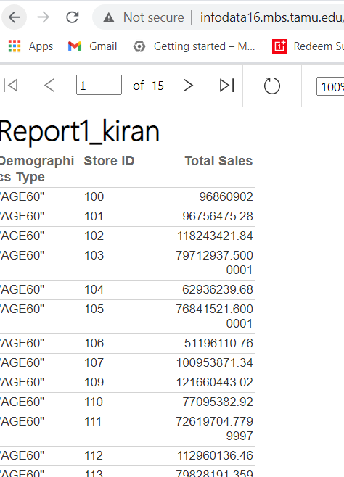

Justification:

From this question, we wish to understand how different types of customers are affecting the sales at different stores. This information will help Dominick’s Fine foods in planning and management of inventory. This business question has been answered using a combination of SSAS and SSRS tools. A connection was established with the 601_Group7_DW_Area’ database in SSMS and then the dimension tables and the fact table of Demographics Information Data Mart were pulled in as the data sources in SSAS. The demographics dimension table contains information about the relevant customer types for all types of stores. The store number attribute is pulled to distinguish the amount of sales with respect of store number on top of the demographics type. This visualization helps us tell the total amount of sales as well sales according to each demographic in every store.

**Business Question 3**: Which are the top 10 stores to sell meat, meat frozen and fish?

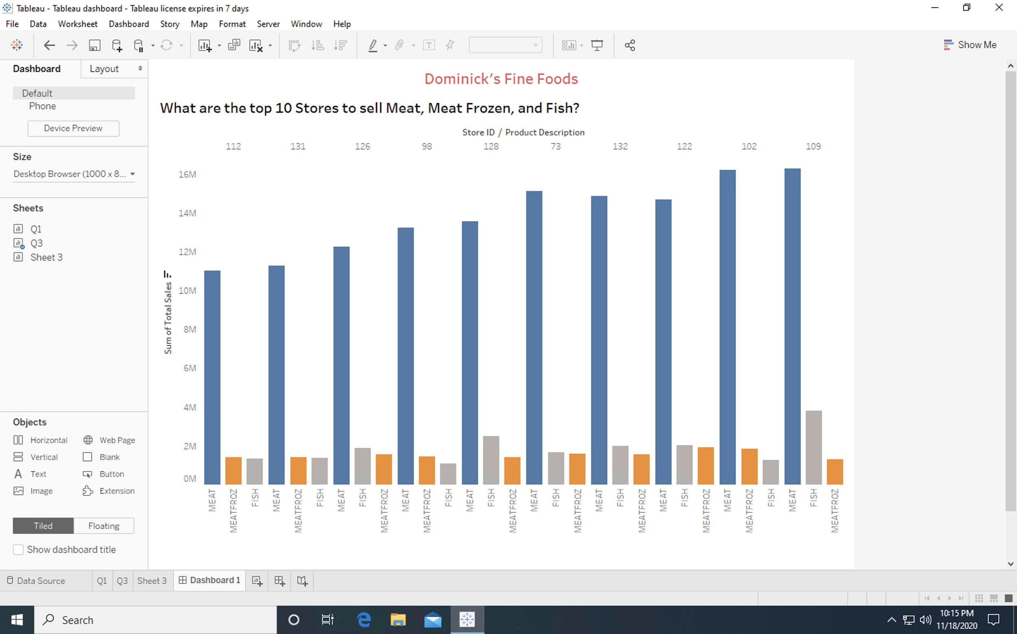

Justification: This infographic shows the sales of meat, meat frozen and fish products across different stores. This business question has been answered with the help of visualization created in Tableau. Product Data mart has been used to answer this business question. A filter is created on product description to include these 3 categories of products and then the sales of these products are viewed for different store keys. The entire dataset is sorted in descending order based on the total sales value and then top 10 stores are shown in this visualization.

**Business Question 4**: Which stores have the maximum pharmacy sales? What factor can be considered to increase pharmacy sale in other stores?

* + - * 1. 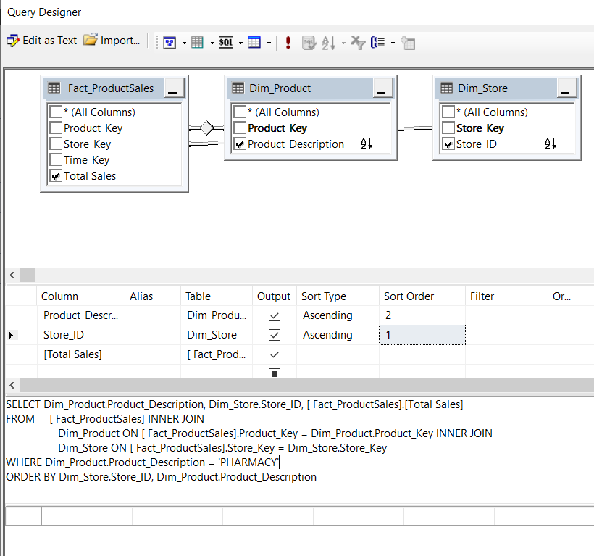Query Designer
        2. Report RDL

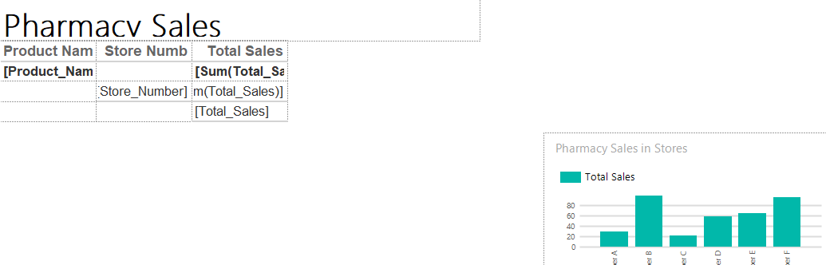

* + - * 1. Final Report SSRS

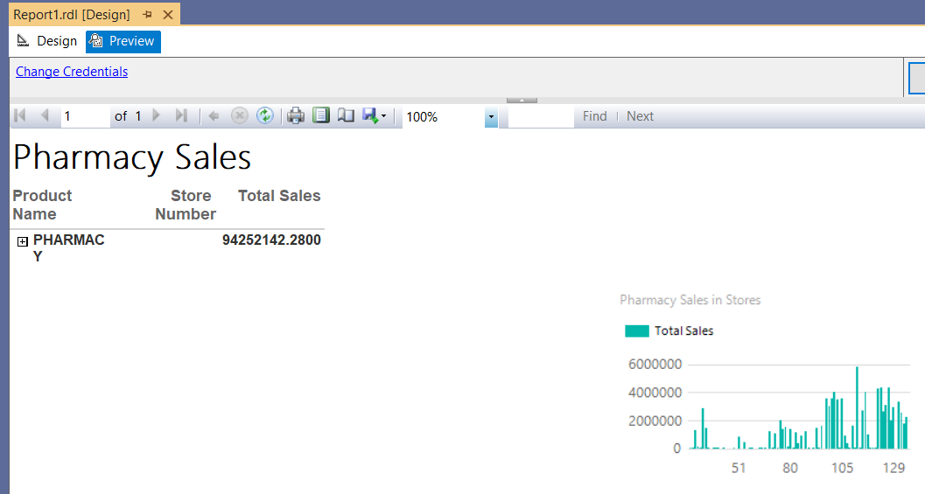

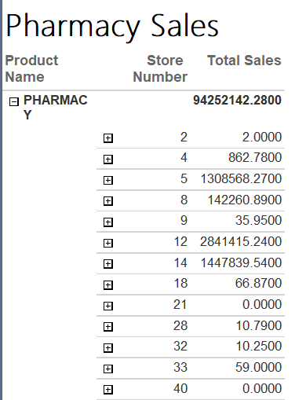

* + - * 1. Creation of shared data sources

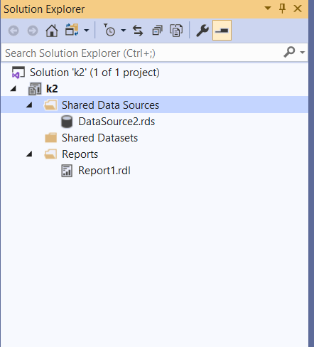

Justification:

This infographic charts the total sales generated by various stores for pharmaceutical products. It becomes evident that the store numbers from 100 to 130 have the maximum amount of sales of these products.. Our rationale behind this hypothesis was to assist decision makers at DFF to be able to expand the business at according to the growth rate for each store. We see that the stores 20 to 65 contributes the least contributions to sales, which could imply that the company needs to market their products well in those particular stores to achieve equilibrium. It could also imply an untapped potential in a specific store according to the location.

**Business Question 5**: Which stores have contributed the most towards profit from Grooming products?

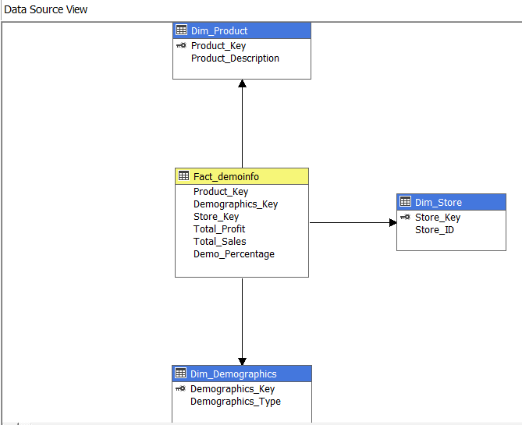a. Data cube structure

b. Deployment in Visual Studio



c. Deployment in SSAS

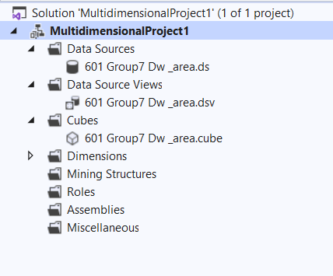

d. Final Output

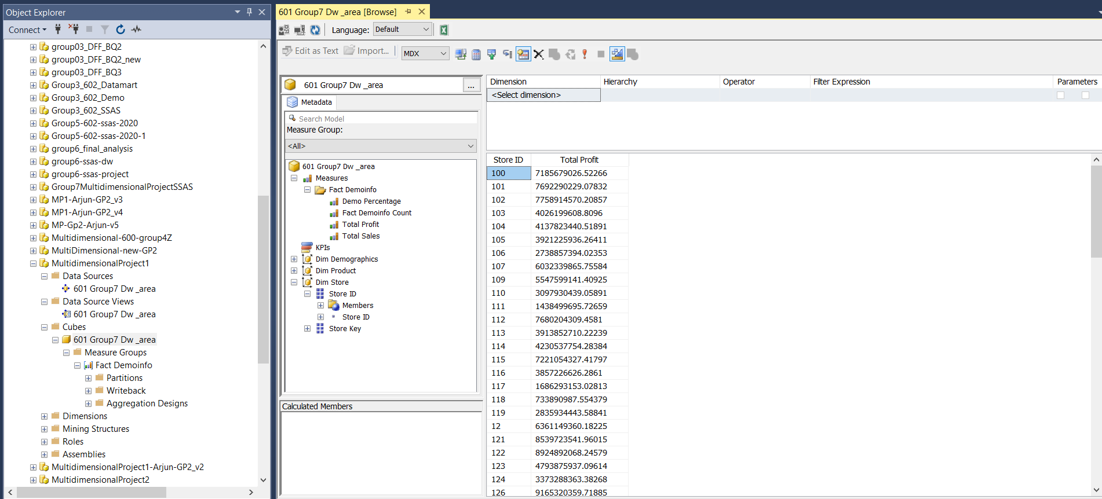

Justification:

This business question is answered using SSAS. The mechanism includes designing a cube structure using Visual Studio and deploying it in the Analysis Services. This business question addresses the amount of sales occurred due to purchase pattern of grooming products. Total Profit was calculated from the Movement table (WGRO) and the results were stored in WGRO_temp. While creating the Fact_demoinfo table, total profit of grooming products for different stores was stored as a measure. Through this fact table we can see which stores have contributed the most towards profit from grooming products.

# References

1. Daniel Toro-Gonzalez, Jill J. McCluskey, and Ron C. Mittelhammer. “Beer Snobs Do Exist: Estimation of Beer Demand by Type.” Journal of Agricultural and Research Economics (JARE) (2014).
2. Jami, Ata, and Himanshu Mishra. “Downsizing and Supersizing: How Changes in Product Attributes Influence Consumer Preferences.” Journal of Behavioral Decision Making (2013).
3. Levy, Daniel, Dongwon Lee, Haipeng (Allan) Chen, Robert J. Kauffman, and Mark Bergen. “ Price Points and Price Rigidity.” The review of Economics and Statistics 93.4 (2011):1417-1431.
4. https://anuradhasrinivas.files.wordpress.com/2013/03/data-warehousing-fundamentals-by-paulraj-ponniah.pdf
5. https://www.sqlservercentral.com/blogs/the-kimball-approach